|  |
| --- |
| **NIST MGI MDCS**  **User Guide** |
| MGI MDCS Version 1.0.0  (DRAFT) |
|  |
|  |
|  |
|  |
|  |
|  |

Prepared by the NIST MGI MDCS Team and:

DakotaLogo.rev12.wmf

1110 Bonifant St., Suite 310

Silver Spring, MD 20910

(240) 839-7812

[www.Dakota-Consulting.com](http://www.Dakota-Consulting.com)

Table of Contents

1 Introduction to NIST MGI MDCS 5

1.1 Welcome 5

1.2 User Guide Objectives 5

1.3 What is MDCS? 5

1.4 The Significance of MDCS to NIST 5

1.5 Access to MDCS 6

1.6 MDCS Groups 6

2 System Requirements 7

2.1 System Requirements 7

2.1.1 Client 7

2.1.2 Server 7

3 Installation Instructions 8

3.1 Installation Instructions for WINDOWS 8

3.1.1 Automated Instructions 8

3.1.2 Manual Instructions 13

3.2 Installation Instructions for Mac 17

3.2.1 Automated Instructions 17

3.2.2 Manual Instructions 17

3.3 Installation Instructions for Linux 21

3.3.1 Manual Instructions 21

3.4 Installation Instructions for Unix 23

3.4.1 Manual Instructions 23

4 Navigation and System Conventions 24

5 Account Registration 26

5.1 Account Registration 26

5.1.1 Request an Account 26

5.1.2 Administrator Fulfills Request 27

6 Account Access 28

6.1 Account Access 28

6.1.1 Login Process 28

6.1.2 Maintain Profile 30

Edit Profile 30

Change Password 33

6.1.3 Logout Process 37

6.1.4 Forgot Password 38

7 Administrator Role 39

7.1 Administrator Activities 39

7.2 User Management 39

7.2.1 Create a User Account 42

7.2.2 Modify a User Account 45

7.2.3 Online Account Requests 47

7.3 Templates and Ontologies 48

7.3.1 Template Management 48

Manage Template Versions 53

Edit Template Information 57

Delete Template 58

Restore Template 60

7.3.2 Ontology Management 62

Manage Ontology Versions 67

Edit Ontology Information 70

Delete Ontology 72

Restore Ontology 74

8 Scientist Role 75

8.1 Scientist Activities 75

8.2 Data Curation 75

8.2.1 View Data 96

Download XML: 100

Save XML to Repository: 101

8.3 Data Exploration 104

8.3.1 Query by Example: 104

8.3.2 SPARQL Endpoint Query 119

8.4 E-mail Template 133

9 RESTful API 135

10 Federation of Queries 138

11 Resources for help 140

11.1 Resources for help 140

11.1.1 MDCS Help 140

11.1.2 MDCS Contact 141

11.1.3 MDCS Support Points of Contact 143

12 System Architecture 144

13 Index 145

14 Index of Figures 146

# Introduction to NIST MGI MDCS

## Welcome

The NIST Materials Genome Initiative (MGI) Materials Data Curation System (MDCS) User Guide is designed to be a comprehensive guide to the Materials Data Curation System.

## User Guide Objectives

In using this guide, the user will gain familiarity with MDCS, including the roles of each of the participants. The guide will demonstrate how the user can perform the following tasks:

* Enter and curate materials data
* Search and explore materials data
* Manage templates
* Manage user accounts
* Use the RESTful API interface
* Perform Federation Queries
* System installations
* System architecture

## What is MDCS?

MDCS allows for the curation of materials data into a repository using predefined templates. The system also allows for browsing and exploring of the materials data using the predefined templates as well.

## The Significance of MDCS to NIST

The missions of the Materials Genome Initiative and National Institute of Standards and Technology (NIST) are tightly aligned. NIST promotes U.S. innovation and industrial competitiveness by advancing measurement science, standards, and technology in ways that enhance economic security and improve our quality of life. MGI addresses precisely these mission elements by providing the means to reduce the cost and development time of materials discovery, optimization, and deployment. Both missions are driven by industrial competitiveness, with the creation of an innovation infrastructure as the means to this end.

Given NIST expertise in the integration, curation, and provisioning of critically evaluated data and models, NIST has assumed a leadership role within the MGI. In order to foster widespread adoption of the MGI paradigm both across and within materials development ecosystems, NIST is establishing essential data exchange protocols and the means to ensure the quality of materials data and models. These efforts will yield the new methods, metrologies, and capabilities necessary for accelerated materials development. NIST is working with stakeholders in industry, academia, and government to develop the standards, tools and techniques enabling acquisition, representation, and discovery of materials data; interoperability of computer simulations of materials phenomena across multiple length and time scales; and the quality assessment of materials data, models, and simulations.

Internally NIST is conducting several path-finder projects to enable integration of key aspects of the materials innovation infrastructure, expose challenges in the construction of this infrastructure, and to serve as exemplars for the broader MGI effort. This includes pilot projects to develop super alloys and advanced composites, both new, energy efficient materials for transportation applications. These activities are coordinated by the NIST Material Measurement Laboratory, in partnership with the NIST Information Technology Laboratory, and with broad participation across the Institute

In summary, NIST is establishing (1) the essential materials data and model exchange protocols and the (2) means to ensure the quality of materials data and models, ultimately (3) establishing new methods, metrologies, and capabilities necessary for accelerated materials development. Additionally, though its efforts to (4) integrate these activities, NIST is working to test and disseminate its developed infrastructure and best practices to its stakeholders. (Taken directly from <http://nist.gov/mgi/> )

MDCS provides NIST and the scientific community with a centralized, up-to-date, repository of materials data. MDCS improves and facilitates the sharing of data as well as allows the transformation of data from one representation to another.

## Access to MDCS

An individual may make a request to access MDCS using the online request form. Once the MDCS administrator accepts the account request, the user is notified that the account is created with the appropriate credentials.

## MDCS Groups

There are two groups within MDCS:

**Scientists –** A scientist curates and explores data according to specified templates.

**Administrators** – An administrator supports the scientist user group by managing accounts, and managing templates and ontologies.

# System Requirements

## System Requirements

The MDCS system requirements are divided in 2 categories. The client section details the minimum client requirements as well as the choices of supported browsers on each user’s machine. The server section requirements details the minimum server requirements.

### Client

Supported browsers:

* Internet Explorer 6.0 or later
* Mozilla Firefox 2.0 or later
* Google Chrome
* Safari

### Server

Python 2.7 or higher

Django Framework 1.6

MongoDB 2.6 or higher

MongoEngine

Django DajaxICE

Apache Jena 2.12 or higher

Django REST Framework

Django Auth LDAP

Django REST Swagger

# Installation Instructions

## Installation Instructions for WINDOWS

### Automated Instructions

1. Double-click on setup.exe.

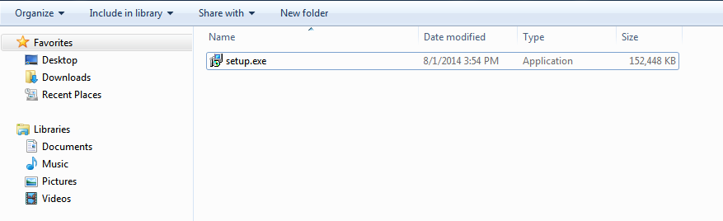

Figure Automated Instructions for Windows

1. A pop-up asking for administrator access will appear.

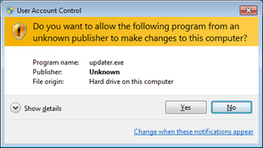

Figure Pop-up requesting administrator access

1. Allow the program to run on your computer by typing your username and password and click on ‘Yes’, or simply by clicking on ‘Allow’.
2. Use the setup assistant to install the program. Go to the next step using the ‘Next’ button.

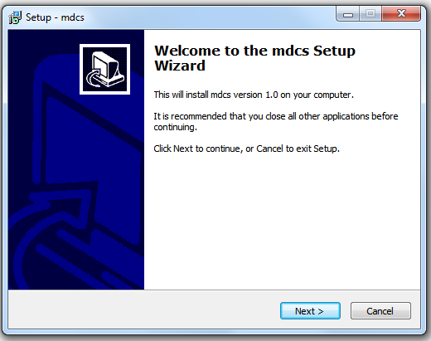

Figure MDCS Setup Wizard

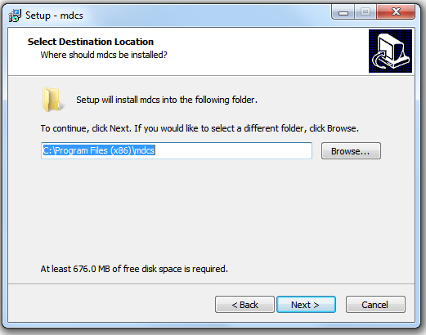

Figure Select Destination Location

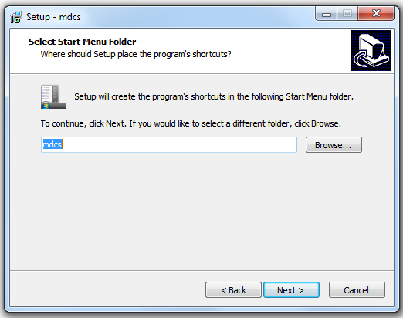

Figure Select Start Menu Folder

1. Then click on the ‘Install’ button to start the installation.

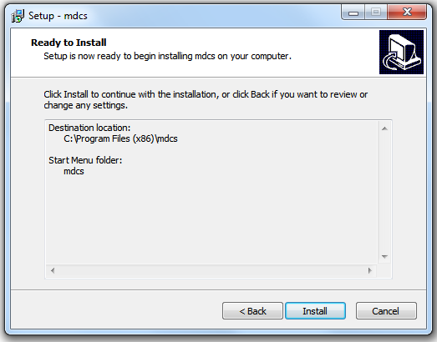

Figure Ready to Install

1. Wait for the installation process to finish.

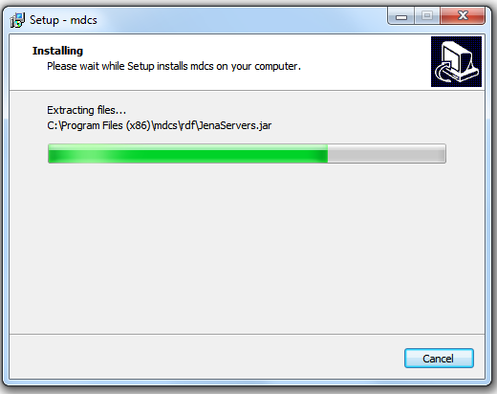

Figure Installing

1. Click on Finish to close the setup assistant.

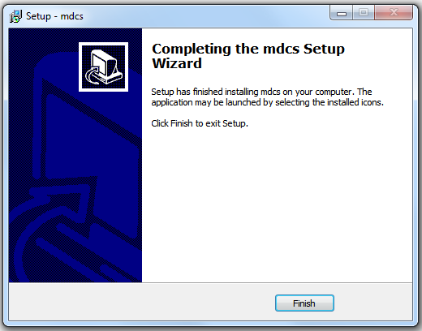

Figure Completing the MDCS Setup Wizard

1. The program is now installed on the computer and a shortcut is created on the desktop.

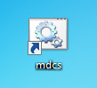

Figure MDCS Shortcut

1. To run MDCS, you have to run it as an administrator. Right-click on the MDCS shortcut on the desktop and select ‘Run as administrator’. A pop-up asking for administrator access will appear again. Allow MDCS to run on your computer by typing your username and password and click on ‘Yes’, or simply by clicking on ‘Allow’.

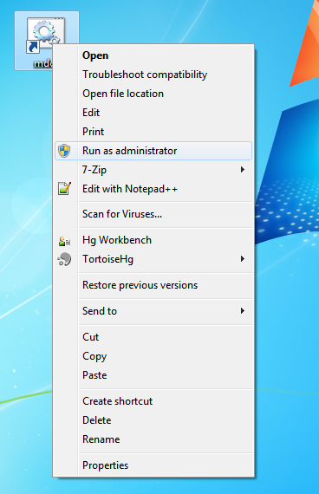

Figure MDCS Shortcut Right Click

1. Once the program is running the three following Windows should appear. Let them open to let MDCS run well.

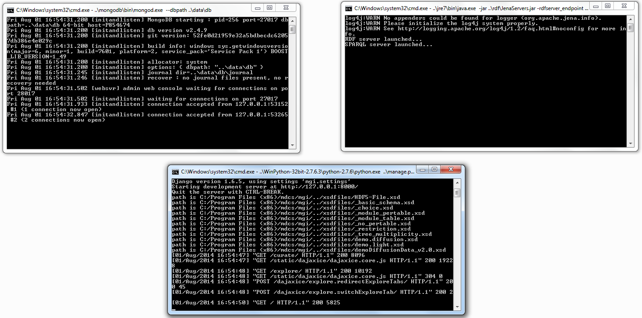

Figure Open Windows while MDCS is running

### Manual Instructions

**Setup:**

**For python:**

1. Download python 2.7 (<https://www.python.org/download/>)
2. Add to PATH:

C:\Python27\

C:\Python27\Scripts

**For pip:**

We need pip to do the installation of the required dependencies. pip requires setuptools and it has to be installed first, before pip can run:<http://www.pip-installer.org/en/latest/installing.html>

1. Download get-pip.py
2. In a command prompt :

python get-pip.py

**For the virtual environment:**

1. In a command prompt:

pip install virtualenvwrapper-win

1. Add environment variable (Win 7 :Start, right click on Computer, Properties, click on Advance system settings in the left panel, go to advanced tab, Environment Variables…, New)

WORKON_HOME=%USERPROFILE%\Develop\Envs

1. In a command prompt and then :

mkdir %WORKON_HOME%

cd %WORKON_HOME%

mkvirtualenv mgi

1. To use the environment:

workon mgi (the prompt will change and become mgi. You should always see the mgi prompt when installing new packages)

**For ZeroMQ:**

1. In a command prompt:

pip install pyzmq

**For Jena:**

1. Be sure that the folder <PROJECT PATH>\mdcs\data exists and contains a folder named ts. Otherwise, in a command prompt:

cd <PROJECT PATH>\mdcs

mkdir data

cd data

mkdir ts

1. Be sure that a jdk7 is installed on your computer and that it is in your path. In a command prompt, the following command should display the version of javac (1.7.*):

javac –version

Otherwise:

* Download a jdk7 from<http://www.oracle.com/technetwork/java/javase/downloads/jdk7-downloads-1880260.html>
* Install the jdk
* Add C:\Program Files\Java\jdk1.7.0_60\bin to your path.

1. In a command prompt:

cd <PROJECT PATH>\mdcs\rdf

javac -cp “lib/*” RdfServer.java SparqlServer.java JenaServers.java

java -cp “lib/*;.” JenaServers -rdfserver_endpoint “tcp://127.0.0.1:5555” -sparqlserver_endpoint “tcp://127.0.0.1:5556” -tdb_directory <TS PATH> -project_uri <PROJECT URI>

Command Example: C:\Users\<username>\workspace\MDCS_PROJECT\mdcs\rdf>java -cp "lib/*;." JenaServers -rdfserver_endpoint "tcp://127.0.0.1:5555" -sparqlserver_endpoint "tcp://127.0.0.1:5556" -tdb_directory "C:\Users\<username>\workspace\MDCS_Project\mdcs\data\ts" -project_uri “http://www.example.com/”

**For MongoDB:**

1) Download Mongo db (<http://www.mongodb.org/downloads>) and install it in C:.

2) In a command prompt :

c:

mongod –dbpath PROJECT_PATH\data\db

**For Mongoengine:**

1) In a command prompt :

pip install mongoengine (<http://docs.mongoengine.org/guide/installing.html>)

**For Django/Dajax/Dajaxice:**

1. In a command prompt :

pip install Django (<https://docs.djangoproject.com/en/1.6/topics/install/>)

pip install django-dajax (<http://django-dajax.readthedocs.org/en/latest/installation.html>)

pip install django-dajaxice (<http://django-dajaxice.readthedocs.org/en/latest/installation.html>)

Go to C:\Users\<username>\Develop\mgi\Lib\site-packages and modify the following files to make dajaxice work:

Any Python version :

* In dajaxice\core\__init__.py :
  + Replace :
    - from Dajaxice
  + By :
    - from .Dajaxice
* In dajaxice\urls. py
  + Replace :
    - from django.conf.urls.defaults import *
  + By :
    - from django.conf.urls import patterns, url, include

Python 3.* :

* In Views.py :
  + Change safe_dict(d) to :

def safe_dict(d):

"""

Recursively clone json structure with UTF-8 dictionary keys

<http://www.gossamer-threads.com/lists/python/bugs/684379>

"""

if isinstance(d, dict):

return dict([(k, safe_dict(v)) for k, v in d.items()])

elif isinstance(d, list):

return [safe_dict(x) for x in d]

else:

return d

**For ldap:**

1. Install the django-auth-ldap package:

a. Download django-auth-ldap package from pypi (<https://pypi.python.org/pypi/django-auth-ldap/1.2.0>)

b. In a command prompt:

cd PATH_TO_django-auth-ldap_FOLDER

python setup.py install build

**For Django Rest Framework:**

1. In a command prompt :

pip install djangorestframework (<http://www.django-rest-framework.org/>)

pip install django-rest-framework-mongoengine

pip install django-rest-swagger

**For MS Excel to HDF5 translation/mapping:**

1. In a command prompt :

pip install xlrd

**For lxml:**

1. Download lxml from pypi (<https://pypi.python.org/pypi/lxml/2.3>)

a. Use the Windows link for Python 2.7 : lxml-2.3.win32-py2.7.exe (win32)

1. Run the installer

a. If you use a virtual environment.

You can’t change the destination folder set in the installer so you will have to install the package in the specified folder (C:\Python27\Lib\site-packages\) and then copy the lxml directories from C:\Python27\Lib\site-packages\ to %USERPROFILE%\Develop\Envs\mgi\Lib\site-packages.

**For xmltodict:**

1. In a command prompt :

pip install xmltodict

**To Run software:**

1. In a command prompt :

mongod –dbpath PROJECT_PATH\data\db

1. In a command prompt :

java -cp “lib/*;.” JenaServers -rdfserver_endpoint “tcp://127.0.0.1:5555” -sparqlserver_endpoint “tcp://127.0.0.1:5556” -tdb_directory <TS PATH> -project_uri <PROJECT URI>

1. In a command prompt :

workon mgi

cd path_to_mdcs_folder

python manage.py runserver

**Access:**

For Materials Data Curation System, Go to: <http://127.0.0.1:8000/>

For Materials Data Curation Administration, Go to: <http://127.0.0.1:8000/admin/>

## Installation Instructions for Mac

### Automated Instructions

### Manual Instructions

**Prerequisites**

Python 2.7.2 (brew install python)

pip ([http://pip.readthedocs.org/en/latest](http://pip.readthedocs.org/en/latest/))

cd ~/

curl -L [http://www.python.org/ftp/python/2.7.2/Python-2.7.2.tgz > Python-2.7.2.tgz](http://www.python.org/ftp/python/2.7.2/Python-2.7.2.tgz)

[tar xzf Python-](http://www.python.org/ftp/python/2.7.2/Python-2.7.2.tgz)2.7.2.tgz

cd python-2.7.2

./configure

make altinstall prefix=~/usr/local exec-prefix=~/usr/local

alias python='~/usr/local/bin/python2.7'

curl<https://bootstrap.pypa.io/get-pip.py> > get-pip.py

python get-pip.py

alias pip=~/usr/local/bin/pip

Any installed package via pip will now go under your '~/usr/local/lib/python2.7/site-packages' directory.

**Setup:**

We need pip to do the installation of the required dependencies. pip requires setuptools and it has to be installed first, before pip can run: <http://www.pip-installer.org/en/latest/installing.html>

Checkout MGI repository into ~/Develop/Workspaces

cd ~/Develop

mkdir Env

pip install virtualenvwrapper (<http://virtualenvwrapper.readthedocs.org/en/latest/>)

export WORKON_HOME=~/Develop/Envs

mkdir -p $WORKON_HOME

source /usr/local/bin/virtualenvwrapper.sh

For Linux: source /usr/bin/virtualenvwrapper.sh

mkvirtualenv mgi

**For MongoDB (in a new terminal):**

cd ~/Develop/Workspaces/mgi/mdcs/

export WORKON_HOME=~/Develop/Envs

source /usr/local/bin/virtualenvwrapper.sh

workon mgi

cd <PROJECT PATH>\mdcs

mkdir data

cd data

mkdir ts

mkdir db

Run MongoDB:

mongod --dbpath data/db/

**For Apache Jena (in a new terminal):**

cd ~/Develop/Workspaces/mgi/mdcs/

export WORKON_HOME=~/Develop/Envs

source /usr/local/bin/virtualenvwrapper.sh

workon mgi

We need to compile and run the rdfserver.java file

cd <PROJECT PATH>/mdcs/rdf

javac -classpath "lib/*" RdfServer.java SparqlServer.java JenaServers.java

java -cp ".:lib/*" JenaServers -rdfserver_endpoint 'tcp://127.0.0.1:5555' -sparqlserver_endpoint 'tcp://127.0.0.1:5556' -tdb_directory '/Users/ssy/Develop/Workspaces/mgi/mdcs/data/ts' -project_uri 'http://www.example.com/'

To query the RDF DB:

sh fuseki-server --loc=/Users/ssy/Develop/Workaces/mgi2/mgi/mdcs/data/ts /ts

**For Django (in a new terminal):**

cd ~/Develop/Workspaces/mgi/mdcs

export WORKON_HOME=~/Develop/Envs

source /usr/local/bin/virtualenvwrapper.sh

workon mgi

pip install Django (<https://docs.djangoproject.com/en/1.6/topics/install/>)

pip install mongoengine (<http://docs.mongoengine.org/guide/installing.html>)

pip install django-auth-ldap (<http://pythonhosted.org/django-auth-ldap/>)

pip install django-dajax (<http://django-dajax.readthedocs.org/en/latest/installation.html>)

pip install xlrd (needed for Microsoft Excel to HDF5 translation/mapping)

pip install xmltodict (<https://github.com/martinblech/xmltodict>)

pip install pyzmq (<https://github.com/zeromq/pyzmq>)

pip install lxml (<http://lxml.de/>)

pip install djangorestframework (<http://www.django-rest-framework.org/>)

pip install django-rest-framework-mongoengine (<https://pypi.python.org/pypi/django-rest-framework-mongoengine>)

pip install django-rest-swagger (<https://github.com/marcgibbons/django-rest-swagger>)

(for now: add the templates to mongodb by uncommenting the lines under curate(request) inside mgi/views.py and load the curate page once. Make sure to add comments back on).

update SITE_ROOT inside settings.py to correct path of site

example:

SITE_ROOT = '/Users/ssy/Develop/Workspaces/mgi/mdcs'

python manage.py syncdb

Answer yes to:

You just installed Django's auth system, which means you don't have any superusers defined.

Would you like to create one now? (yes/no):yes

Run software:

python manage.py runserver

**Access:**

For Materials Data Curation System, Go to: <http://127.0.0.1:8000/>

For Materials Data Curation Administration, Go to: <http://127.0.0.1:8000/admin/>

## Installation Instructions for Linux

### Manual Instructions

**Prerequisites**

Python 2.7.2 (brew install python)

pip ([http://pip.readthedocs.org/en/latest](http://pip.readthedocs.org/en/latest/))

cd ~/

curl -L [http://www.python.org/ftp/python/2.7.2/Python-2.7.2.tgz > Python-2.7.2.tgz](http://www.python.org/ftp/python/2.7.2/Python-2.7.2.tgz)

[tar xzf Python-](http://www.python.org/ftp/python/2.7.2/Python-2.7.2.tgz)2.7.2.tgz

cd python-2.7.2

./configure

make altinstall prefix=~/usr/local exec-prefix=~/usr/local

alias python='~/usr/local/bin/python2.7'

curl<https://bootstrap.pypa.io/get-pip.py> > get-pip.py

python get-pip.py

alias pip=~/usr/local/bin/pip

Any installed package via pip will now go under your '~/usr/local/lib/python2.7/site-packages' directory.

**Setup:**

We need pip to do the installation of the required dependencies. pip requires setuptools and it has to be installed first, before pip can run: <http://www.pip-installer.org/en/latest/installing.html>

Checkout MGI repository into ~/Develop/Workspaces

cd ~/Develop

mkdir Env

pip install virtualenvwrapper (<http://virtualenvwrapper.readthedocs.org/en/latest/>)

export WORKON_HOME=~/Develop/Envs

mkdir -p $WORKON_HOME

source /usr/local/bin/virtualenvwrapper.sh

For Linux: source /usr/bin/virtualenvwrapper.sh

mkvirtualenv mgi

**For MongoDB (in a new terminal):**

cd ~/Develop/Workspaces/mgi/mdcs/

export WORKON_HOME=~/Develop/Envs

source /usr/local/bin/virtualenvwrapper.sh

workon mgi

cd <PROJECT PATH>\mdcs

mkdir data

cd data

mkdir ts

mkdir db

Run MongoDB:

mongod --dbpath data/db/

**For Apache Jena (in a new terminal):**

cd ~/Develop/Workspaces/mgi/mdcs/

export WORKON_HOME=~/Develop/Envs

source /usr/local/bin/virtualenvwrapper.sh

workon mgi

We need to compile and run the rdfserver.java file

cd <PROJECT PATH>/mdcs/rdf

javac -classpath "lib/*" RdfServer.java SparqlServer.java JenaServers.java

java -cp ".:lib/*" JenaServers -rdfserver_endpoint 'tcp://127.0.0.1:5555' -sparqlserver_endpoint 'tcp://127.0.0.1:5556' -tdb_directory '/Users/ssy/Develop/Workspaces/mgi/mdcs/data/ts' -project_uri 'http://www.example.com/'

To query the RDF DB:

sh fuseki-server --loc=/Users/ssy/Develop/Workaces/mgi2/mgi/mdcs/data/ts /ts

**For Django (in a new terminal):**

cd ~/Develop/Workspaces/mgi/mdcs

export WORKON_HOME=~/Develop/Envs

source /usr/local/bin/virtualenvwrapper.sh

workon mgi

pip install Django (<https://docs.djangoproject.com/en/1.6/topics/install/>)

pip install mongoengine (<http://docs.mongoengine.org/guide/installing.html>)

pip install django-auth-ldap (<http://pythonhosted.org/django-auth-ldap/>)

pip install django-dajax (<http://django-dajax.readthedocs.org/en/latest/installation.html>)

pip install xlrd (needed for Microsoft Excel to HDF5 translation/mapping)

pip install xmltodict (<https://github.com/martinblech/xmltodict>)

pip install pyzmq (<https://github.com/zeromq/pyzmq>)

pip install lxml (<http://lxml.de/>)

pip install djangorestframework (<http://www.django-rest-framework.org/>)

pip install django-rest-framework-mongoengine (<https://pypi.python.org/pypi/django-rest-framework-mongoengine>)

pip install django-rest-swagger (<https://github.com/marcgibbons/django-rest-swagger>)

(for now: add the templates to mongodb by uncommenting the lines under curate(request) inside mgi/views.py and load the curate page once. Make sure to add comments back on).

update SITE_ROOT inside settings.py to correct path of site

example:

SITE_ROOT = '/Users/ssy/Develop/Workspaces/mgi/mdcs'

python manage.py syncdb

Answer yes to:

You just installed Django's auth system, which means you don't have any superusers defined.

Would you like to create one now? (yes/no):yes

Run software:

python manage.py runserver

**Access:**

For Materials Data Curation System, Go to: <http://127.0.0.1:8000/>

For Materials Data Curation Administration, Go to: <http://127.0.0.1:8000/admin/>

## Installation Instructions for Unix

### Manual Instructions

# Navigation and System Conventions

This section describes the conventions used in MGI MDCS that allow for navigating the system.

**Registration Mandatory Fields**: Fields that are required for creating an account in the NIST MGI MDCS are: First Name, Last Name, and email.

**MDCS Icons:** Several different icons are available throughout MDCS for ease of use.

|  |  |
| --- | --- |
|  | The **Add** **Element** icon allows the user to add an occurrence of a certain item in the Template under the Data Curation section. |
|  | The **Delete Element** icon allows the user to delete an occurrence of a certain item in the Template under the Data Curation section. |
|  | The **Add** **Criteria** icon allows the user to add more search criteria within a query under the Data Exploration section. |
|  | The **Delete Criteria** icon allows the user to delete a search criteria within a query under the Data Exploration section. |
|  | The **Use Saved Query** icon allows the user to add a saved query to the Query Builder under the Data Exploration section. |
|  | The **Delete Saved Query** icon allows the user to delete a saved query in the Query Builder under the Data Exploration section. |
|  | The **Accept** icon allows the administrator to approve a new user MDCS account request. |
|  | The **Deny** icon allows the administrator to reject a new user MDCS account request. |

**MDCS Buttons**: Several different buttons facilitate actions within the system.

|  |  |
| --- | --- |
|  | The **Set as current template** button allows the user to select the template for data curation or data exploration. |
|  | The **Clear fields** button allows the user to clear any data entered on the form. |
|  | The **Load form** button allows the user to load a previously saved form for review or further completion. |
|  | The **Save form** button allows the user to save a form and its data for editing at a later time. |
|  | The **Download** button allows the user to download a form or a XML schema locally. |
|  | The **Select Chemical Element** button allows the user to select the appropriate chemical element(s) from the periodic table. |
|  | The **Download XML** button allows the user to download the XML schema for the selected template. |
|  | The **Save to repository** button allows the user to save the XML data to the repository and publishes it to a SPARQL endpoint in RDF format. |
|  |  |
|  |  |
|  |  |
|  |  |

**User Guide Tips icons**: The following icons are used in the user guide to assist users in navigating MDCS.

|  |  |
| --- | --- |
|  | The **Information** icon indicates a system navigation tip. |
|  | The **Results** icon indicates the outcome of previous step(s). |

# Account Registration

## Account Registration

A scientist may request a user account in MDCS by completing an online form and submitting it to the MDCS administrator.

### Request an Account

1. Point the browser to MDCS.

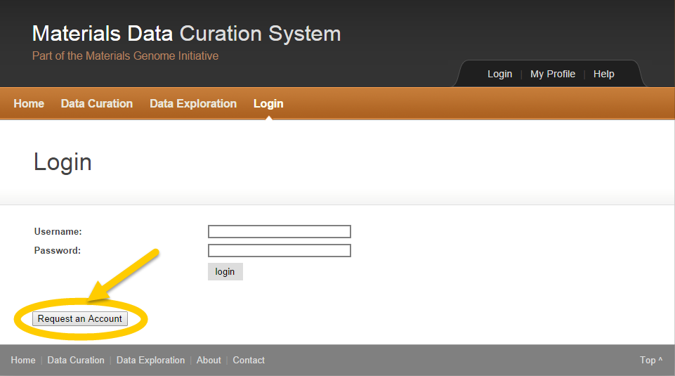

Figure Request MDCS Account

1. Click the **Request an Account** button in the lower left.



A short form with a few mandatory fields appears.

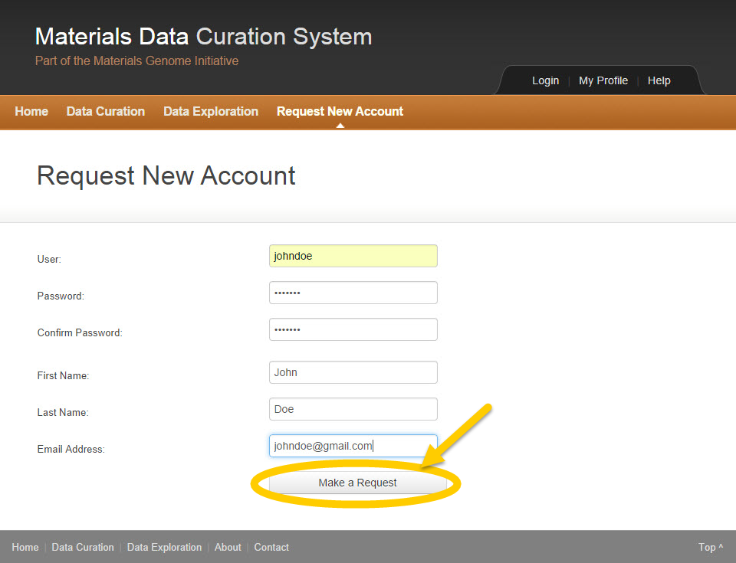

Figure Request MDCS Account Online Form

1. Enter a Username.
2. Enter a Password.
3. Confirm the password.
4. Enter First Name.
5. Enter Last Name.
6. Enter Email Address.
7. Click the **Make a Request** button.



A confirmation window appears to let the user know that the request was sent successfully.

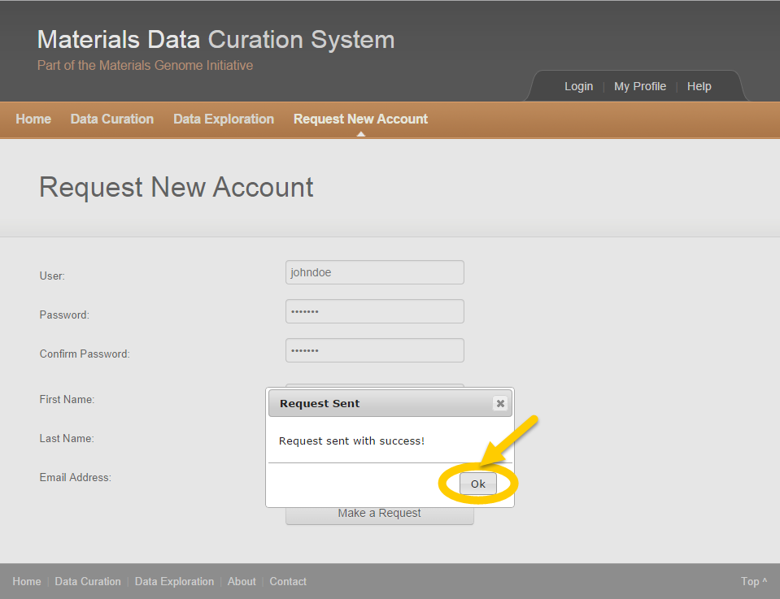

Figure New Account Request Sent Successfully

1. Click the **OK** button.

**

*The Username must be unique.*

### Administrator Fulfills Request

The MDCS administrator receives the account request. The user will get a notification as soon as the administrator accepts the new MDCS account request.

# Account Access

## Account Access

### Login Process

1. Point the browser to MDCS.

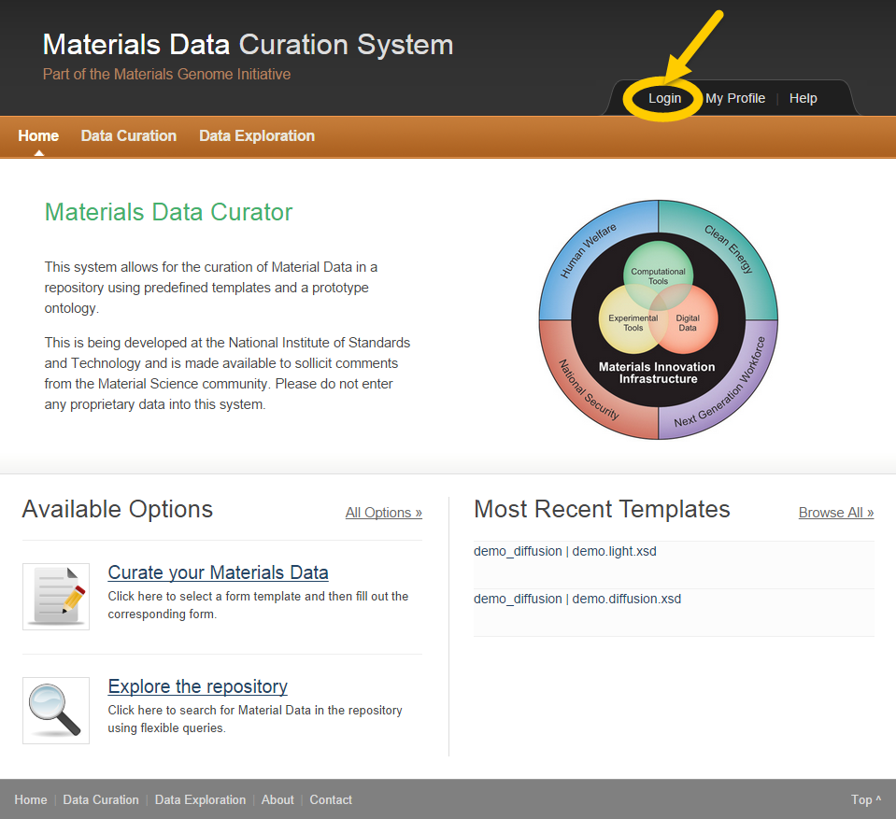

Figure Materials Data Curation System Home

1. Click **Login** in the top right.



The MDCS Login page appears.

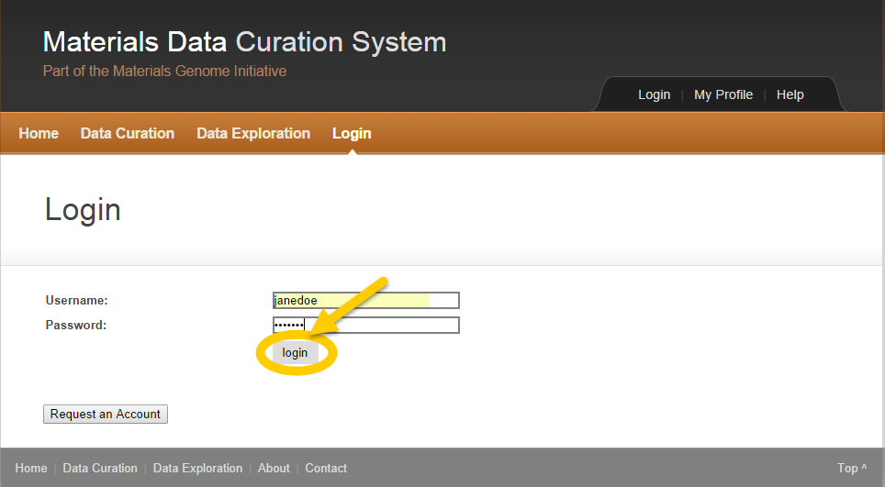

Figure MDCS Login Page

1. Enter Username and Password.
2. Click the **Login** button.



The user is authenticated into MDCS.

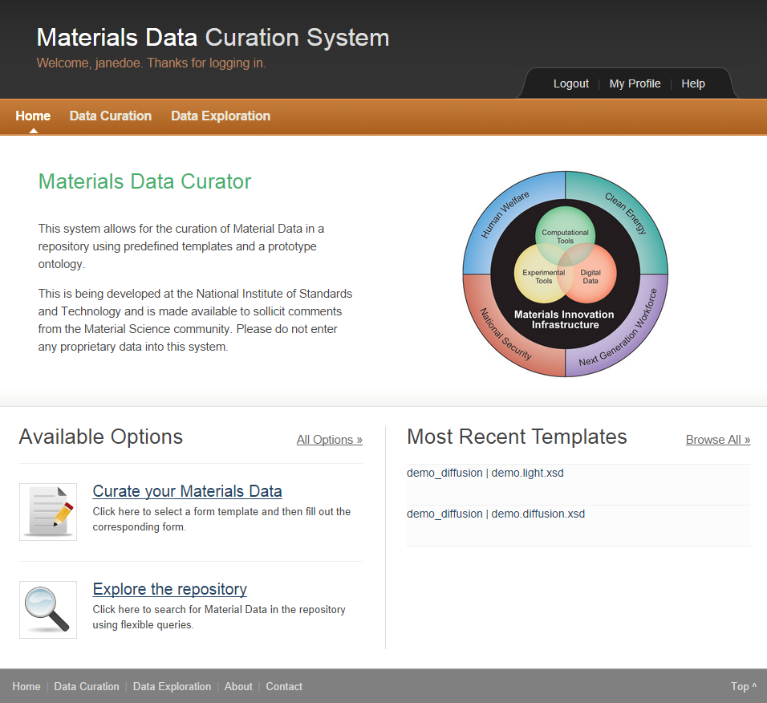

Figure MDCS Home

### Maintain Profile

Once the user is logged in to MDCS. The user may make changes to his or her profile.

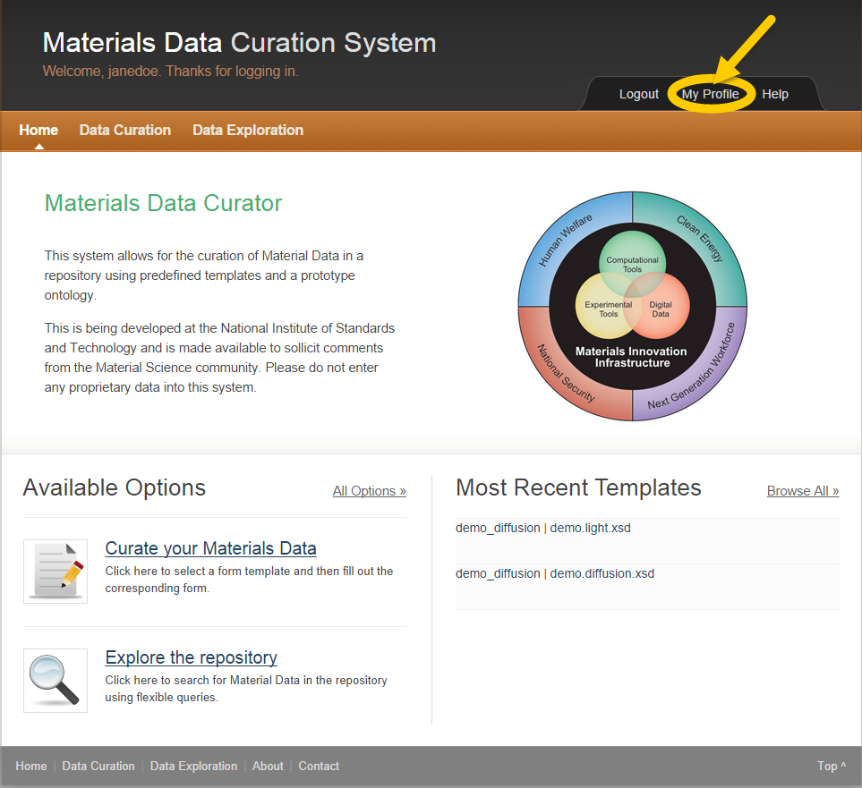

Figure My Profile

1. Click **My Profile** in the top right.

Users may edit their profile and/or change their password.

#### Edit Profile

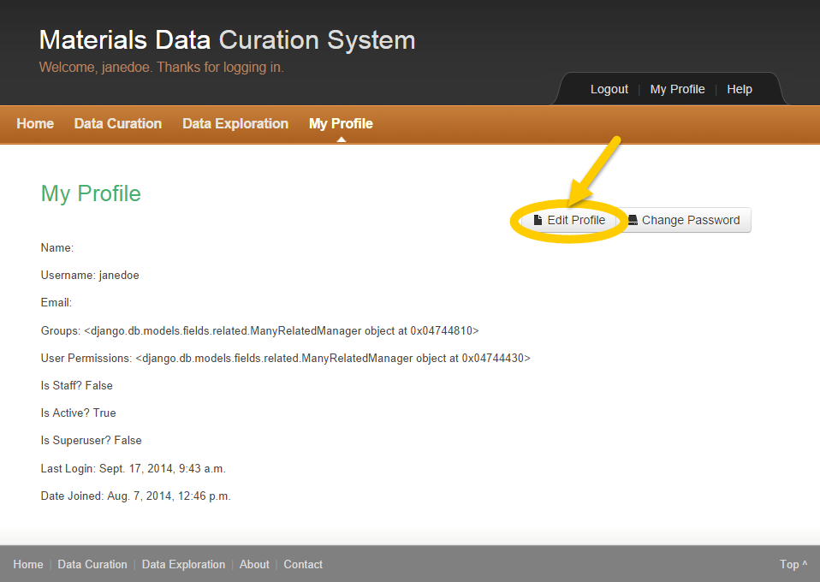

Figure Edit My Profile

1. Click the **Edit Profile** button.

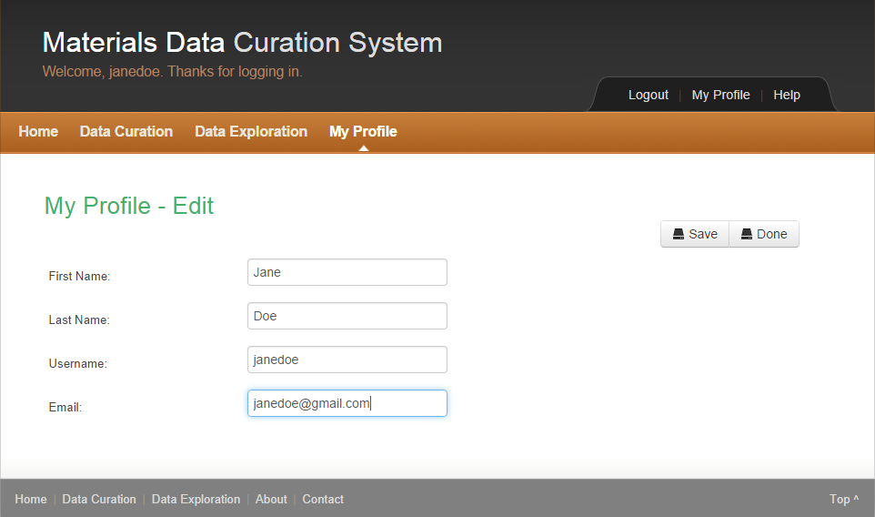

Figure Complete Profile Edit

The user may update First Name, Last Name and/or Email.

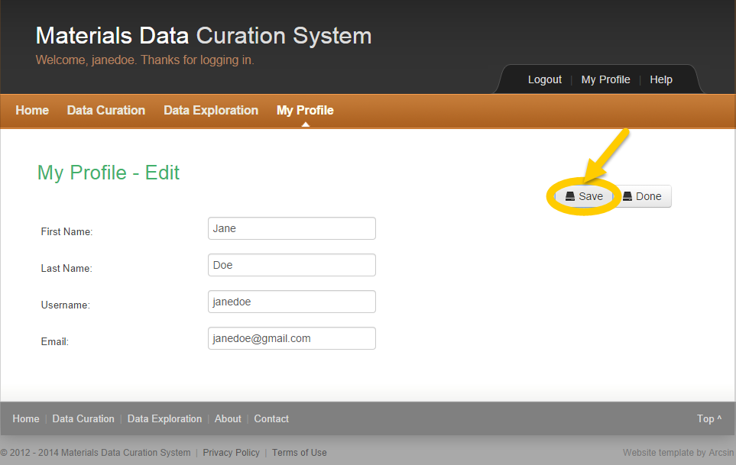

Figure My Profile Save

1. Click the **Save** button to save the changes.



A window appears to inform the user that the profile has been saved.

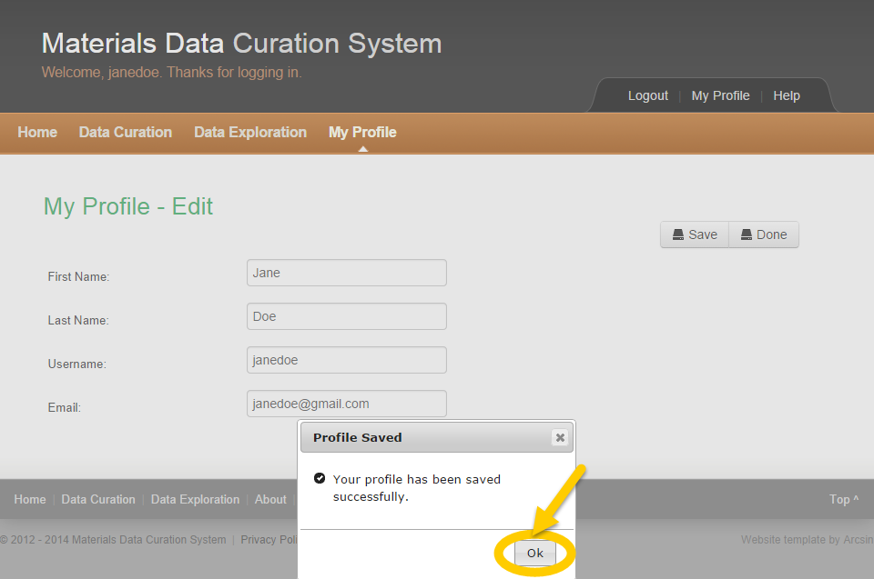

Figure My Profile Saved

1. Click the **OK** button.

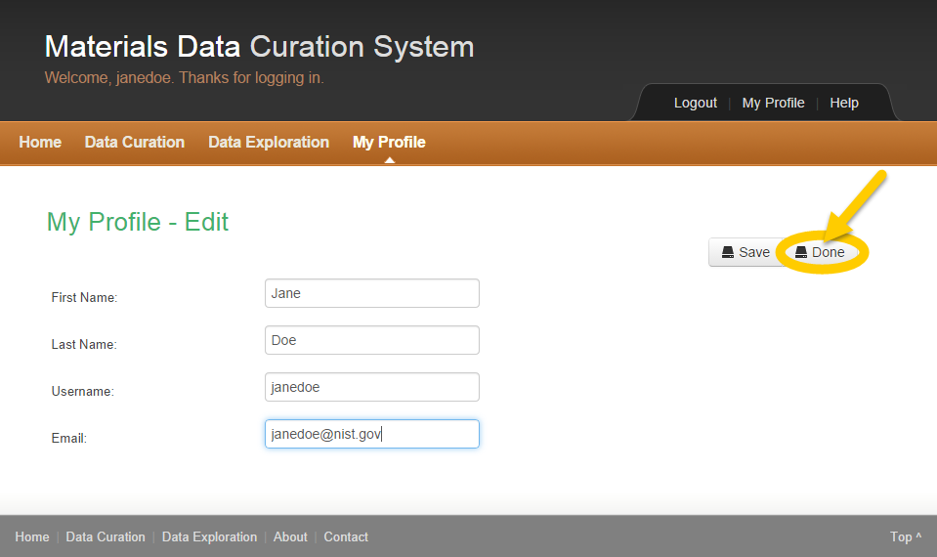

Figure Profile Edits Done

1. Click the **Done** button on the top right to return to the profile.

#### Change Password

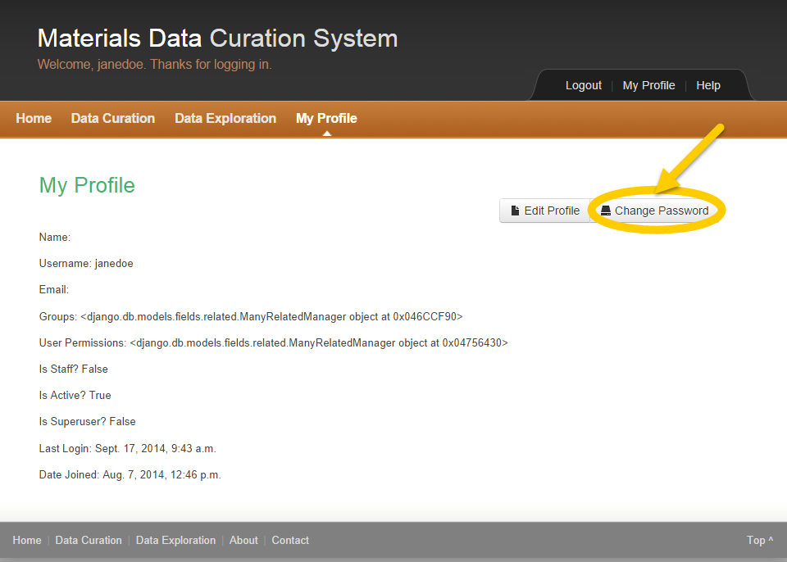

Figure My Profile Change Password

1. Click the **Change Password** button to change the password.

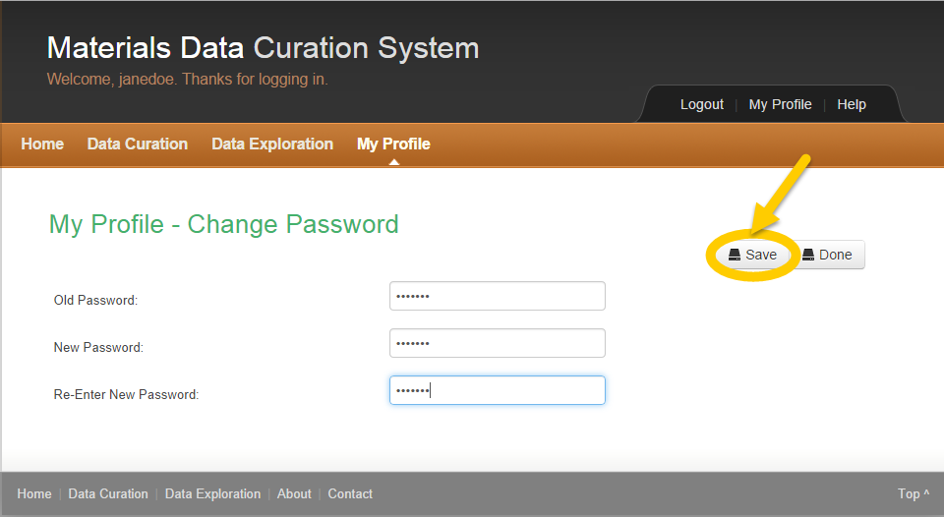

Figure Change Password

1. Enter Old Password.
2. Enter New Password.
3. Re-Enter New Password.
4. Click the **Save** button in the top right.



A Password Changed window appears to confirm that the user has successfully changed the password.

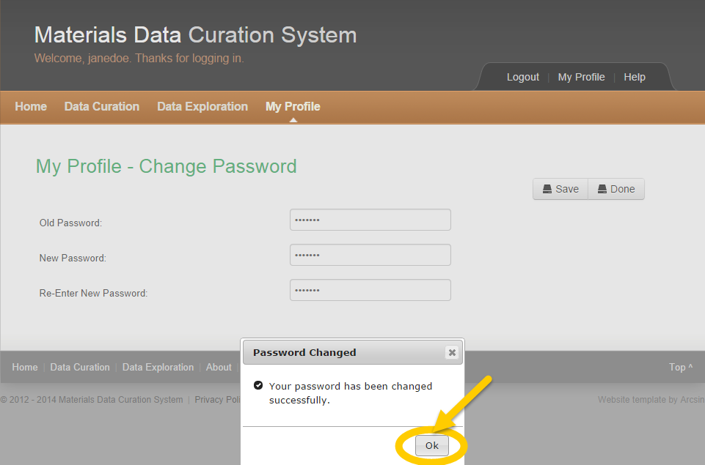

Figure Password Changed

1. Click the **OK** button.

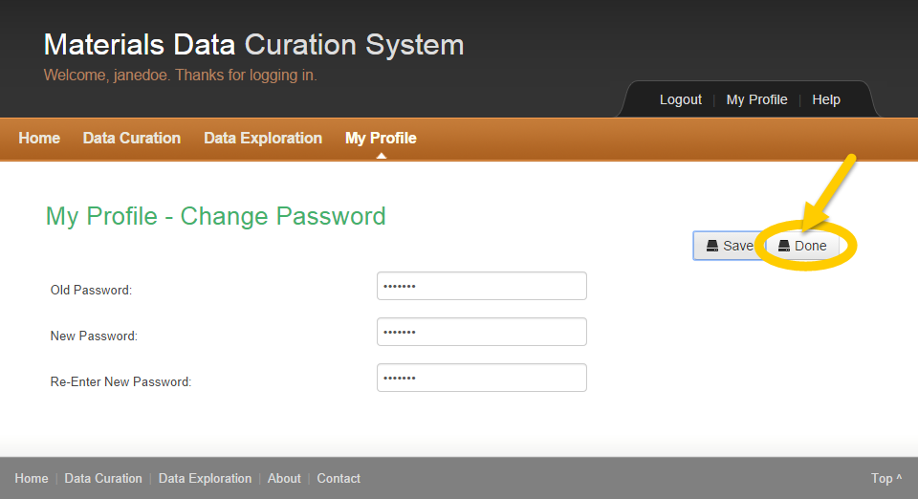

Figure Password Change Done

1. Click the **Done** button on the top right to return to the profile.

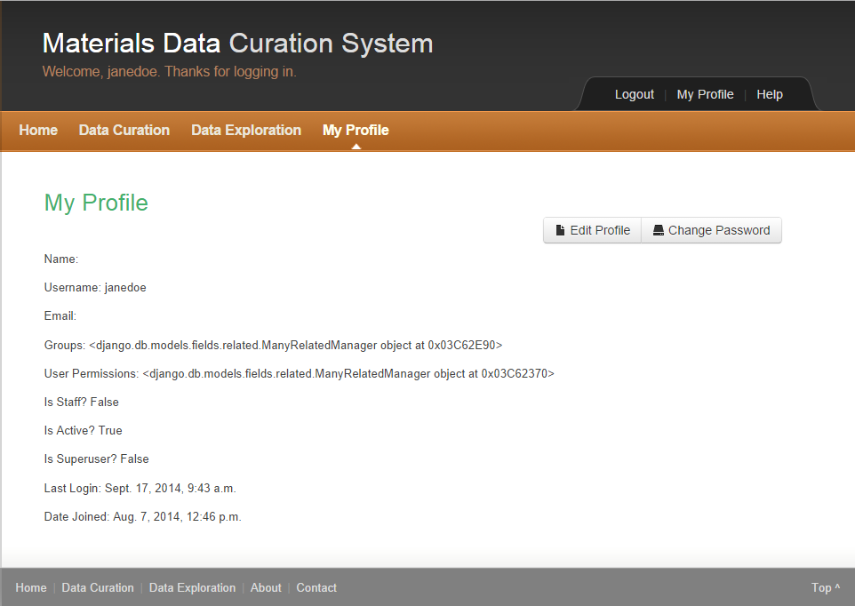

Figure My Profile Updated

### Logout Process

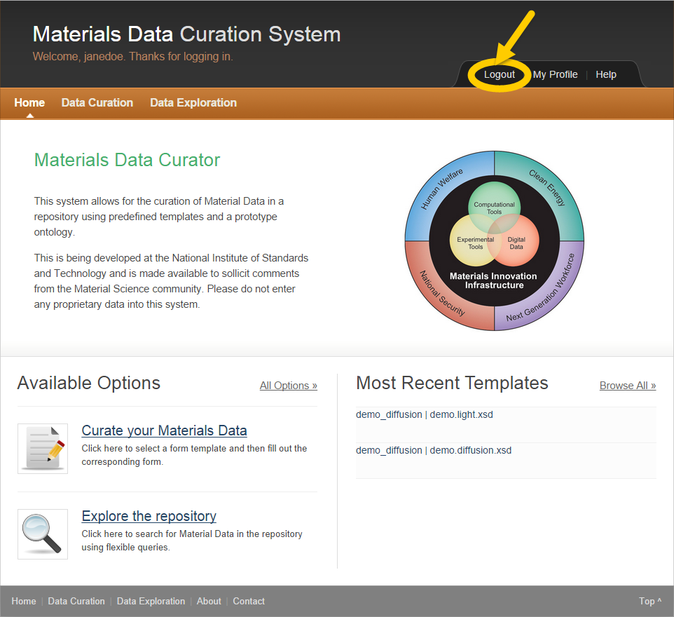

Figure MDCS Logout

1. Click **Logout** in the top right to logout of MDCS.



The MDCS Login page appears.

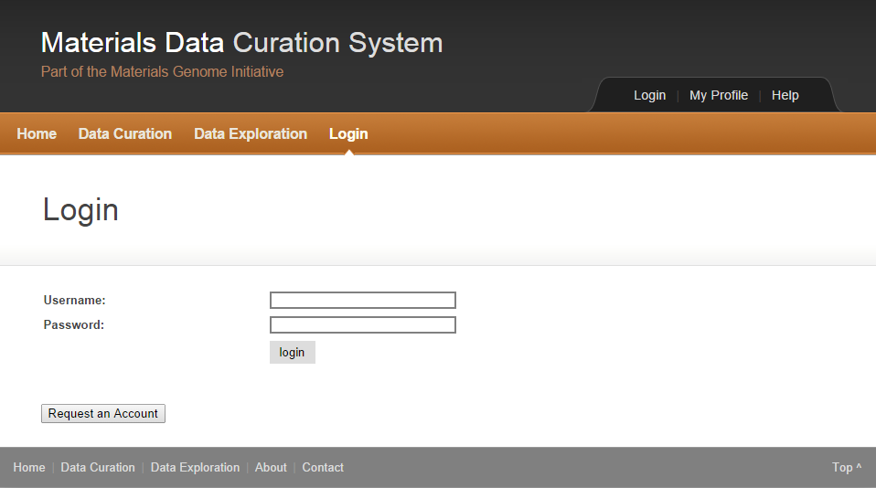

Figure MDCS Login

### Forgot Password

# Administrator Role

## Administrator Activities

The user must have the MDCS administrator role to perform any of the tasks described in this section. The MDCS may perform the following activities:

* Manage User Accounts
* Manage Templates and Ontologies
* Manage Federation of Queries (This is discussed in Chapter 10)

## User Management

1. Point the browser to MDCS.

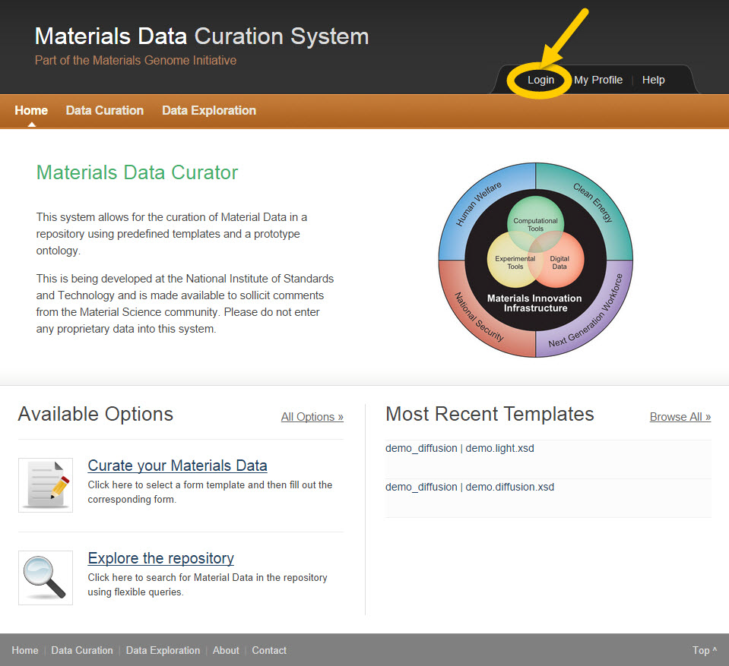

Figure MDCS Home

1. Click the **Login** button in the top right.

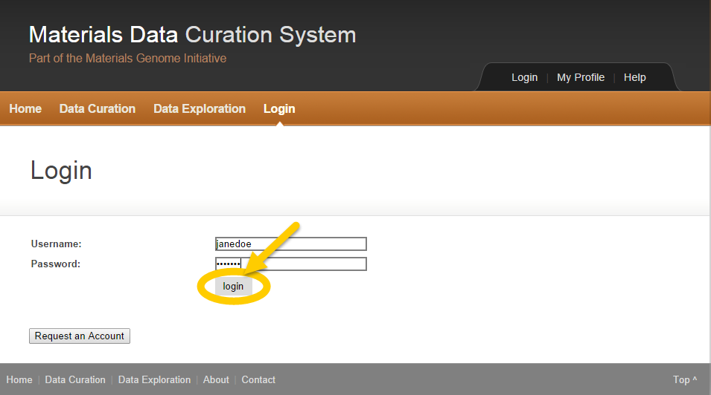

Figure Administrator Login

1. Enter the administrator Username.
2. Enter the administrator Password.
3. Click the **Login** button.



The administrator is authenticated into MDCS.

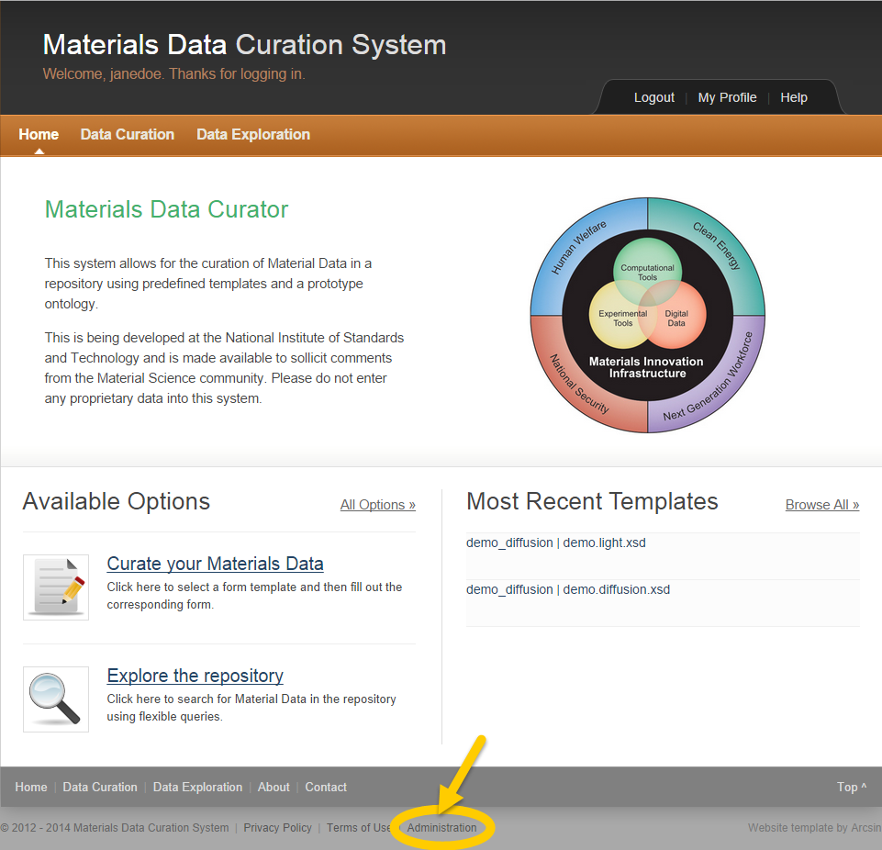

Figure MDCS Administrator Login

1. Click the **Administration** link in the bottom center of the page.



The administrator is admitted into the User Management section.

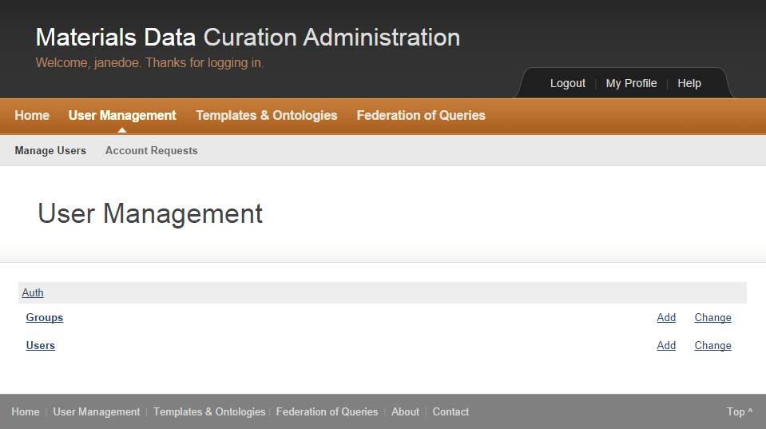

Figure User Management

### Create a User Account

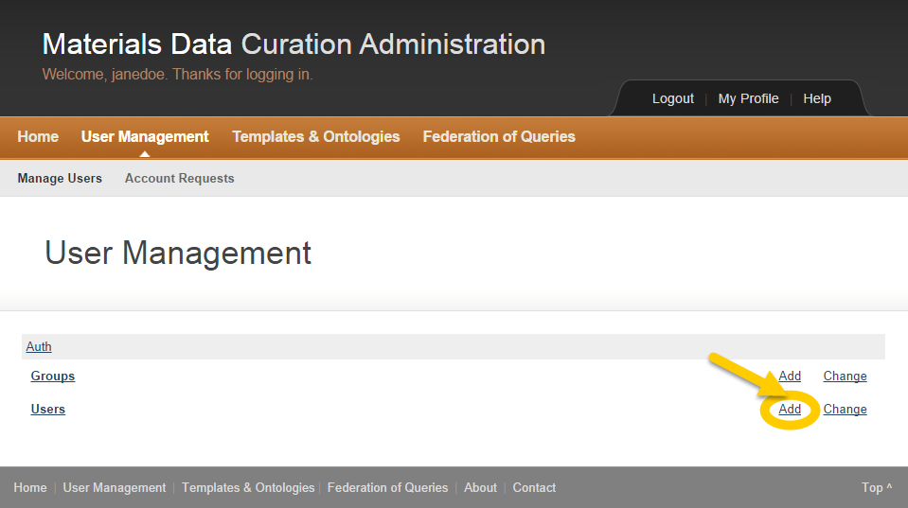

Figure User Management Create a New Account

1. Click the **Add** link on the right side of the page.

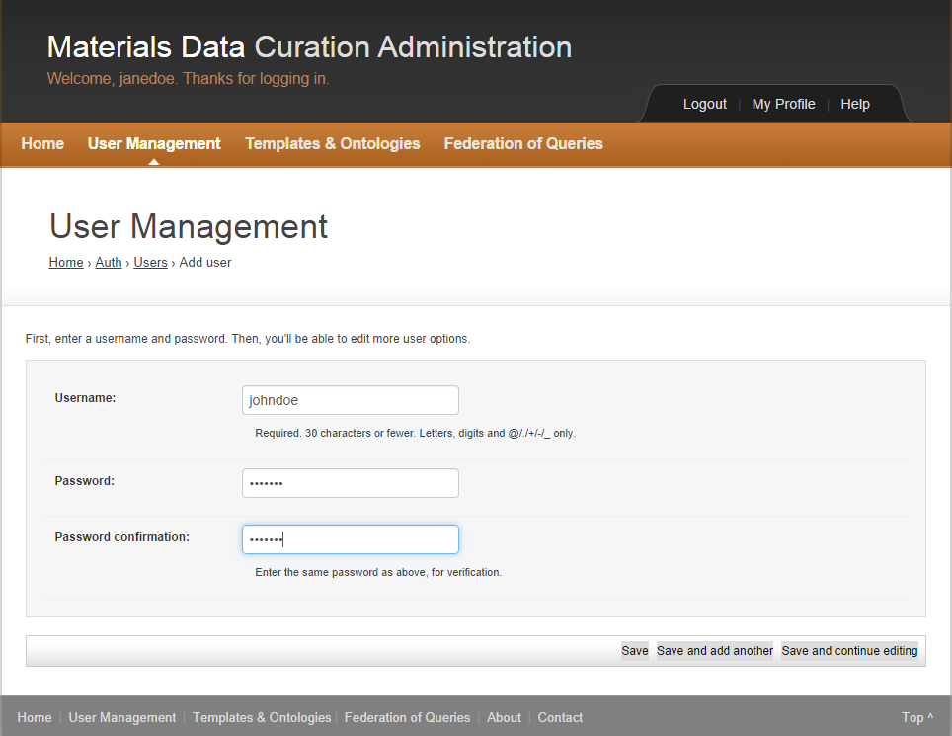

Figure User Management Create an Account

1. Enter a Username.
2. Enter a Password.
3. Re-enter the password in the Password confirmation.

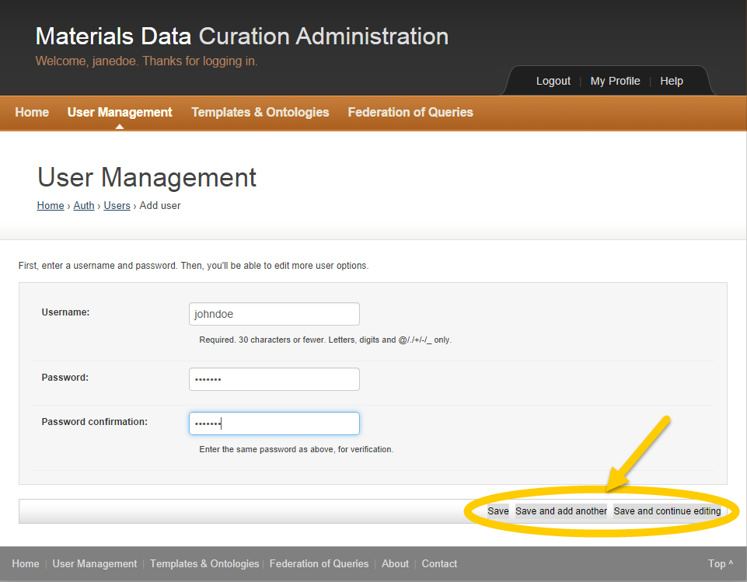

Figure User Management Create an Account

1. The administrator may do one of the following:

* Click the **Save** button to save this new account.
* Click the **Save and add another** button to save this account and create another.
* Click the **Save and continue editing** button to save this account and continue editing the account profile.



The user account is now created and ready for use.

**

*The administrator must provide the credentials to the user.*

### Modify a User Account

A user must have the MDCS administrator role to modify a user account.

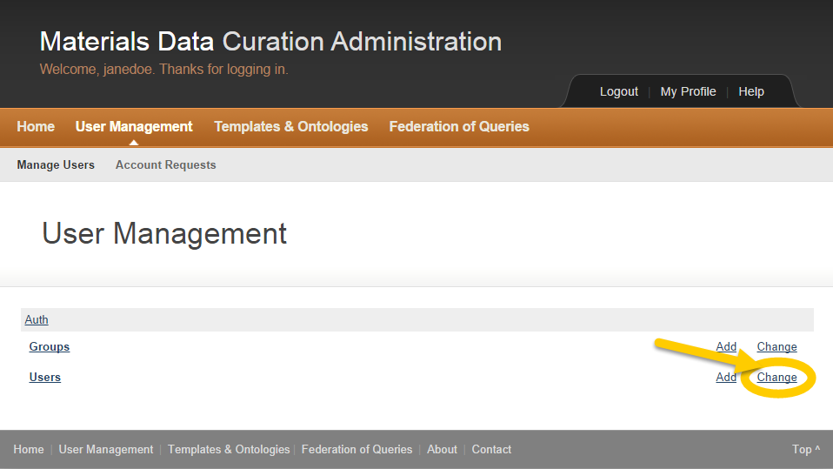

Figure Change a User Account

1. Click the **Change** Link on the right side of the page.



The User Management Edit Account window appears.

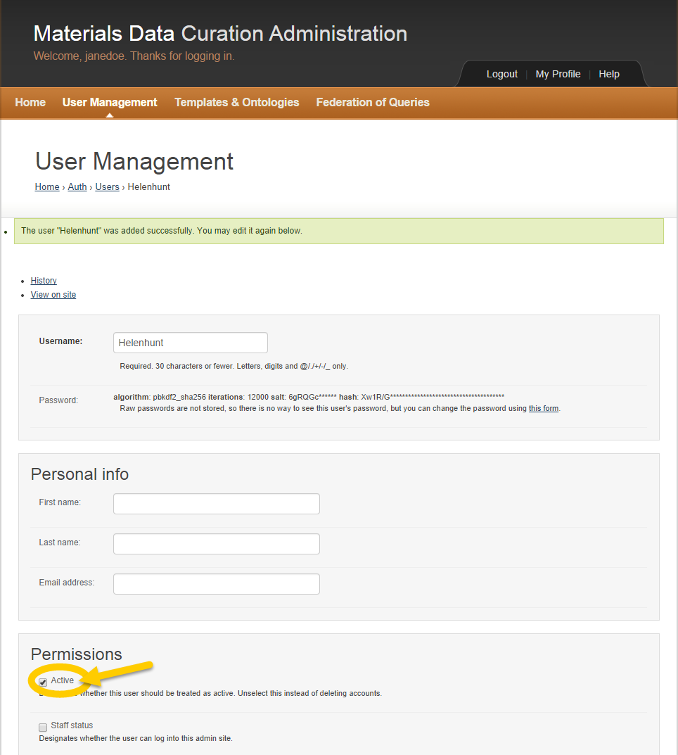

Figure User Management Edit Account

The administrator may edit the user profile.

1. Update First name, Last name and Email address.
2. Make sure that the **Active** checkbox is selected.

**

*It’s recommended that the administrator deactivate accounts instead of deleting them.*

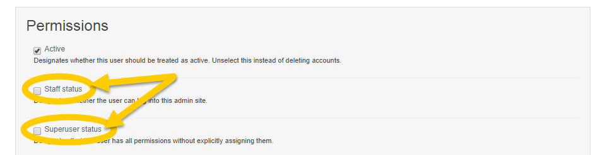

Figure MDCS User Permissions

1. Click the **Staff status** and the **Superuser status** checkboxes to provide the user with the administrator role if appropriate.

### Online Account Requests

A user must have the MDCS administrator role to approve or deny the MDCS online account requests.

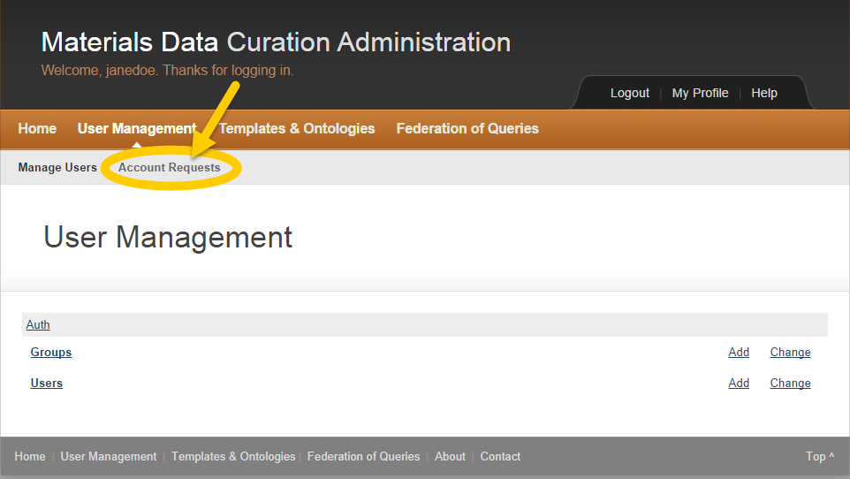

Figure Account Requests

1. Click on **Account Requests** on the top left.



A list of current Account Request(s) appears.

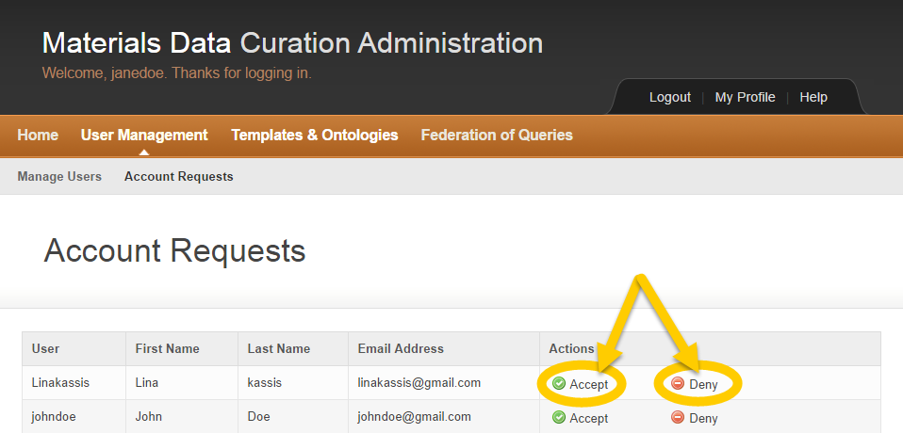

Figure List of Current Account Requests

1. Click on the **Accept** icon to approve the MDCS online account request.
2. Click on the **Deny** icon to reject the MDCS online account request.

## Templates and Ontologies

### Template Management

The MDCS administrator may upload new templates, manage template versions, edit information regarding templates and/or delete templates.

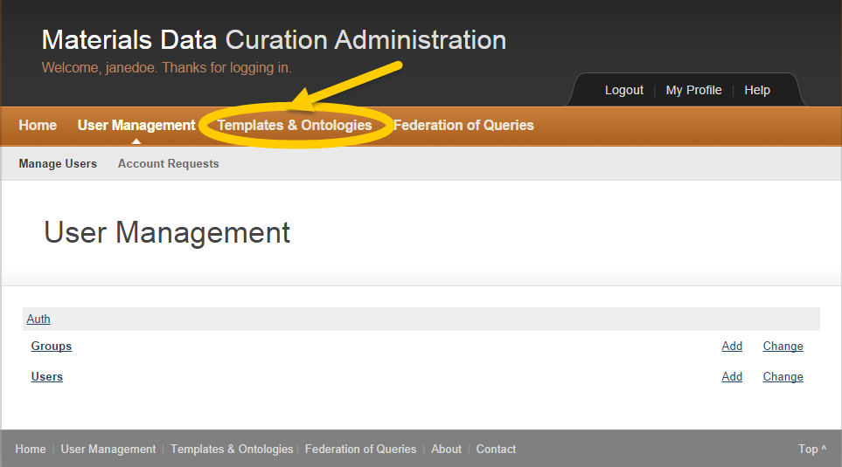

Figure Templates & Ontologies

1. Click **Templates and Ontologies**.



The Template Manager dashboard appears.

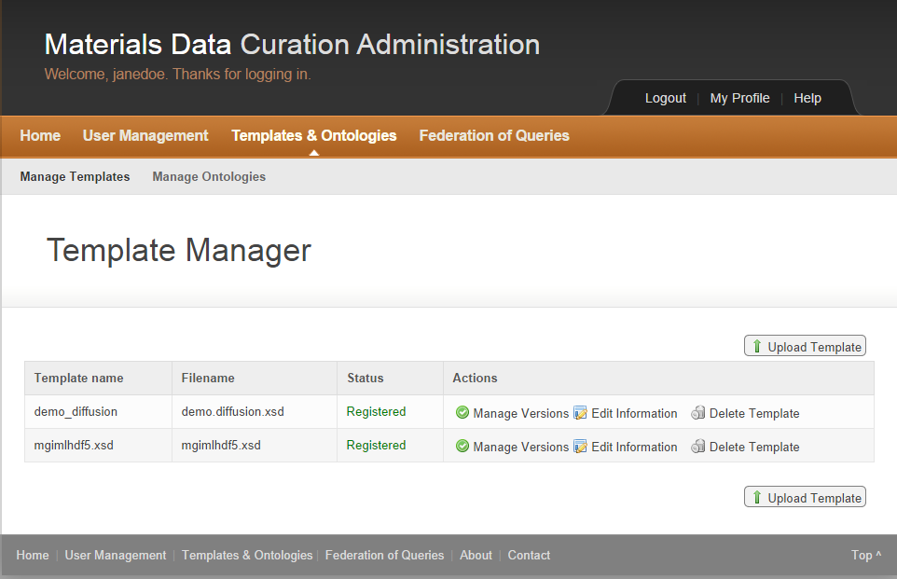

Figure Template Manager

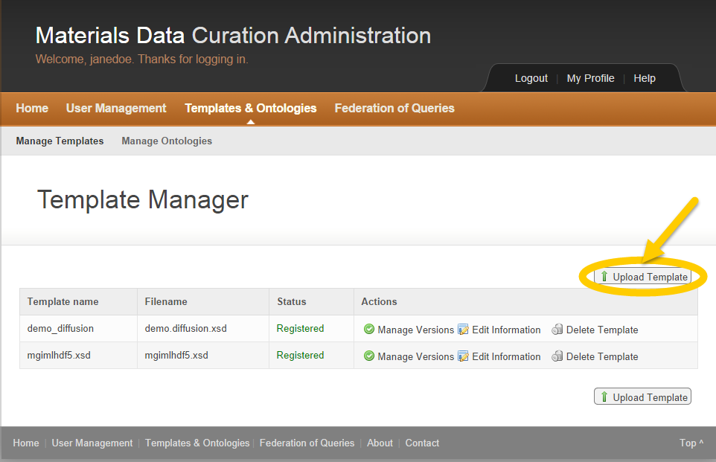

Figure Template Manager Upload Template

1. Click the **Upload Template** button.

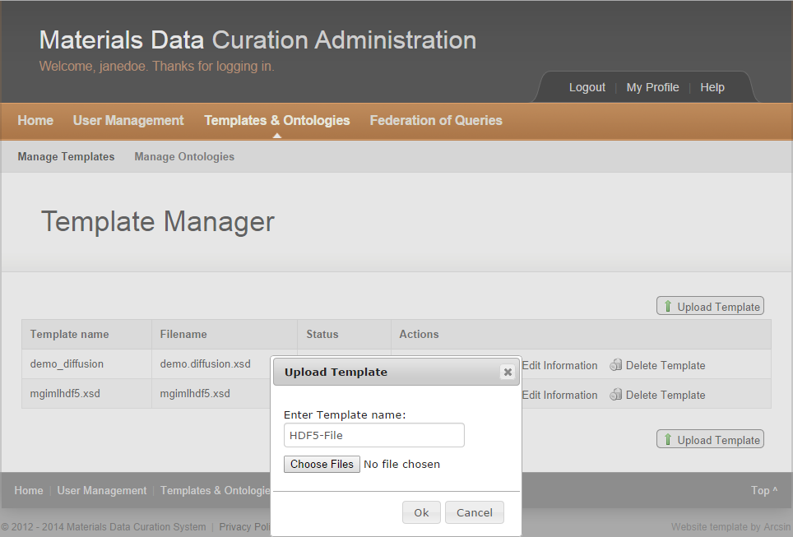

Figure Upload Template Window

1. Enter a Template name.

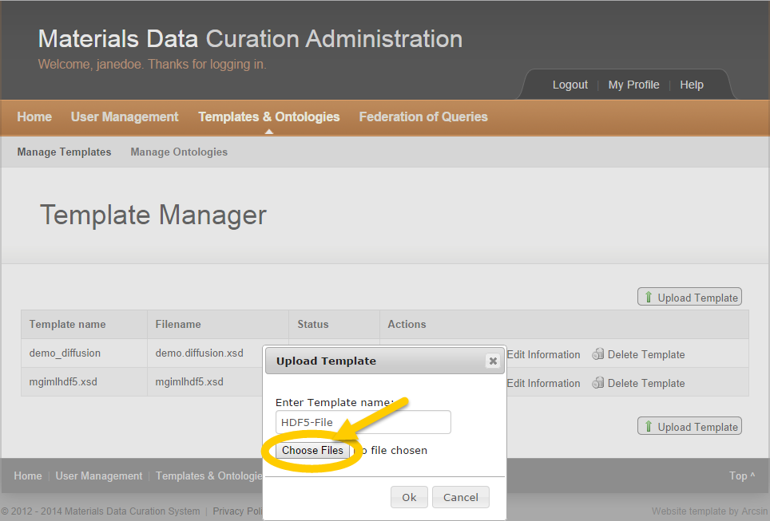

Figure Upload Template Choose File

1. Click the **Choose Files** button to select the file to upload.

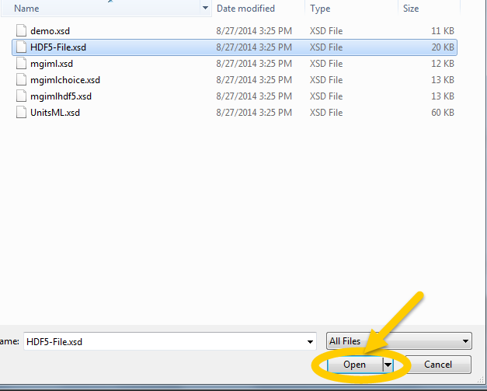

Figure Choose Template to Upload

1. Select the template to upload.
2. Click the **Open** button.

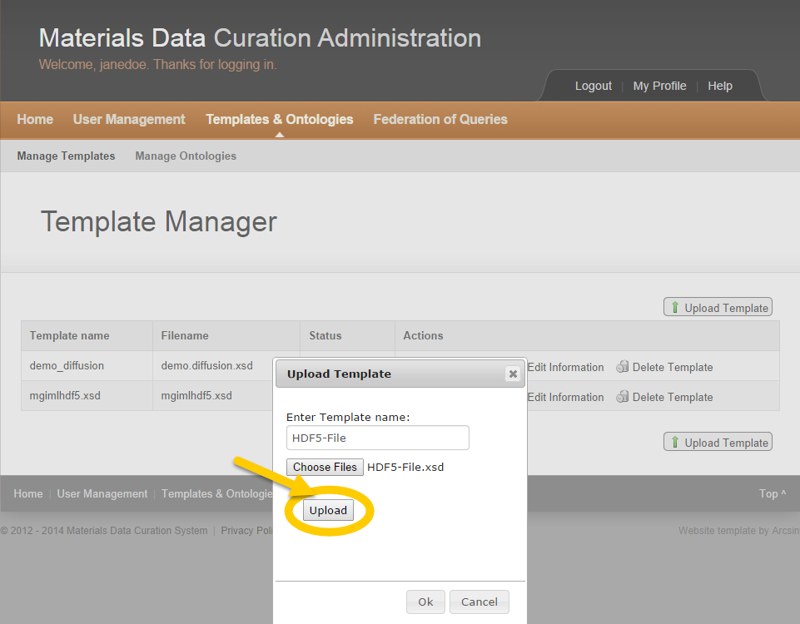

Figure Template Upload

1. Click the **Upload** button.

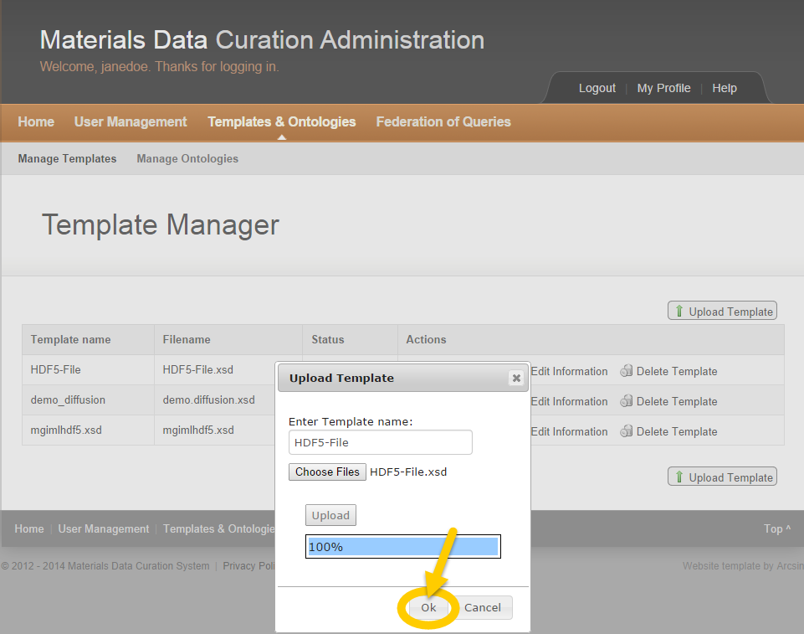

Figure Template Uploaded

1. Click the **OK** button.



The uploaded Template appears in the table.

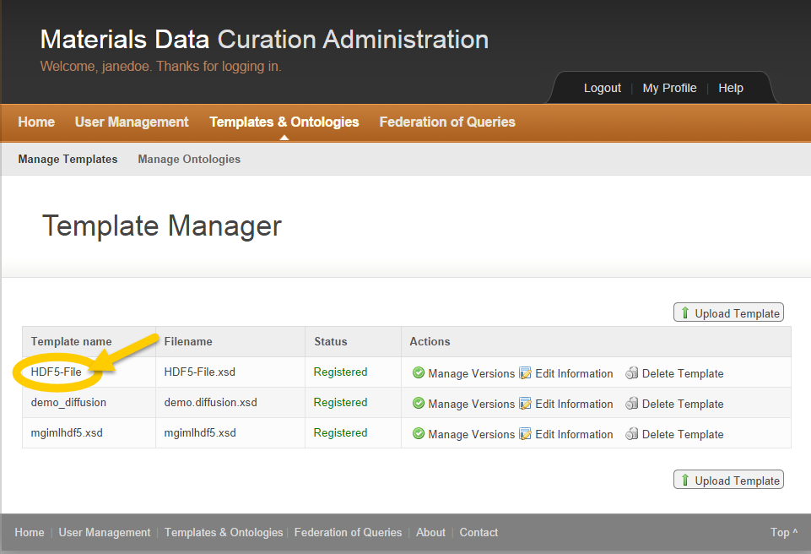

Figure Template Table

#### Manage Template Versions

The MDCS administrator may manage template versions.

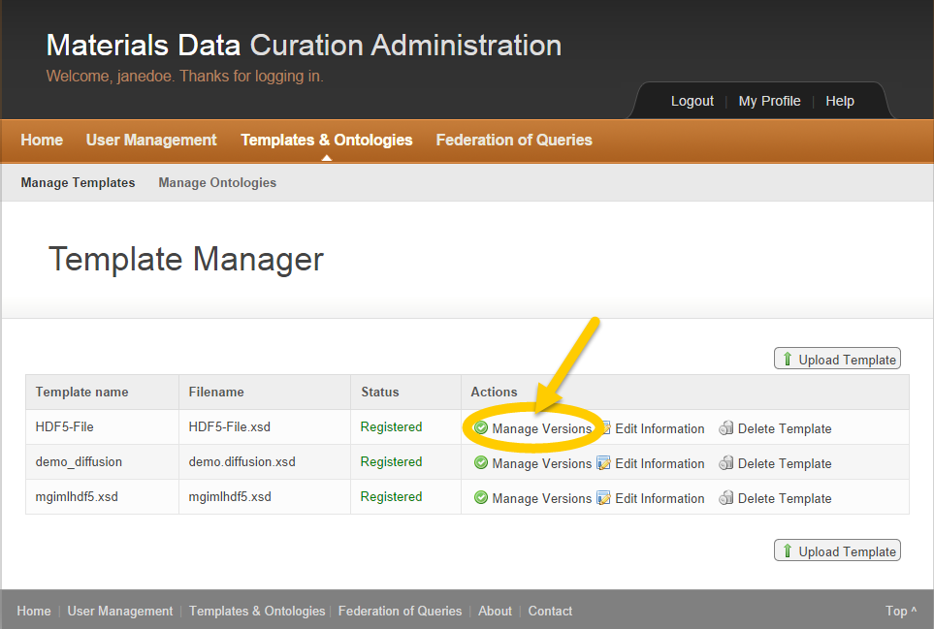

Figure Manage Template Versions

1. Click **Manage Versions** in the Actions column.

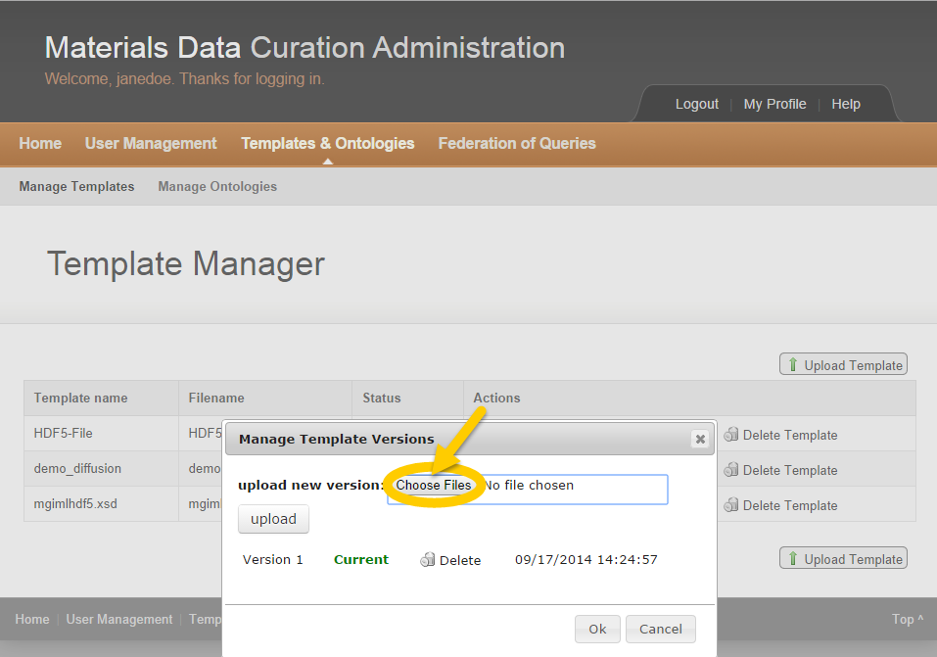

Figure Template Version Choose Files

1. Click on the **Choose Files** button to select the new version to upload.

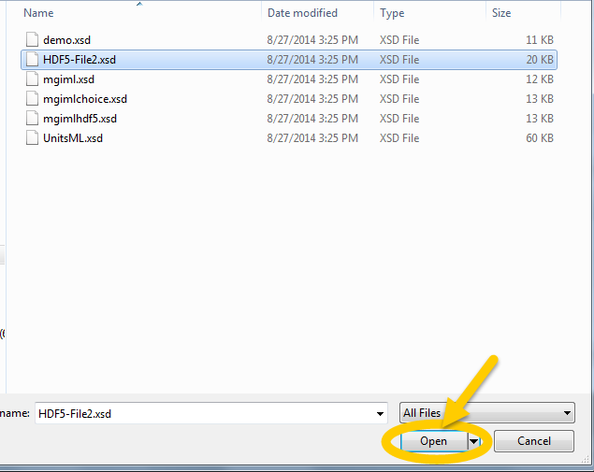

Figure Template Version Select File

1. Select the template version to upload.
2. Click the **Open** button.

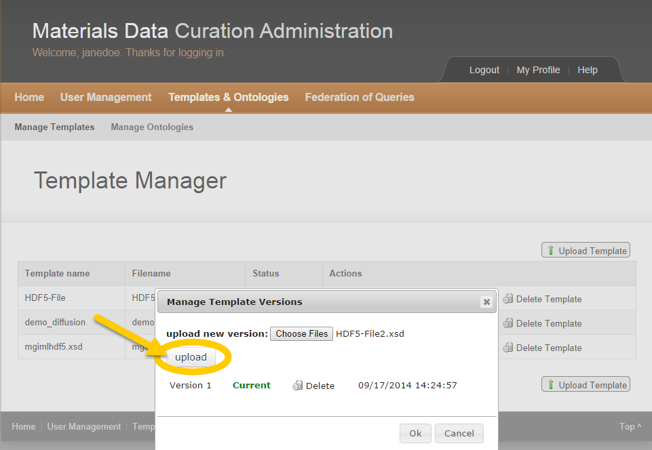

Figure Template Version Upload

1. Click the **Upload** button.

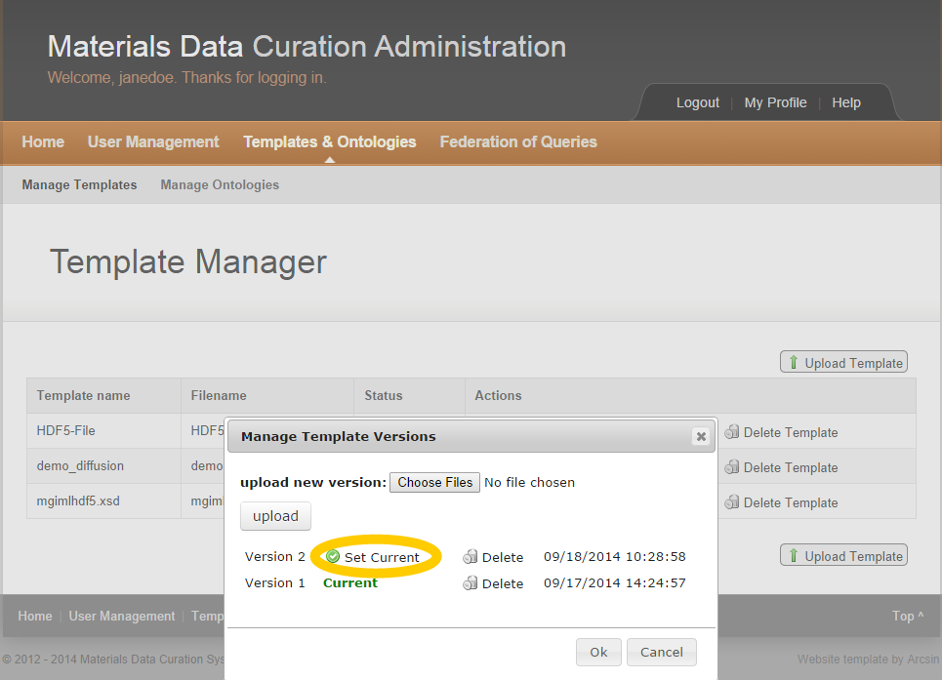

Figure Template Version Set Current

1. Click **Set Current** to designate the template version.

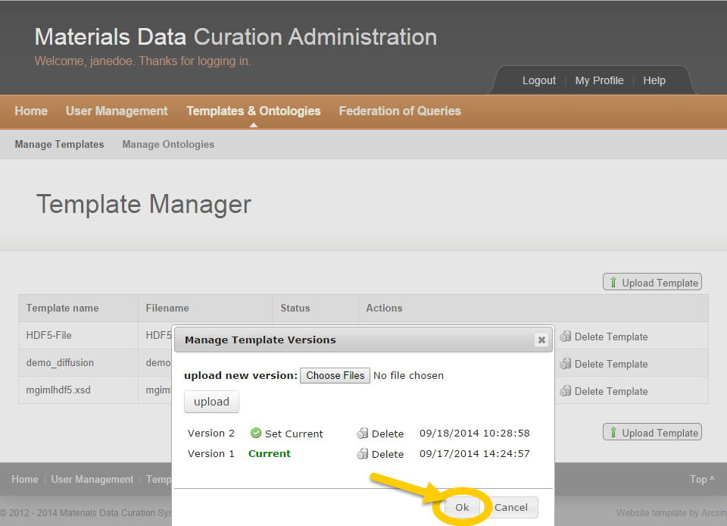

Figure Template Version Uploaded

1. Click the **Ok** button.



The new template version is now registered and appears in the list.

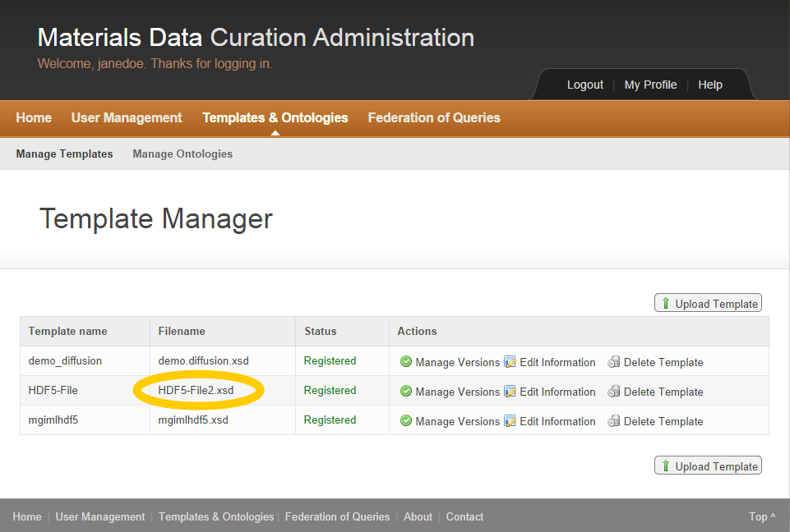

Figure Template Version Registered

#### Edit Template Information

The MDCS administrator may edit template information.

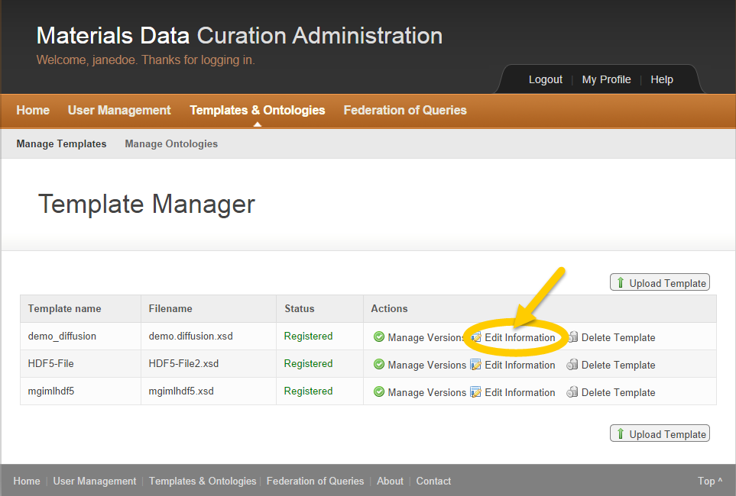

Figure Edit Template Information

1. Click **Edit Information** in the Actions column to edit template information.

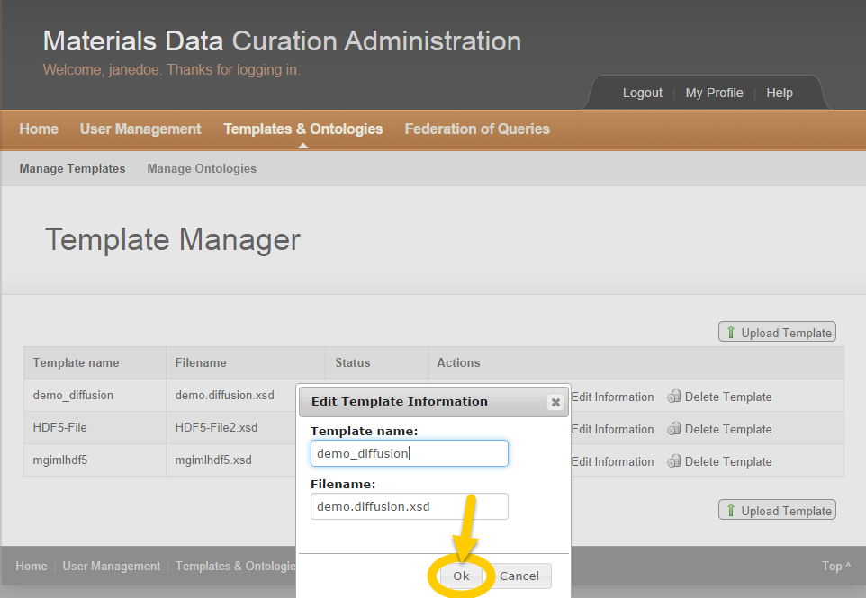

Figure Edit Template Information Complete

1. Edit the Template Name and/or the Filename.
2. Click the **Ok** button.

#### Delete Template

The MDCS administrator may delete a template.

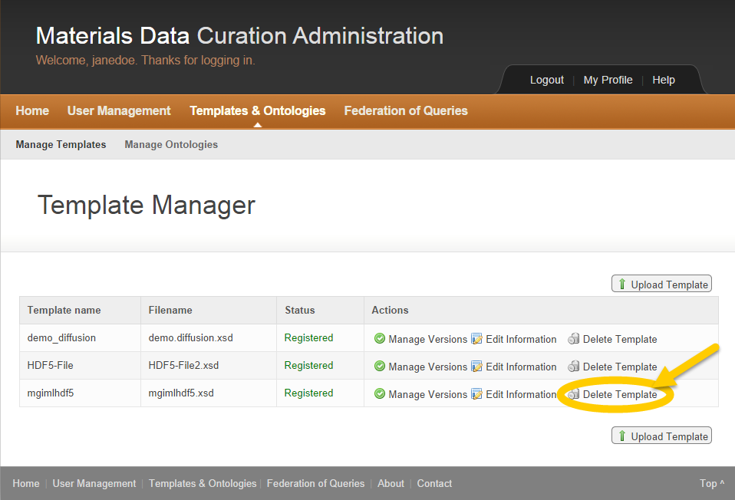

Figure Delete Template

1. Click **Delete Template** in the Actions column.

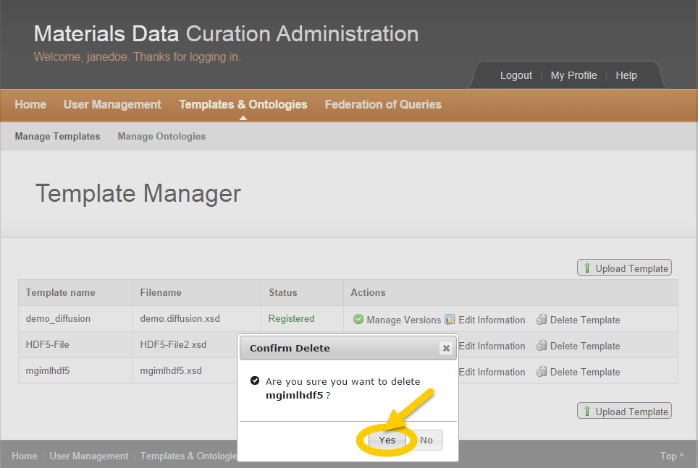

Figure Delete Template Confirmation

1. Click the **Yes** button to confirm the template deletion.



The deleted template remains in the list of templates with “Deleted” as the status.

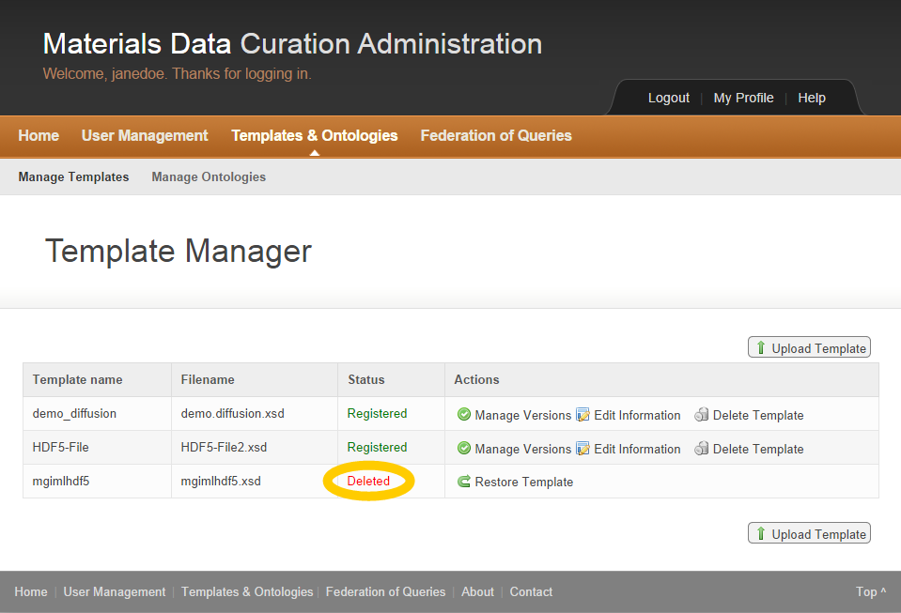

Figure Template Deleted

#### Restore Template

The MDCS administrator may restore a template if deemed necessary.

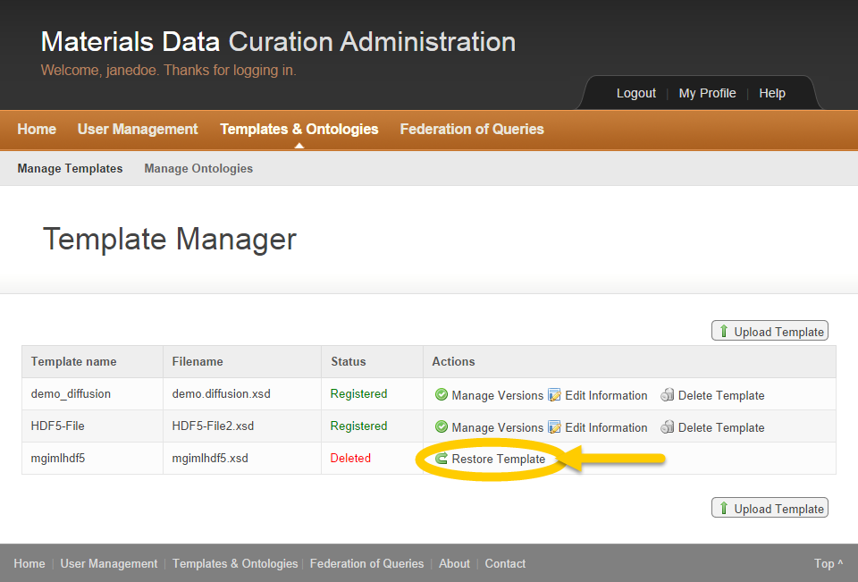

Figure Restore Template

1. Click **Restore Template** in the Actions column to reactivate a deleted template.



The deleted template is now restored with “Registered” as the Status.

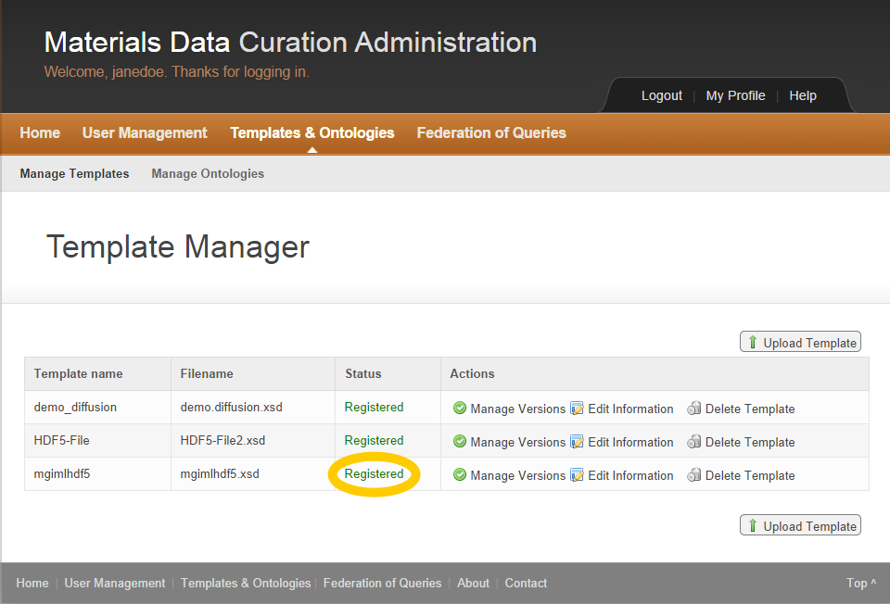

Figure Template Restored

### Ontology Management

The MDCS administrator may upload new ontologies, manage ontology versions, edit information regarding ontologies and/or delete ontologies.



Figure Templates and Ontologies

1. Click **Templates and Ontologies**.

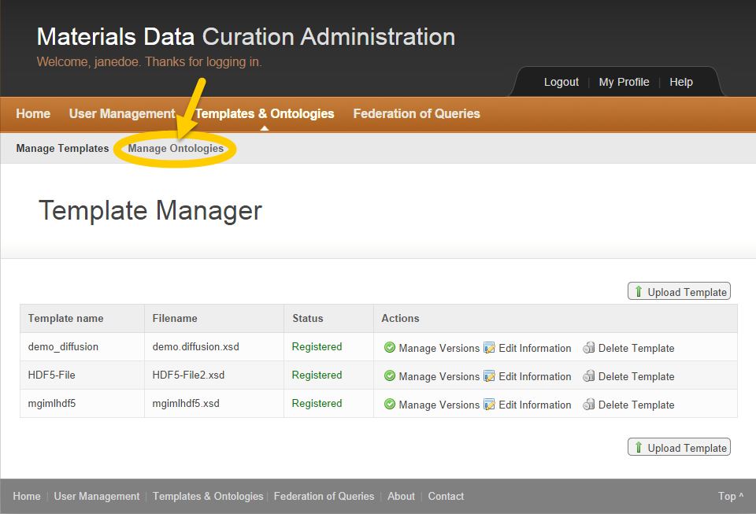

Figure Manage Ontologies

1. Click **Manage Ontologies** on the top left of the page.



The Ontology Manager dashboard appears.

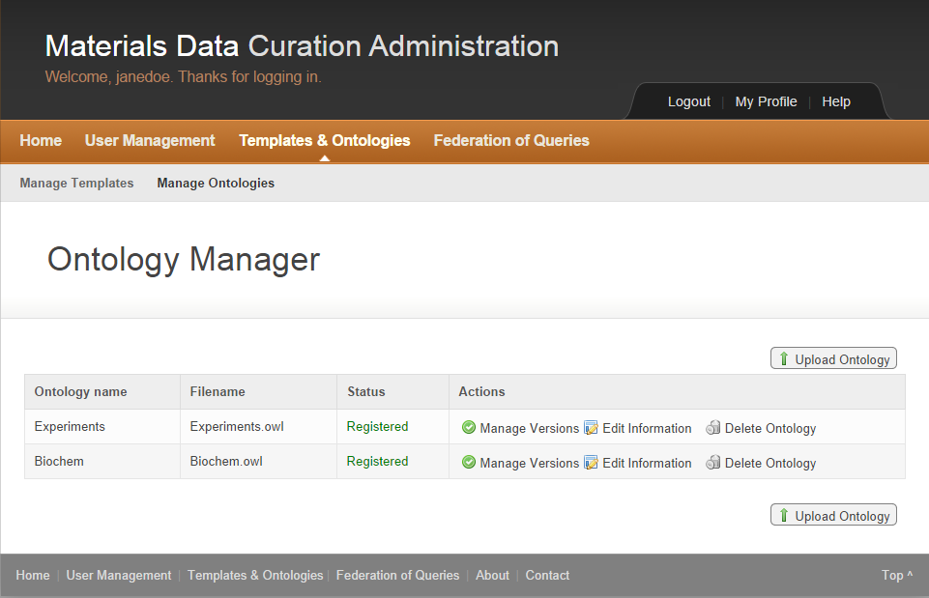

Figure Ontology Manager

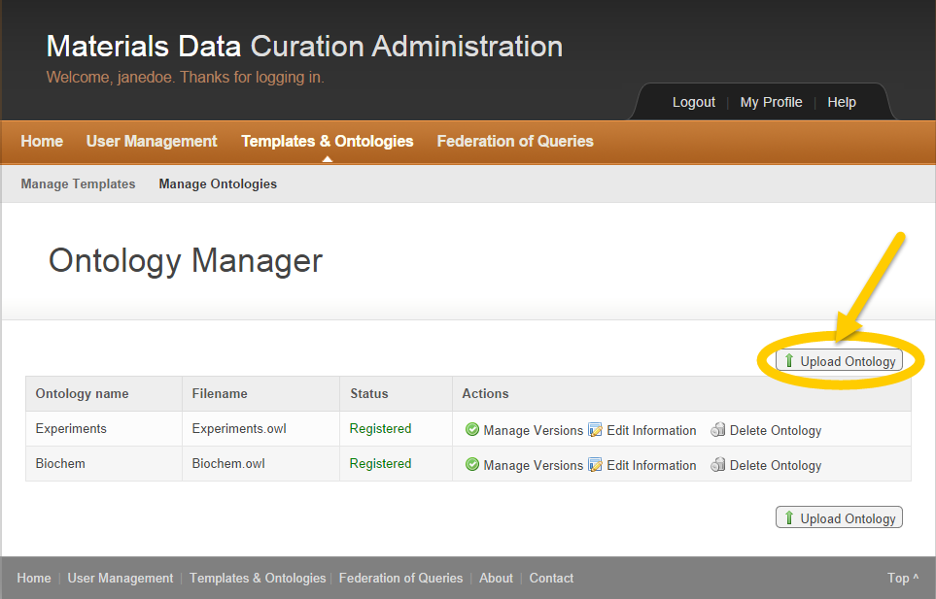

Figure Ontology Manager

1. Click the **Upload Ontology** button.

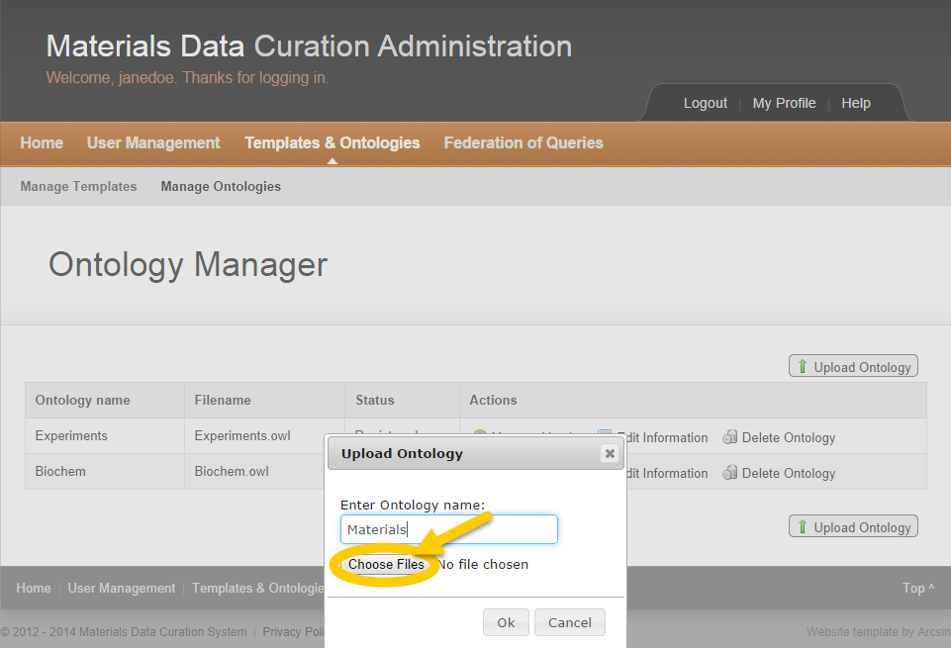

Figure Upload Ontology

1. Enter an Ontology name.
2. Click the **Choose Files** button to select a file.

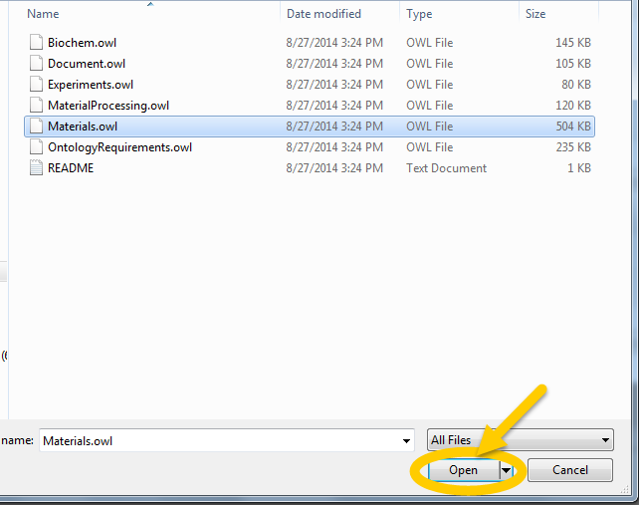

Figure Select Ontology

1. Select the Ontology to upload.
2. Click the **Open** button.

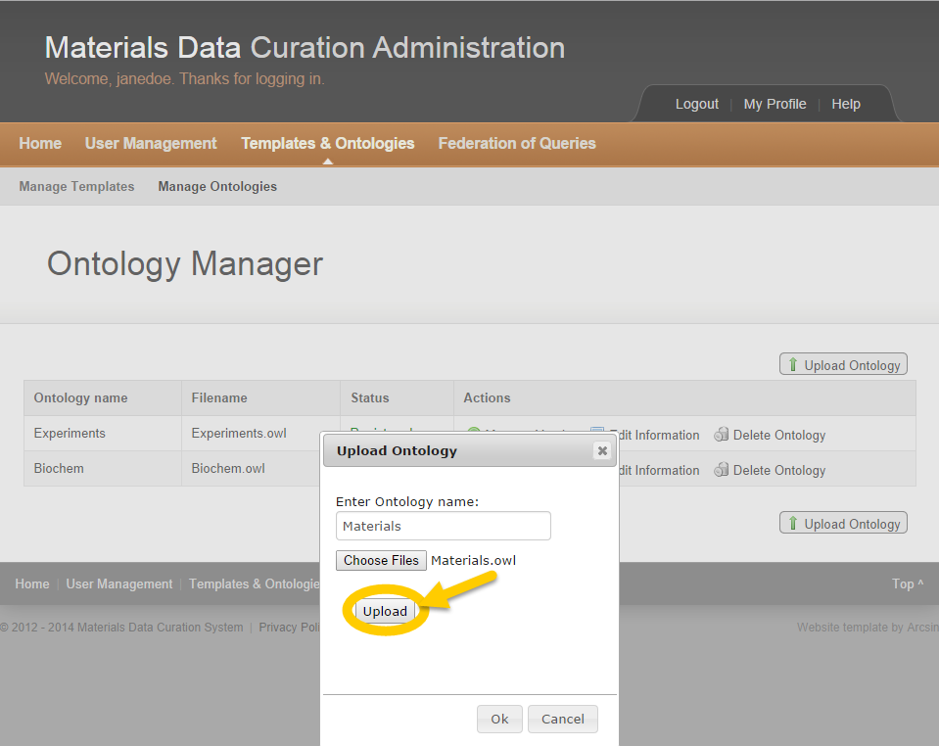

Figure Ontology Upload Window

1. Click the **Upload** button.

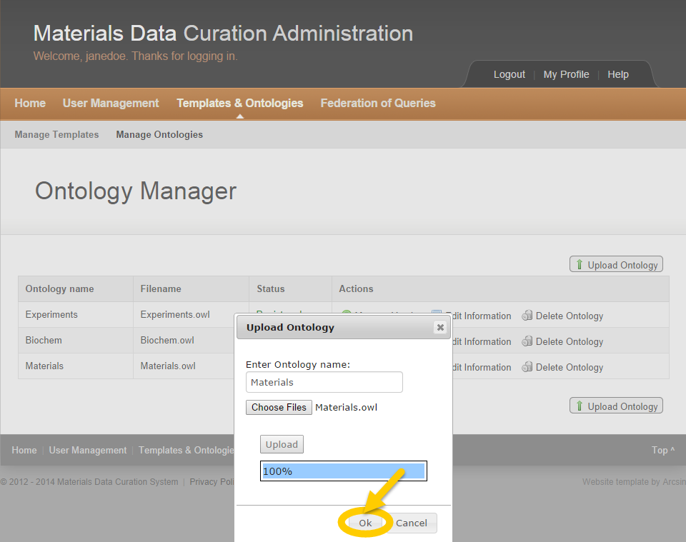

Figure Upload Ontology Window Complete

1. Click the **Ok** button to complete the Ontology upload.



A new ontology is now uploaded with status “Registered.”

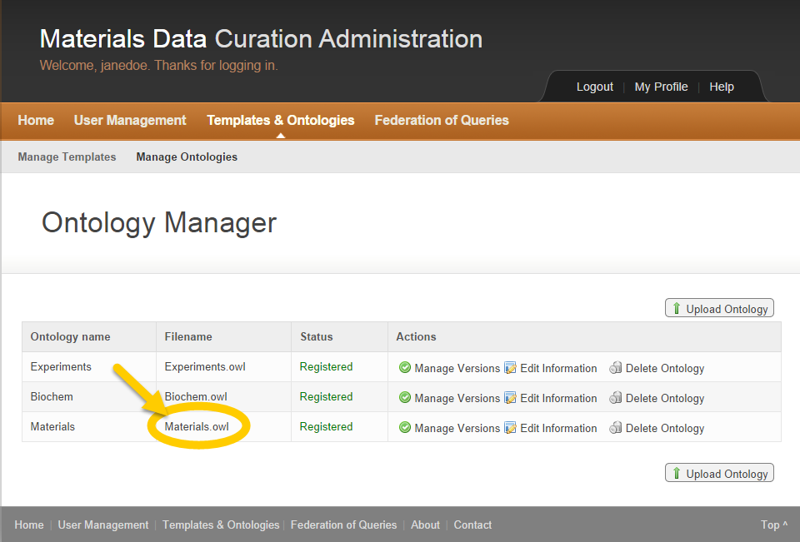

Figure New Ontology Uploaded

#### Manage Ontology Versions

The MDCS administrator may manage ontology versions.

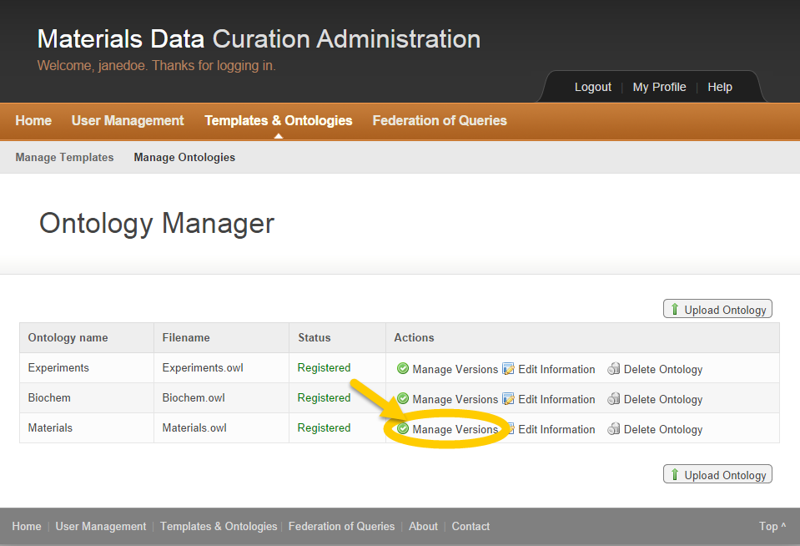

Figure Manage Ontology Versions

1. Click **Manage Versions** in the Actions column.

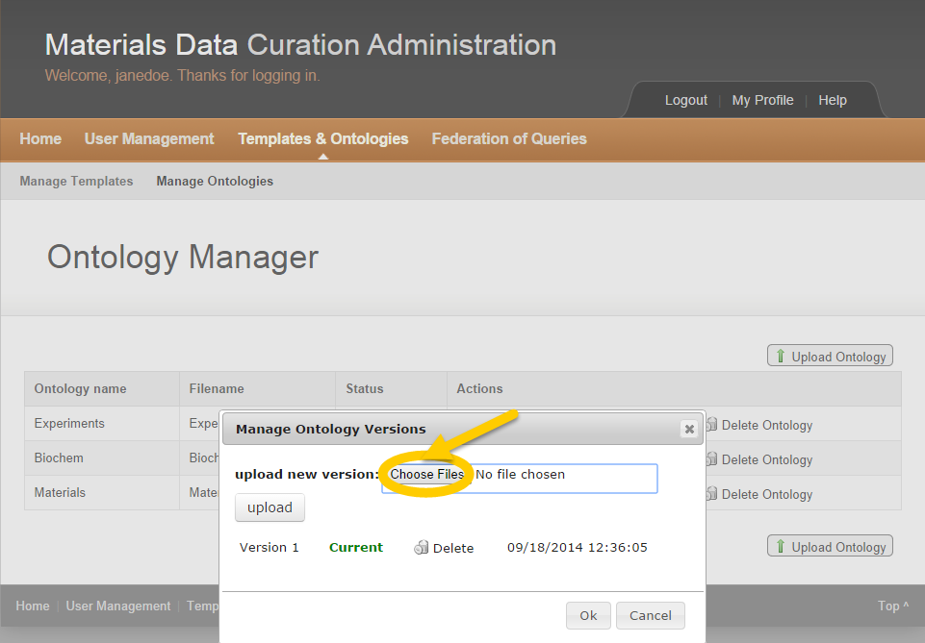

Figure Ontology Versions Choose File Window

1. Click the **Choose Files** button.

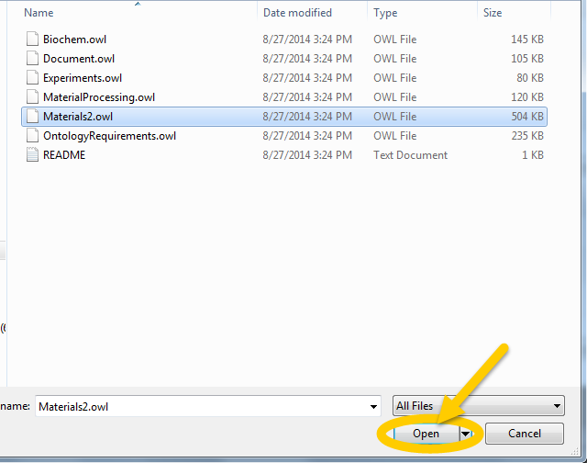

Figure Select Ontology File

1. Click the **Open** button.

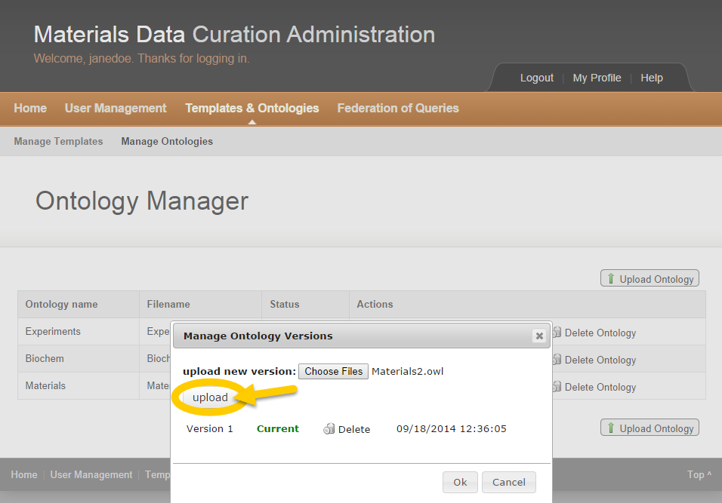

Figure Ontology Version Upload Window

1. Click the **Upload** button.

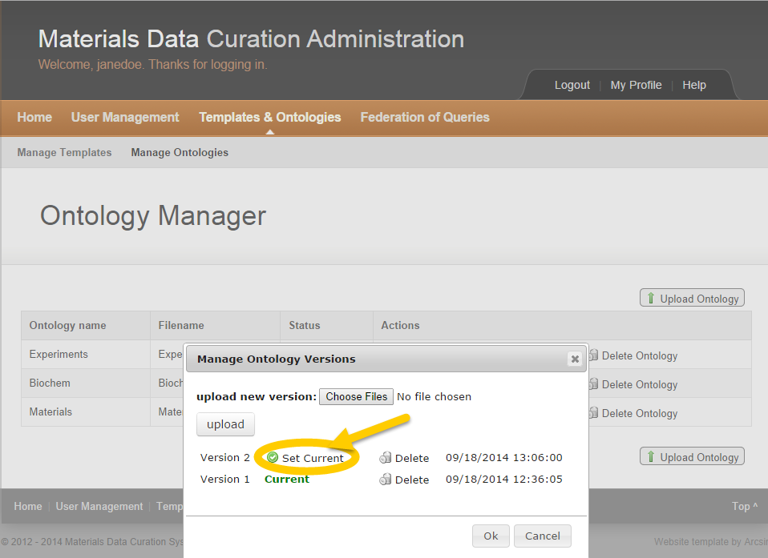

Figure Ontology Version Set Current Window

1. Click **Set Current** to designate the ontology version.

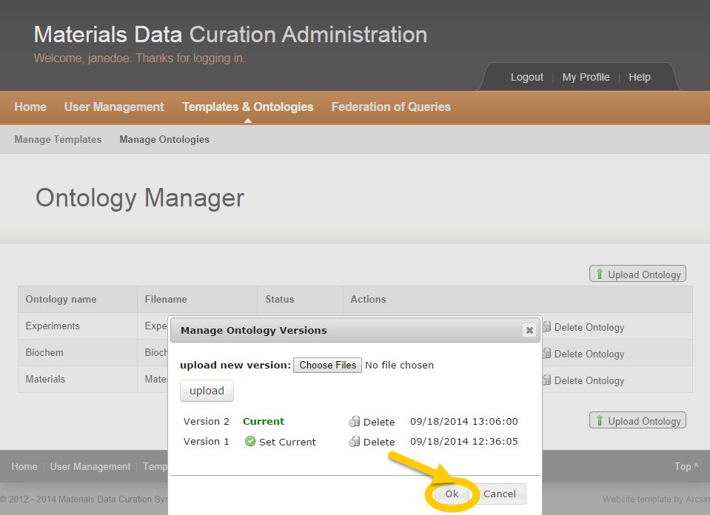

Figure Ontology Version Confirmation Window

1. Click the **Ok** button.



The new ontology version is now registered and appears in the list.

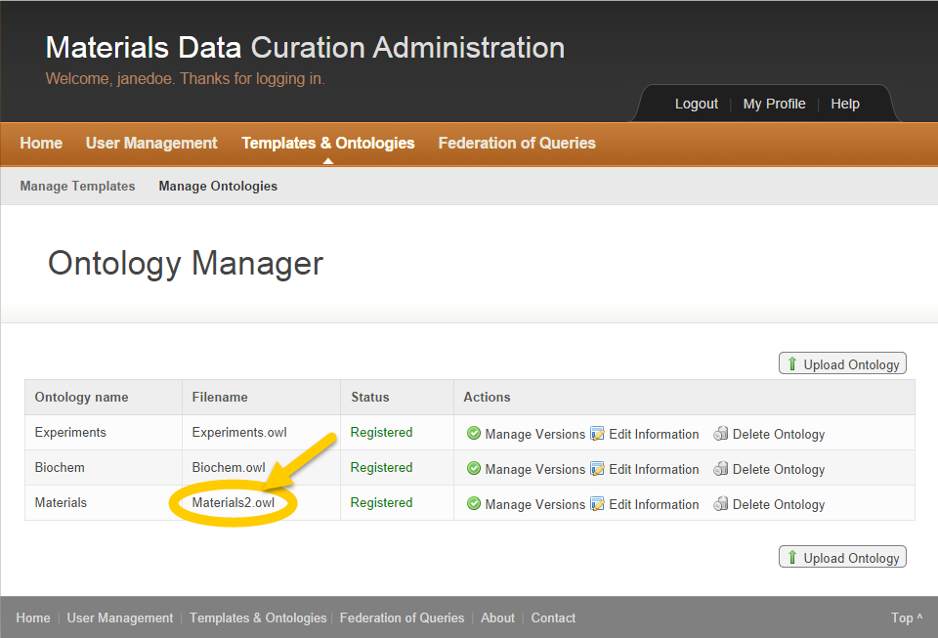

Figure Updated Ontology Version

#### Edit Ontology Information

The MDCS administrator may edit ontology information.

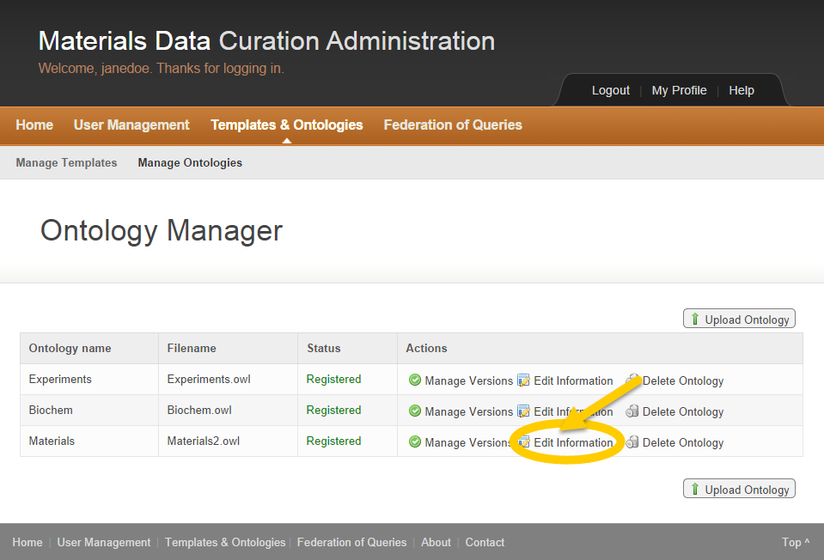

Figure Edit Ontology Information

1. Click **Edit Information** in the Actions column to edit ontology information.

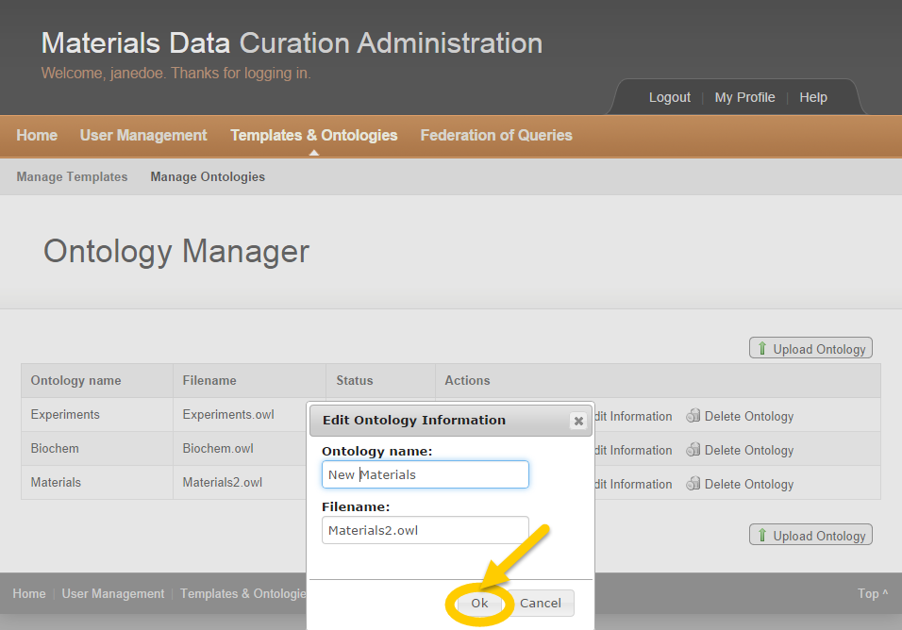

Figure Edit Ontology Information Window

1. Update Ontology Name and/or Filename.
2. Click the **Ok** button.



The updated ontology information appears in the list.

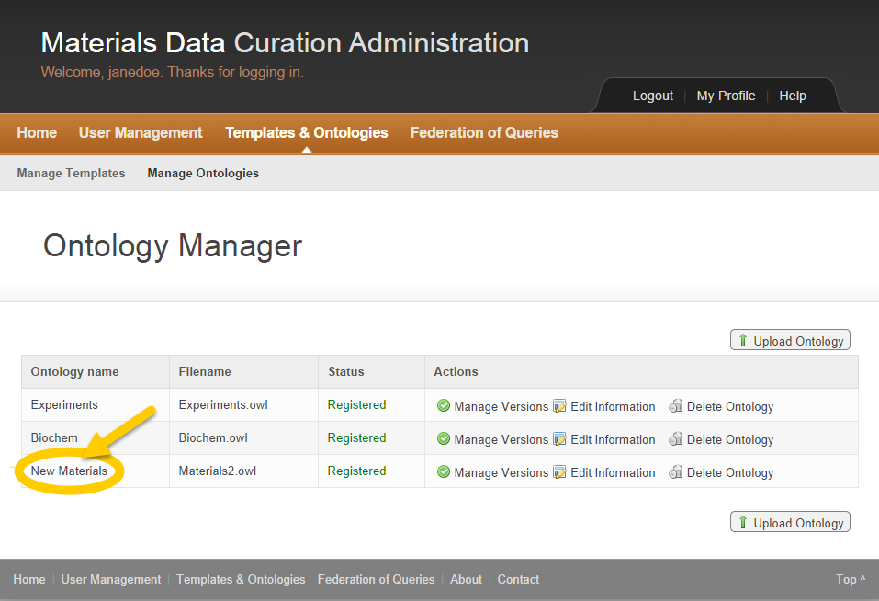

Figure Ontology Information Updated

#### Delete Ontology

The MDCS administrator may delete an ontology.

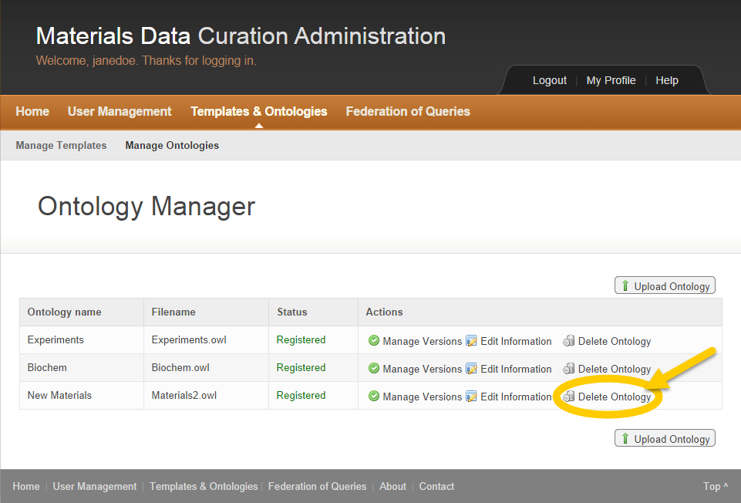

Figure Delete Ontology

1. Click **Delete Ontology** in the Actions column.

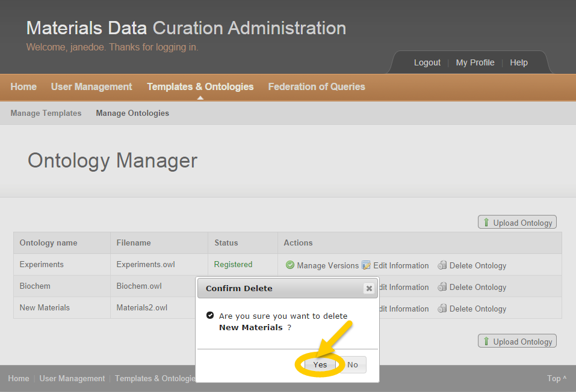

Figure Ontology Delete Confirmation Window

1. Click the **Yes** button to confirm the ontology deletion.



The deleted ontology remains in the list of ontologies with “Deleted” as the status.

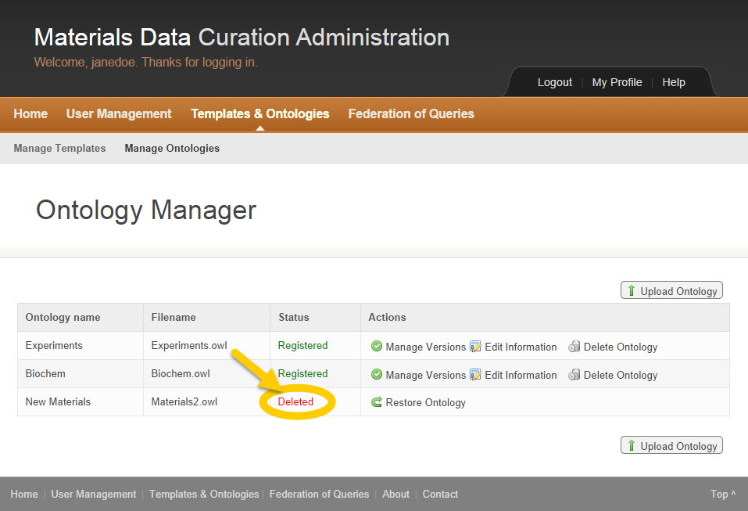

Figure Ontology Deleted

#### Restore Ontology

The MDCS administrator may restore an ontology if deemed necessary.

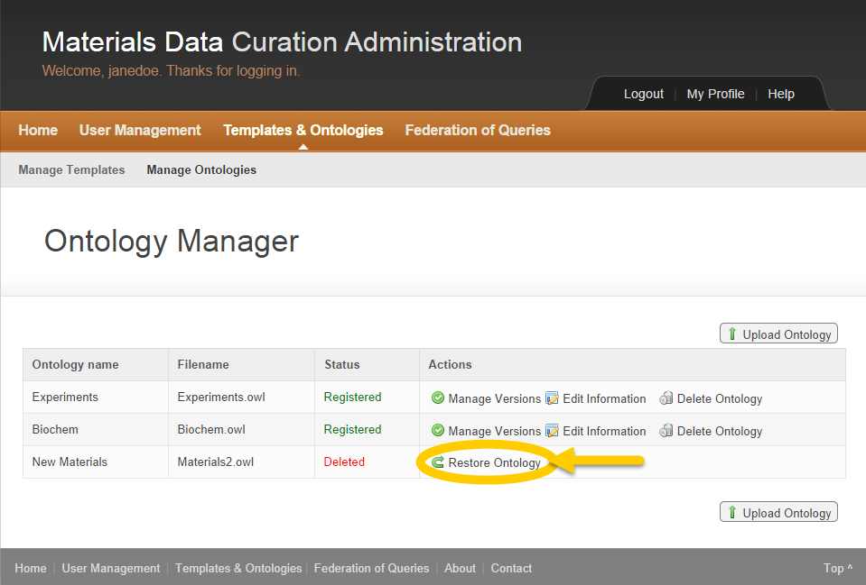

Figure Restore Ontology

1. Click **Restore Ontology** in the Actions column to reactivate a deleted ontology.



The deleted ontology is now restored with “Registered” as the status.

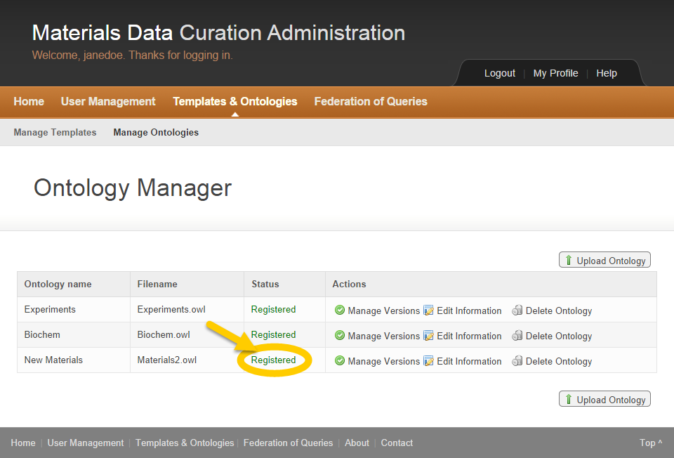

Figure Restored Ontology

# Scientist Role

## Scientist Activities

MDCS allows scientists to curate and explore data according to selected templates.

## Data Curation

1. Click on **Data** **Curation** in the top left.

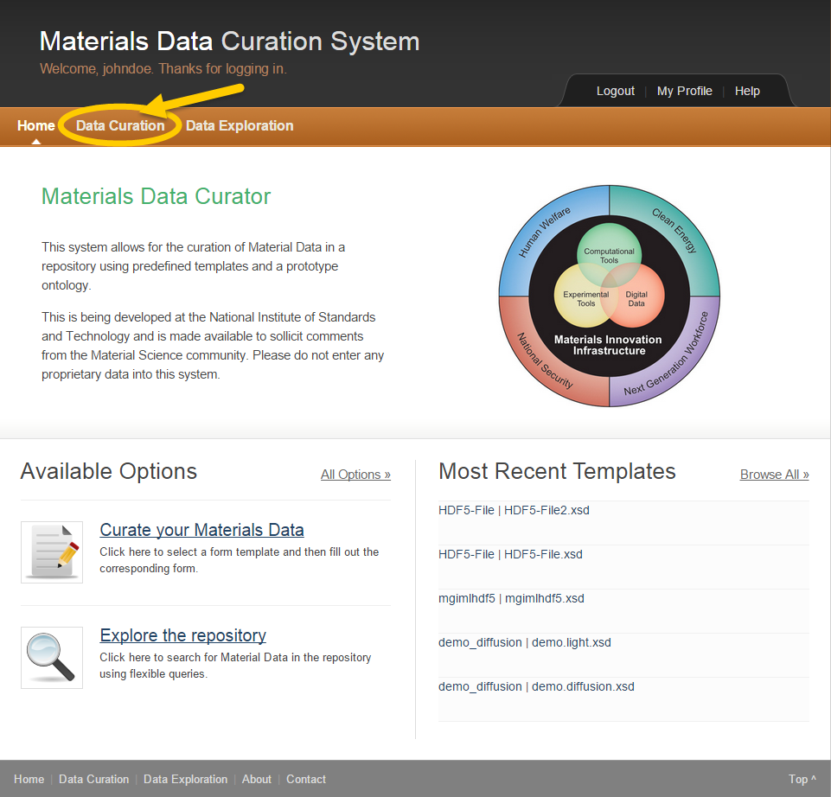

Figure MDCS Scientist Page



The Data Curation Main Page appears.

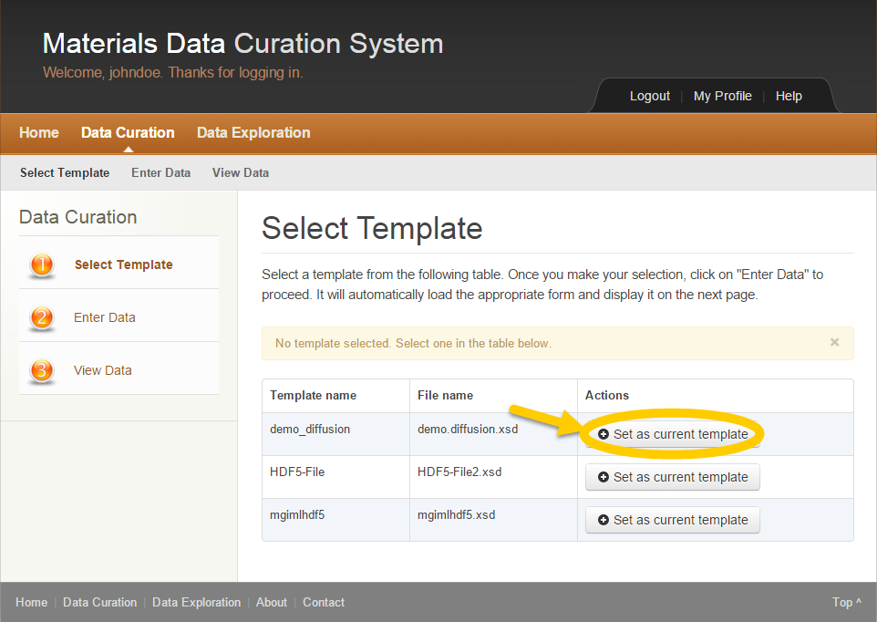

Figure Data Curation Main Page

1. Click on the **Set as current template** button in the Actions column to select the template to use.



A message window appears to inform the user that the template is loaded.

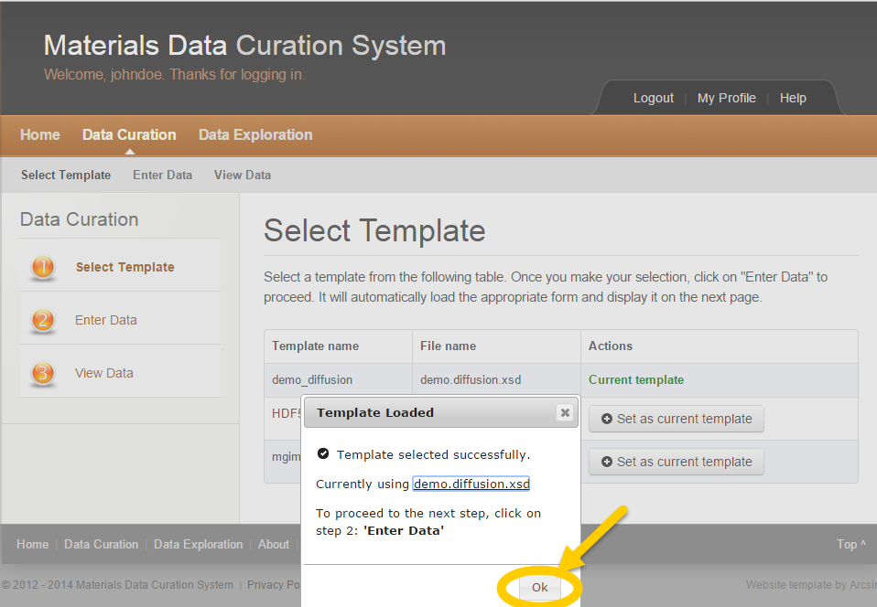

Figure Data Curation Template Loaded

1. Click the **OK** button.



The template selected is now designated as Current template.

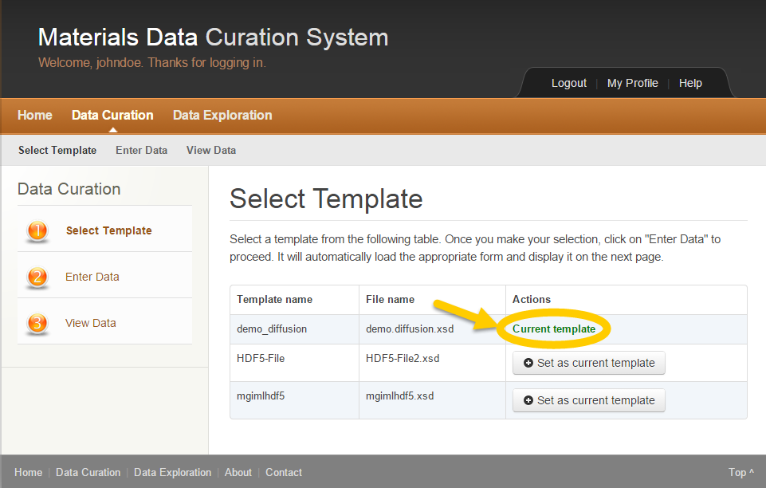

Figure Current Template Page

The user has successfully selected a template.



In Data Curation, the user must always perform step 1 **Select Template** before step 2 **Enter Data** and step 3 **View Data**.

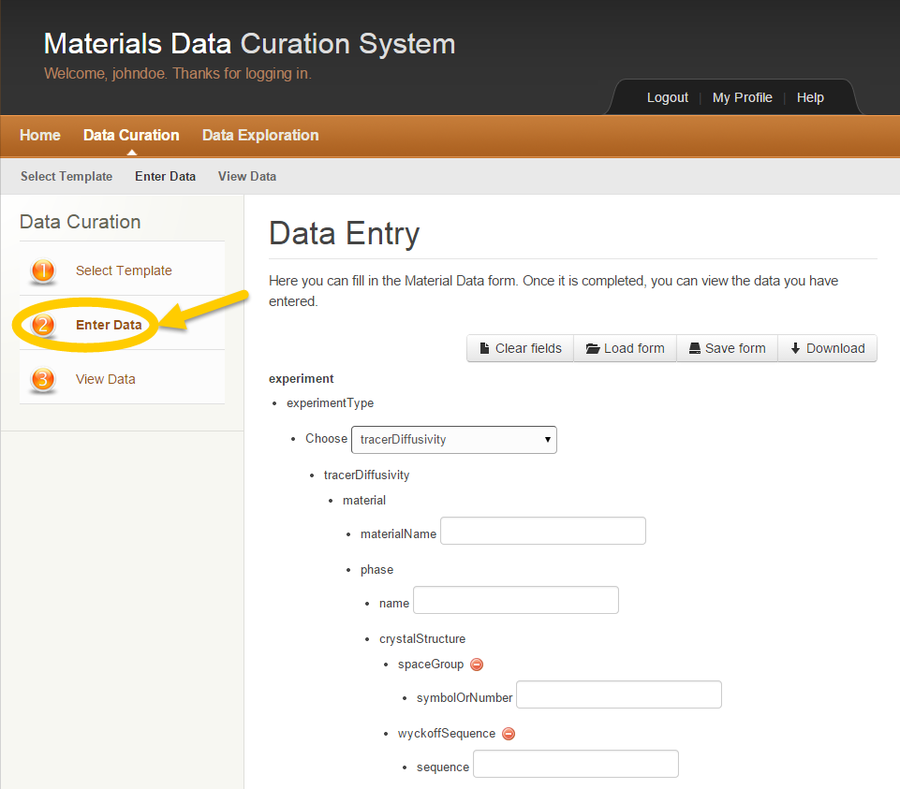

Figure Data Entry Page

1. Click on step 2 **Enter Data** in the left column.

To complete the form:

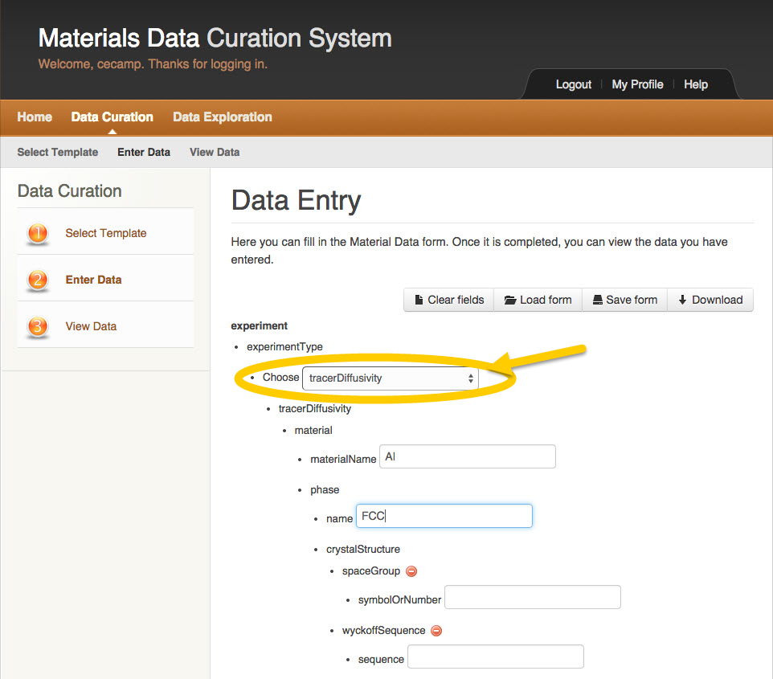

Figure Data Entry Dropdowns

1. Select items from the dropdowns.

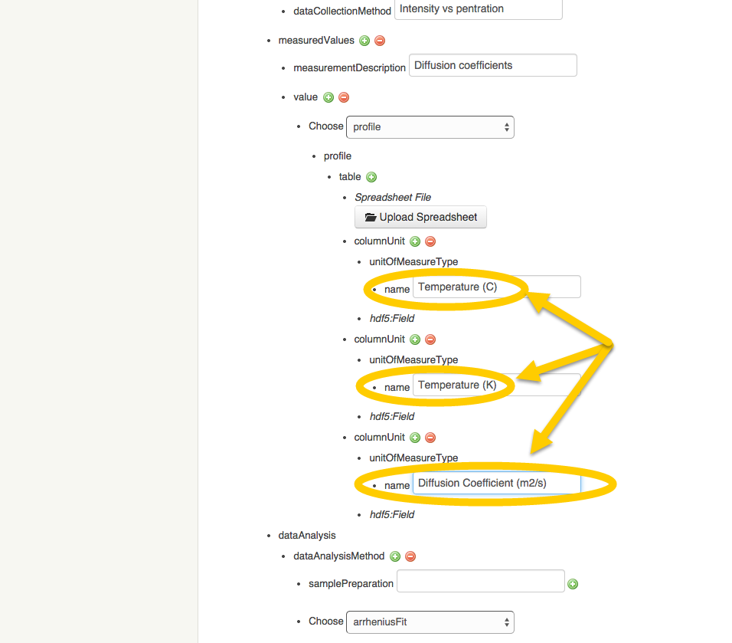

Figure Data Entry Text Fields

1. Enter information in the text fields.

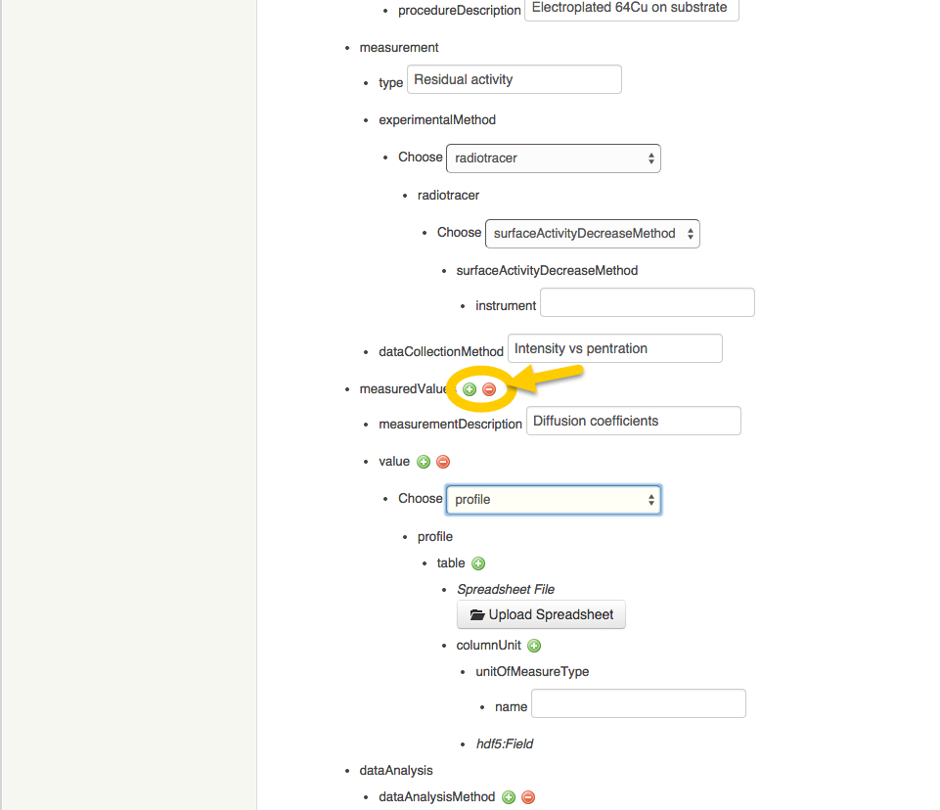

Figure Data Entry Add/Reduce Icons

1. Use the Add and/or Reduce icons to add or reduce the occurrence of certain fields.

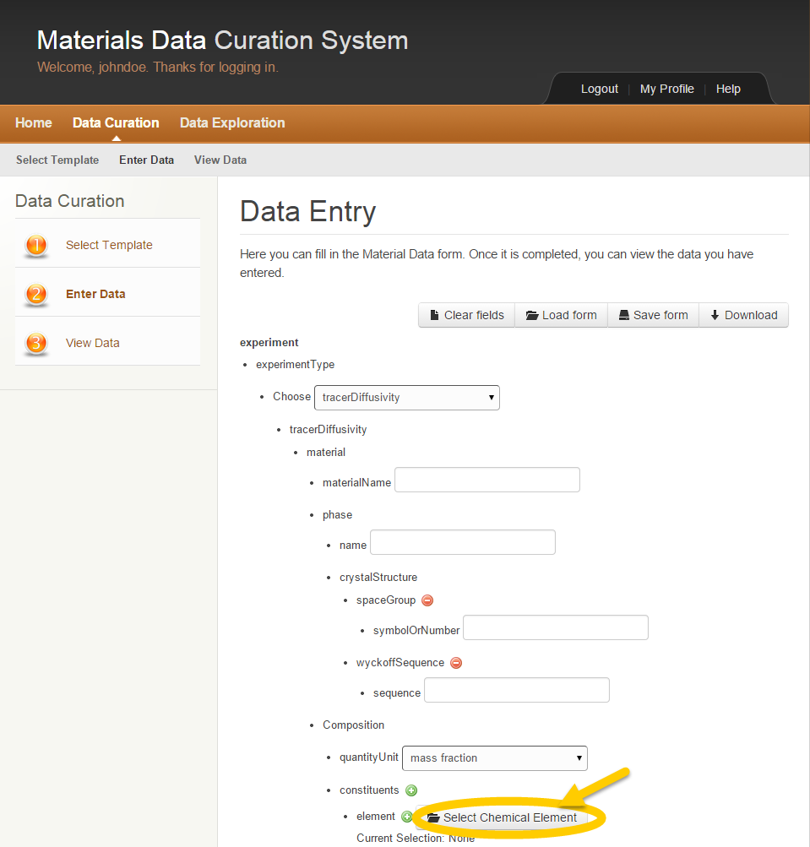

Figure Data Entry Select Chemical Element

1. Click the **Select Chemical Element** button.



The Periodic Table Select Element window appears.

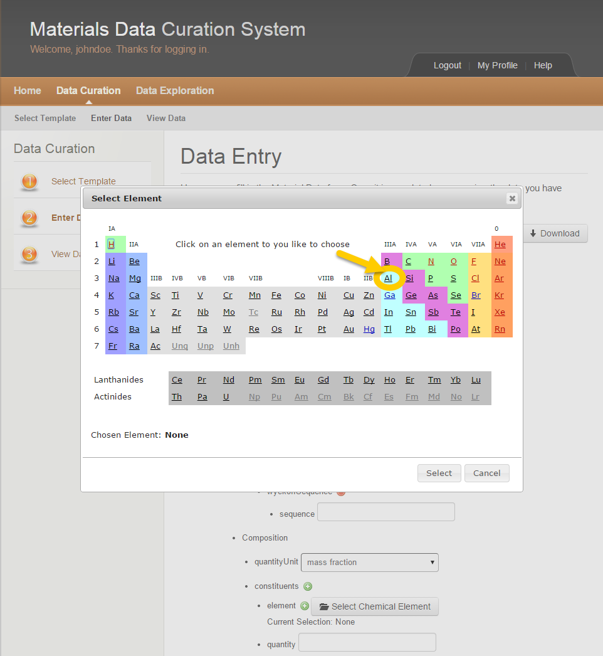

Figure Periodic Table

1. Click on the element in the Periodic Table.



The selected element appears in the lower left of the Periodic table.

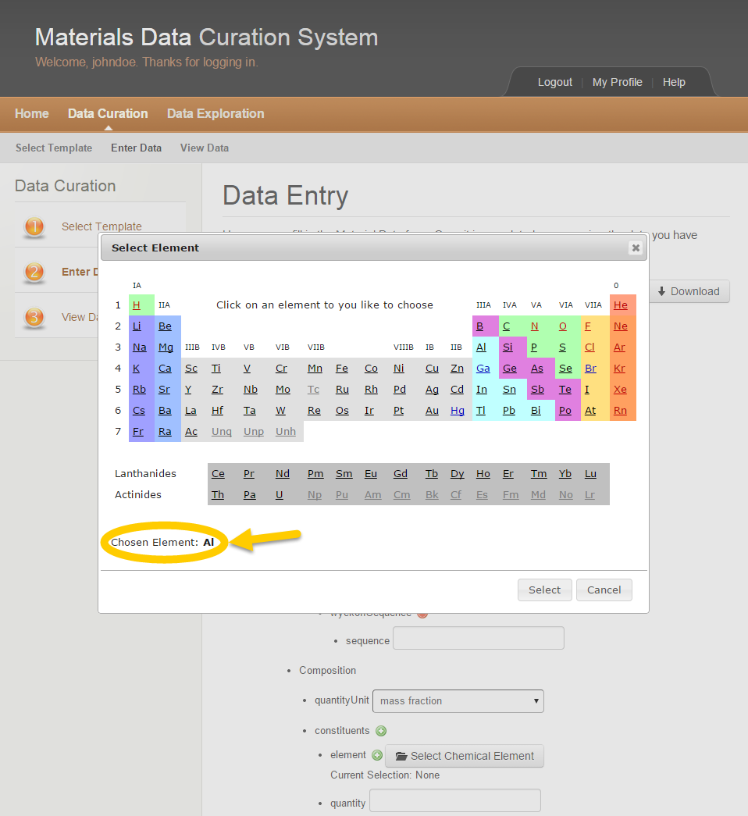

Figure Chosen Element

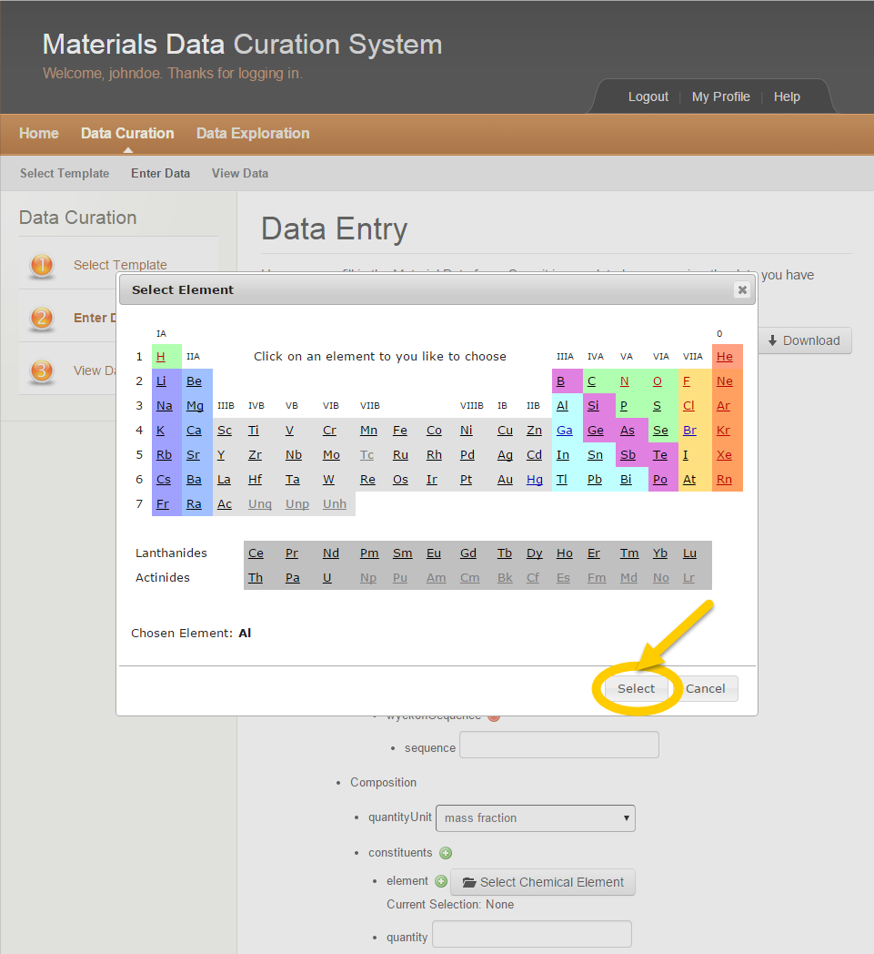

Figure Complete Element Selection

1. Click the **Select** button to complete the selection.



The element selected appears on the form as the Current Selection.

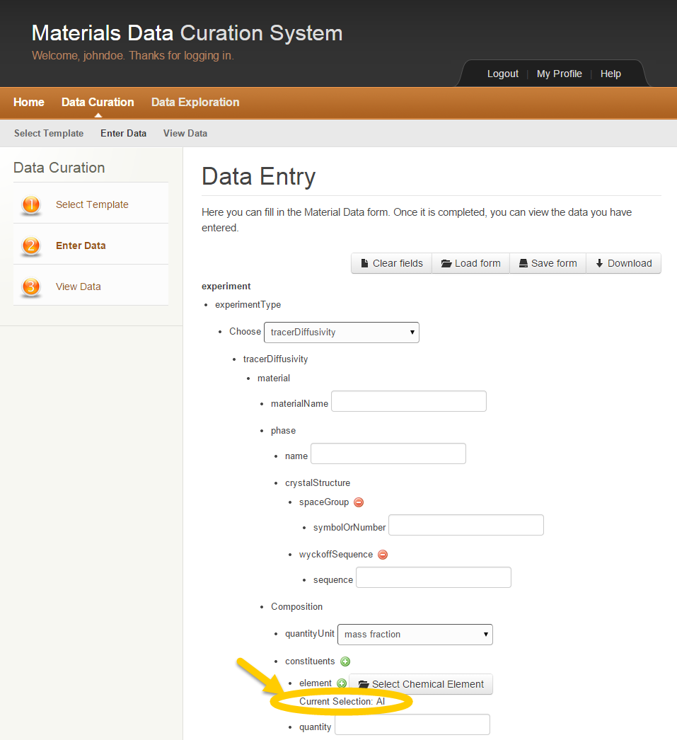

Figure Element Selection Completed

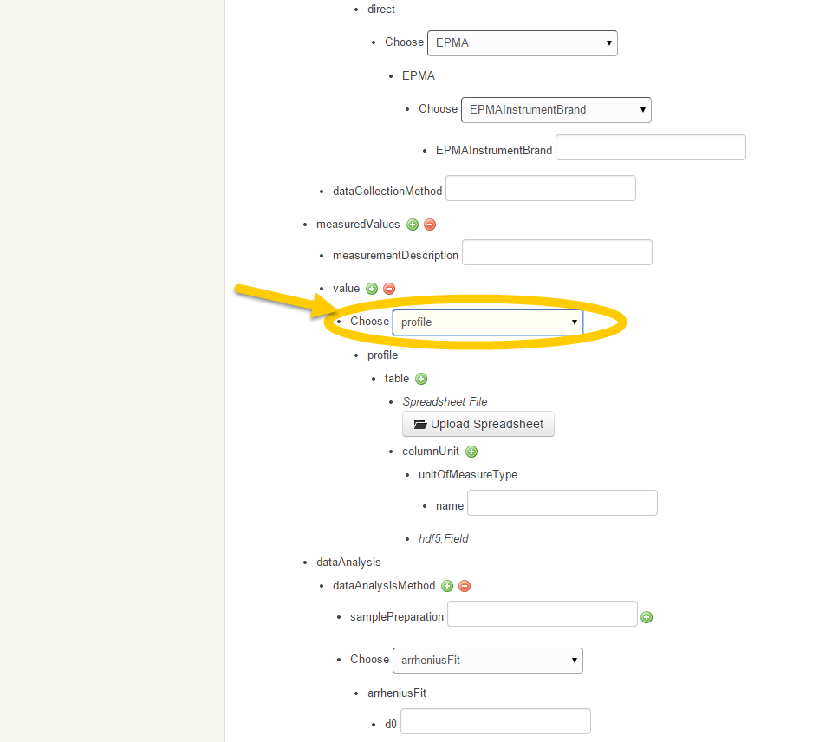

Figure Data Entry Choose Profile

1. Choose Profile in the dropdown to upload spreadsheet.

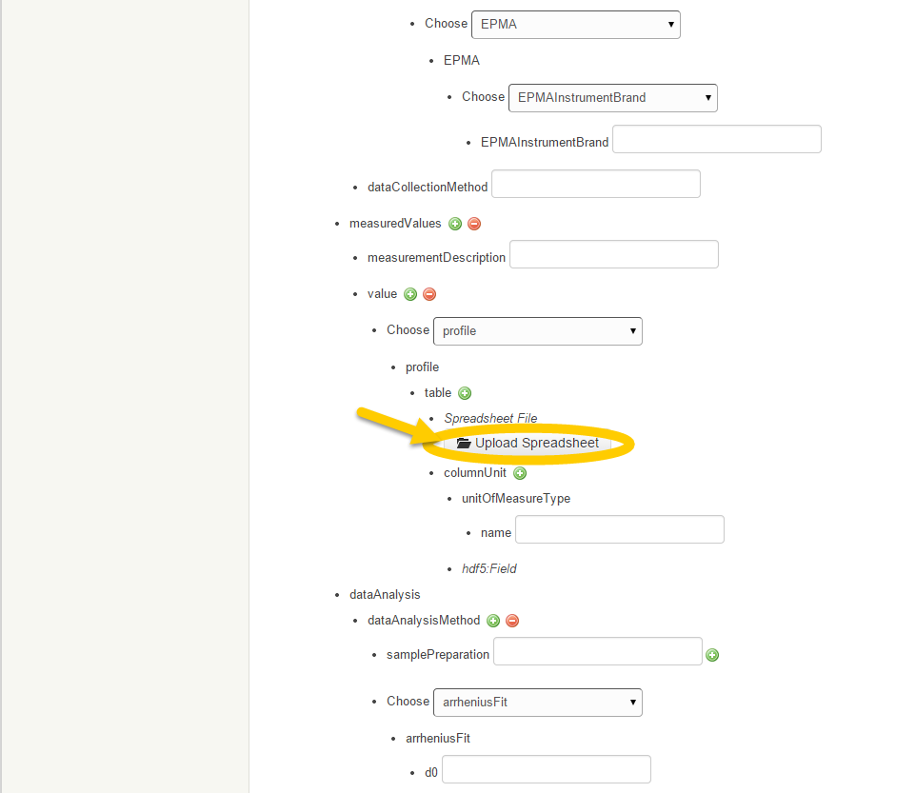

Figure Data Entry Upload Spreadsheet

1. Click the **Upload Spreadsheet** button.

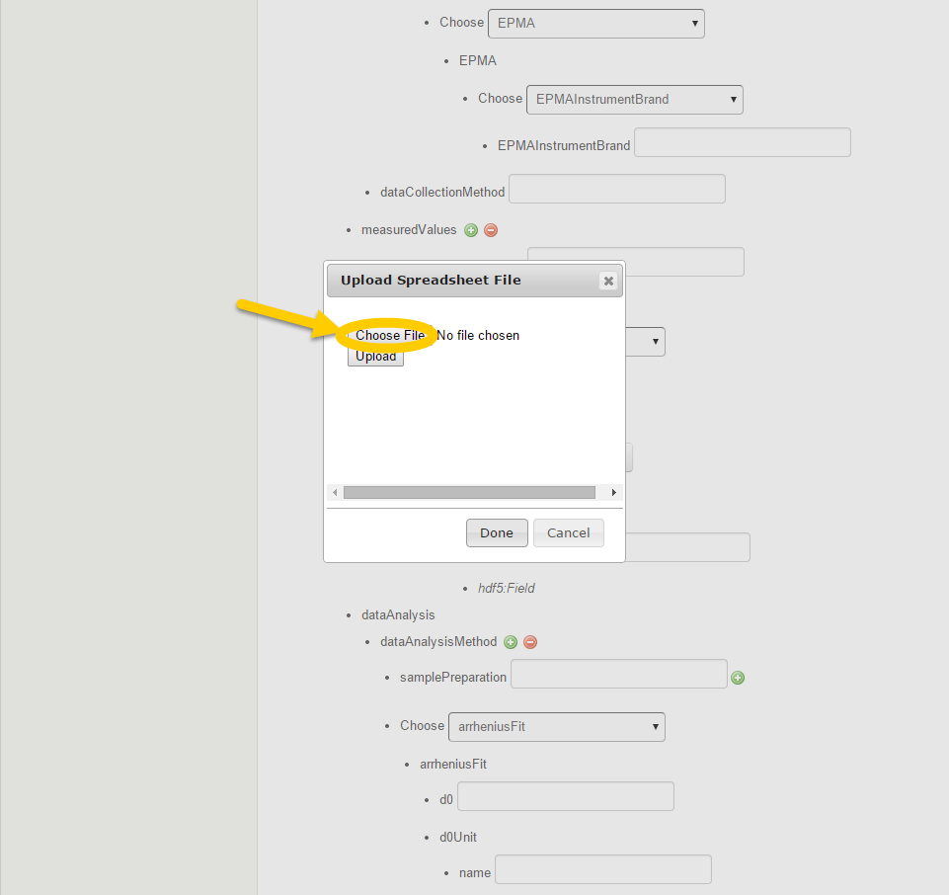

Figure Data Entry Choose File

1. Click on the **Choose File** button to select the file.

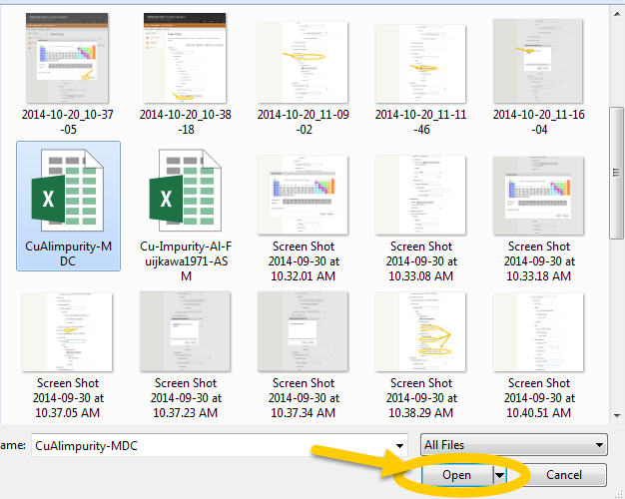

Figure Data Entry Choose File to Upload

1. Select the file.
2. Click the **Open** button to choose the file to upload.



The name of the selected file appears in the Upload Spreadsheet File window.

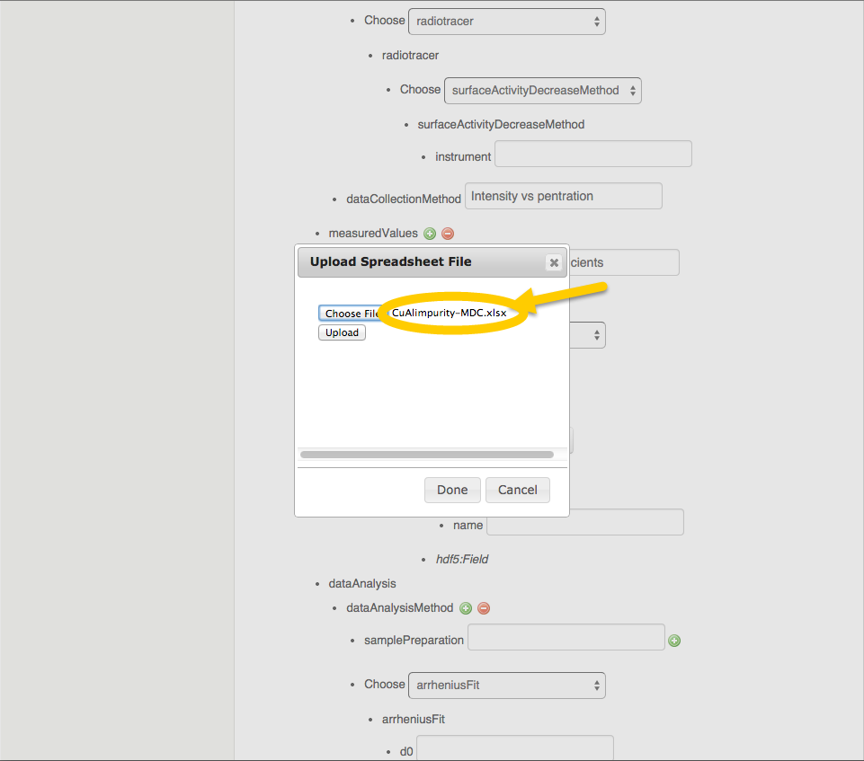

Figure Data Entry Upload File

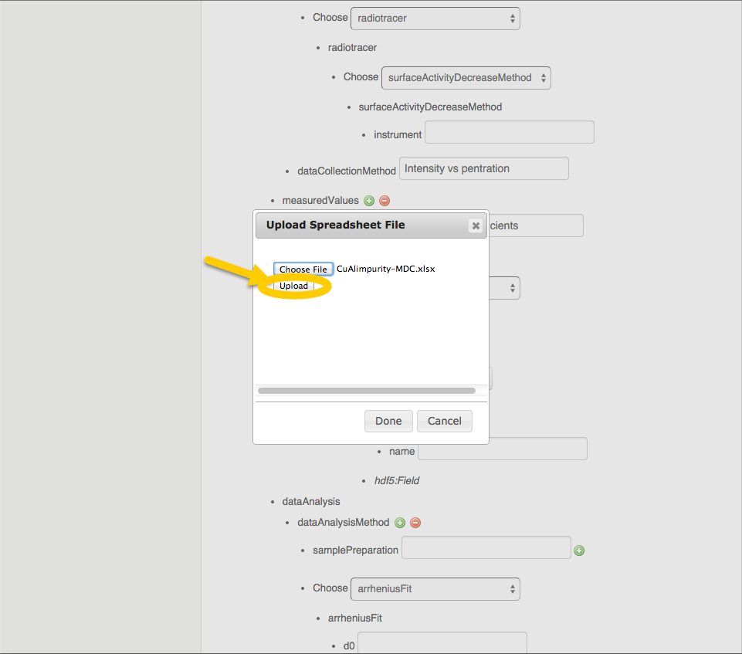

Figure Data Entry Upload File Button

1. Click the **Upload** button.



The File Upload Successful window appears.

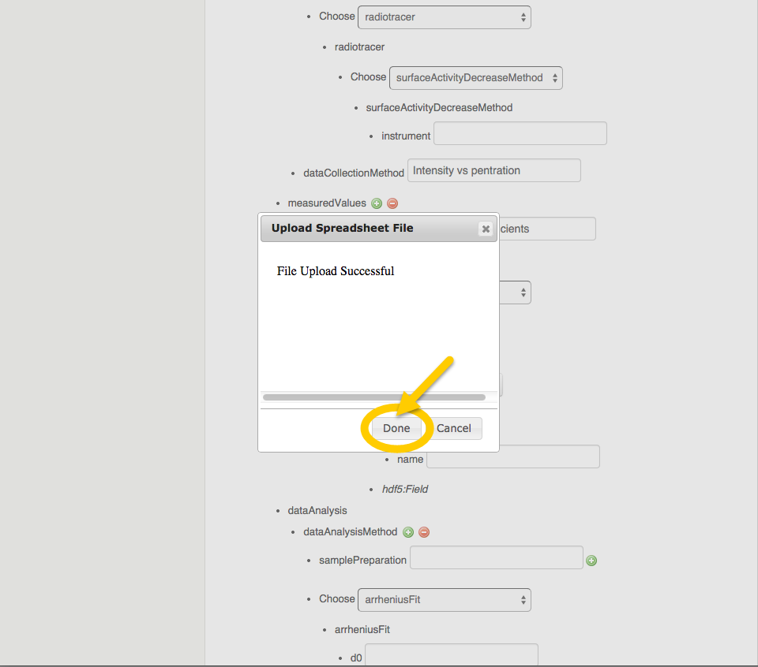

Figure Data Entry File Upload Successful Window

1. Continue filling out the form until it’s complete.

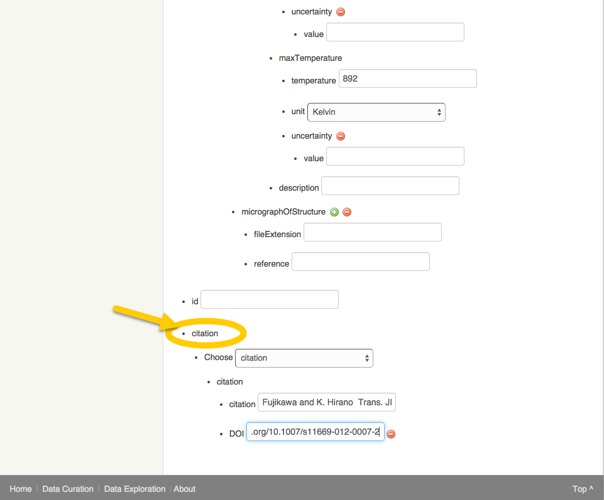

Figure Data Entry Citation

1. Enter the data regarding the Citation.



*It’s not necessary to save the form to view the data within.*

### View Data

After completing step 2 **Data Entry**. The user may now view the data entered in step 1 to review.

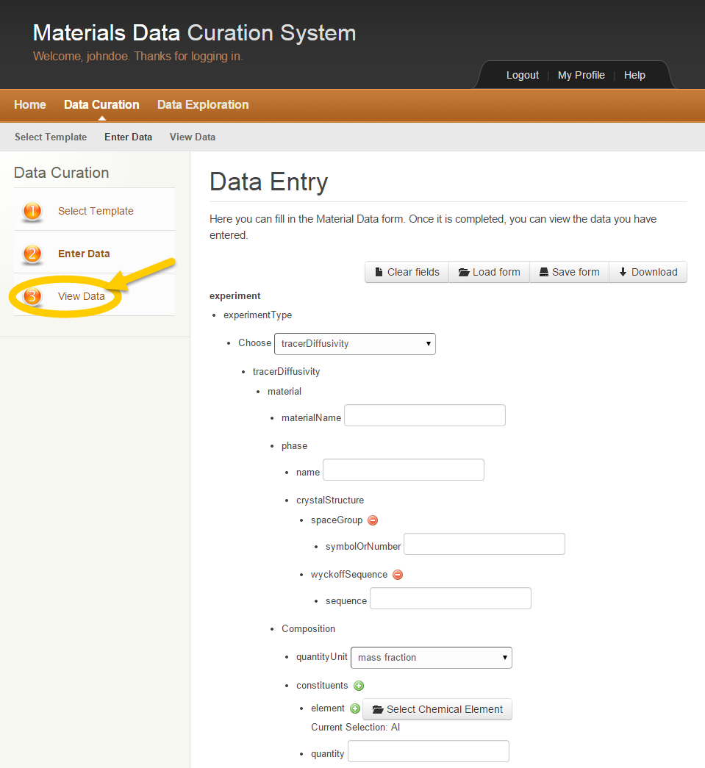

Figure MDCS View Data

1. Click on step 3 **View Data** in the left column.



The XML View for the selected template appears including the data entered in the previous step.

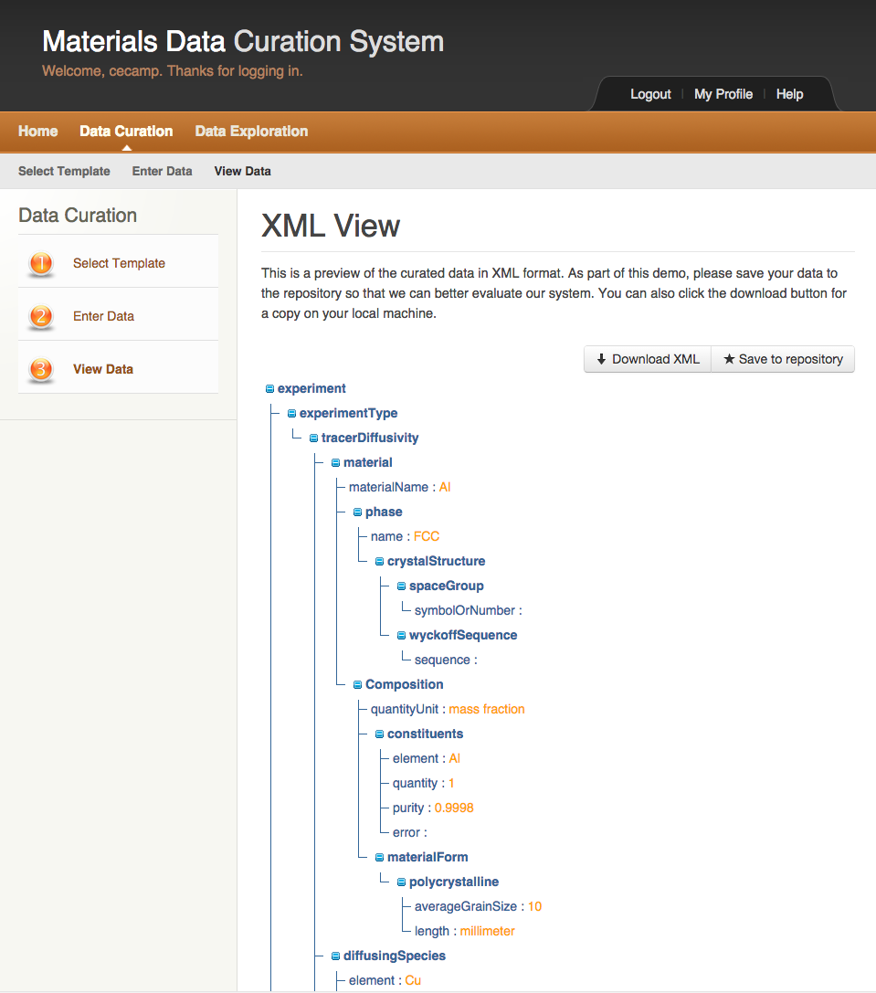

Figure XML View (Sample 1)

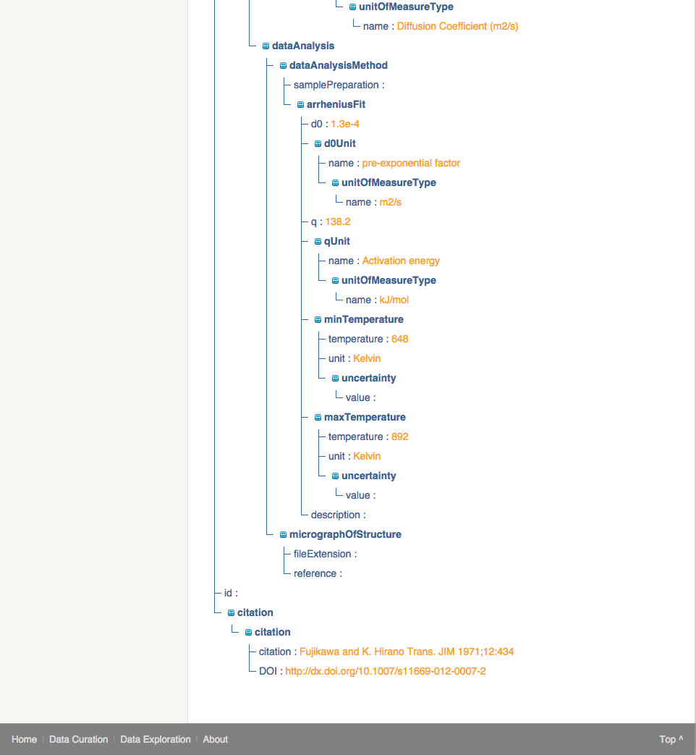

Figure XML View (Sample 2)

#### Download XML:

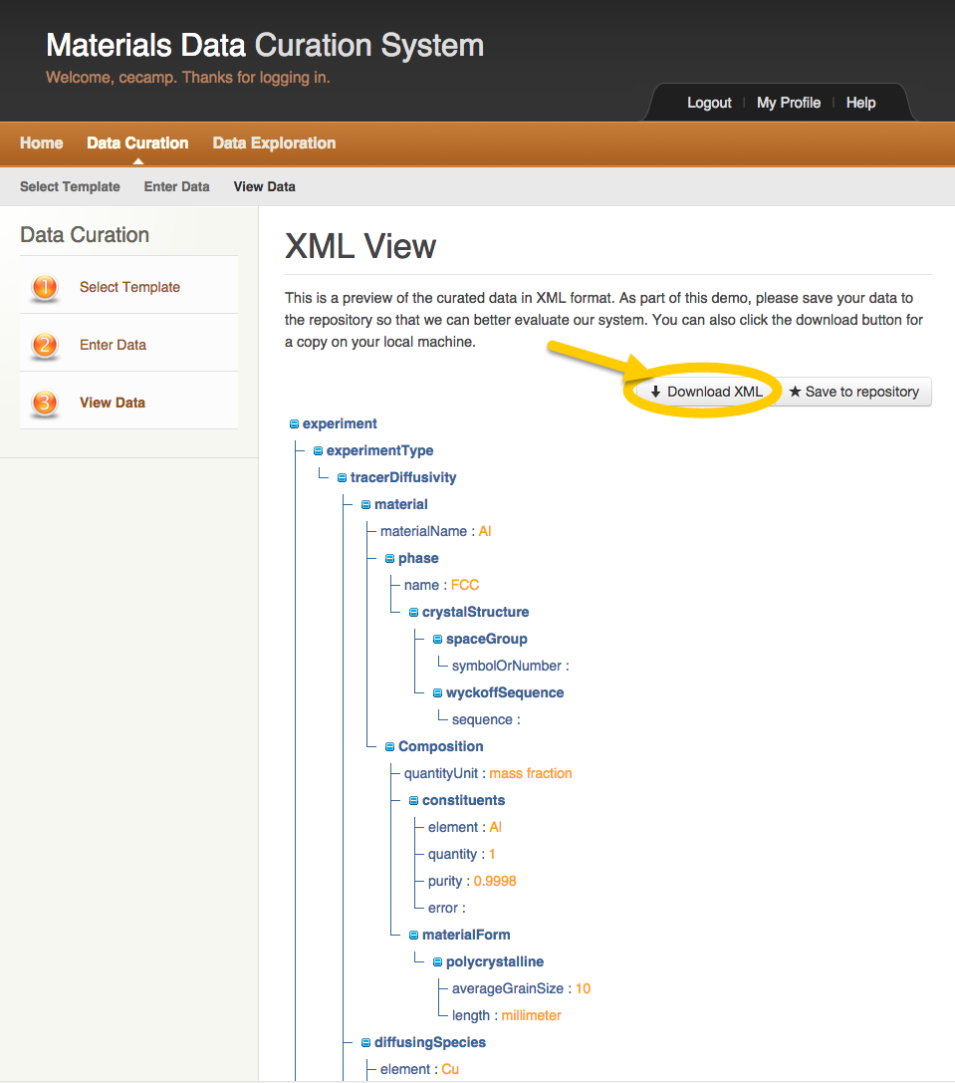

Figure XML View Download XML

1. Click the **Download XML** button.

The XML data file for the selected template is downloaded to the user’s computer.

#### Save XML to Repository:

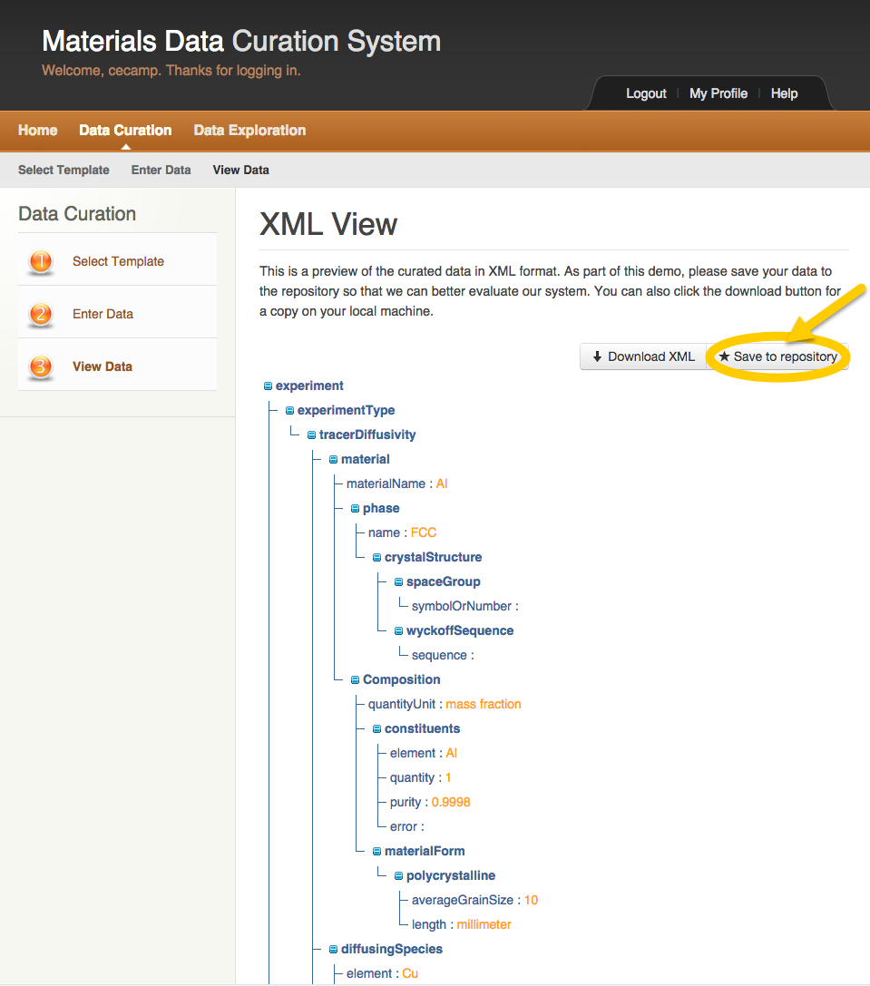

Figure XML View Save to Repository

1. Click the **Save to repository** button.



A window appears to allow the user to name the XML data file.

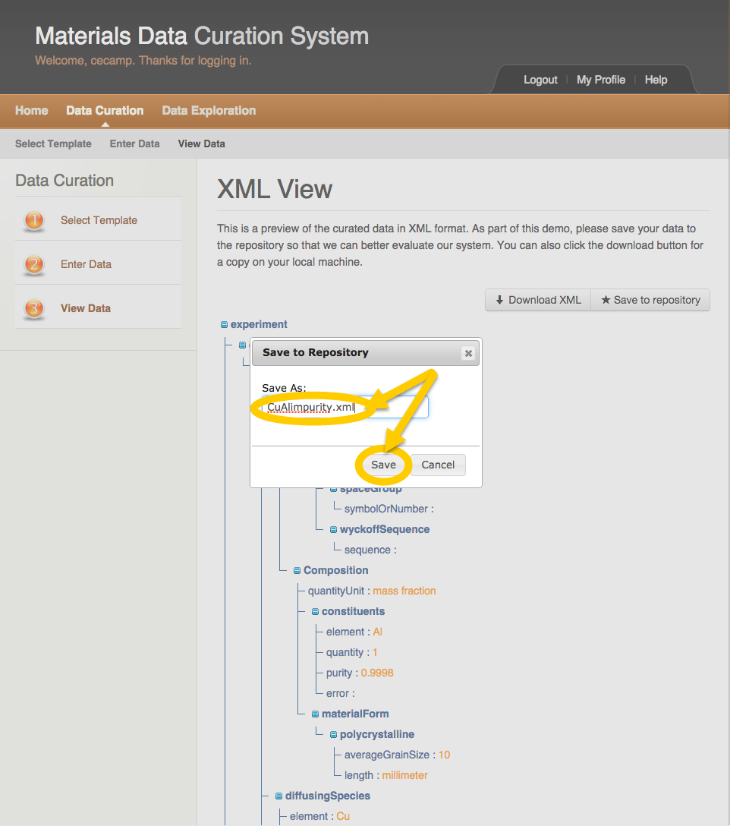

Figure Save XML to repository Name File

1. Enter a name for the XML data file.
2. Click the **Save** button.



A Save to repository successful message window appears.

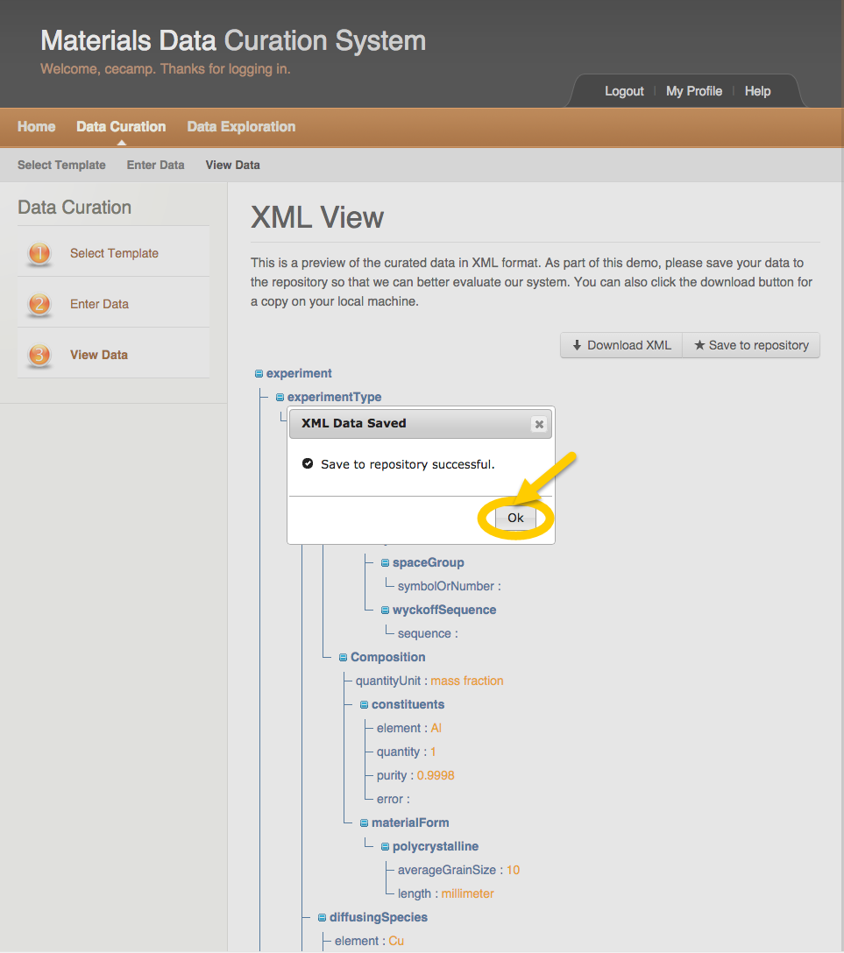

Figure XML Data Saved to Repository

1. Click the **Ok** button.

The XML data for this template is now searchable within NIST MGI MDCS.

## Data Exploration

There are two ways to explore data within NIST MGI MDCS:

* Query by Example
* SPARQL Endpoint Query

### Query by Example:

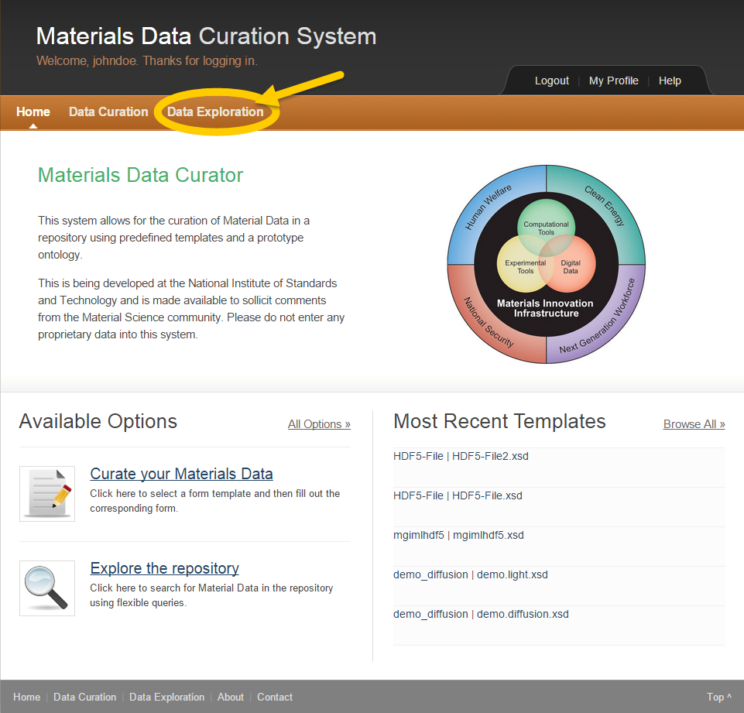

Figure Data Exploration

1. Click on **Data Exploration** in the top left.



The Data Exploration Main page appears.

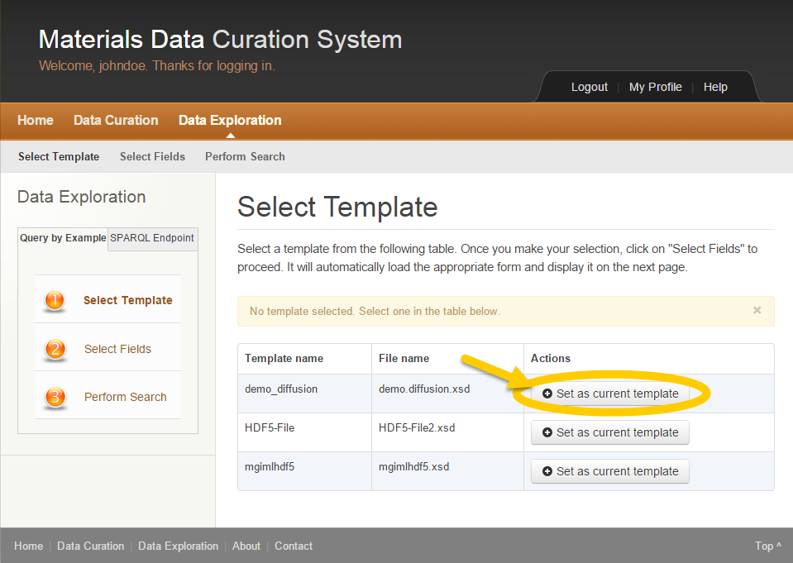

Figure Data Exploration Select Template

1. To complete Step 1 **Select Template**, click the **Set as current template** button in the Actions column to select the template to use.

The user explores data within MDCS using a pre-defined selected template.

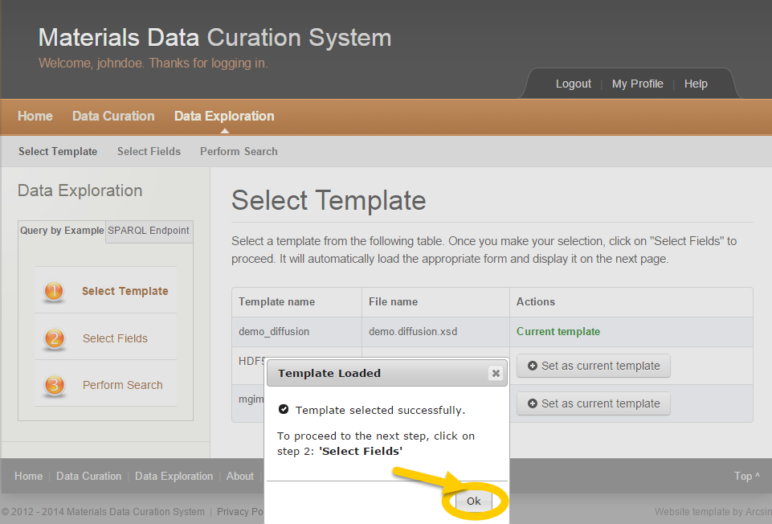

Figure Data Exploration Template Loaded

1. Click the **Ok** button.



In the Actions column, the selected template is now designated as **Current** **template**.

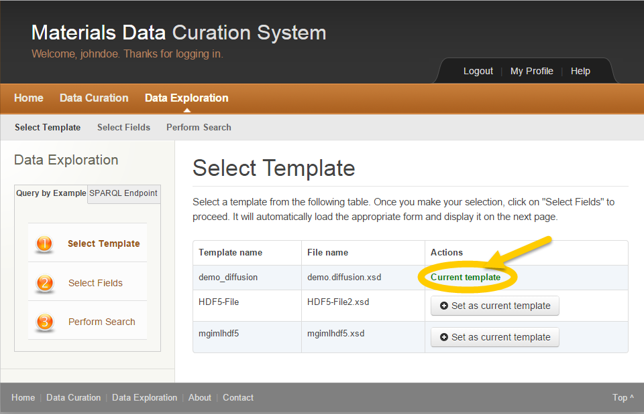

Figure Data Exploration Current Template

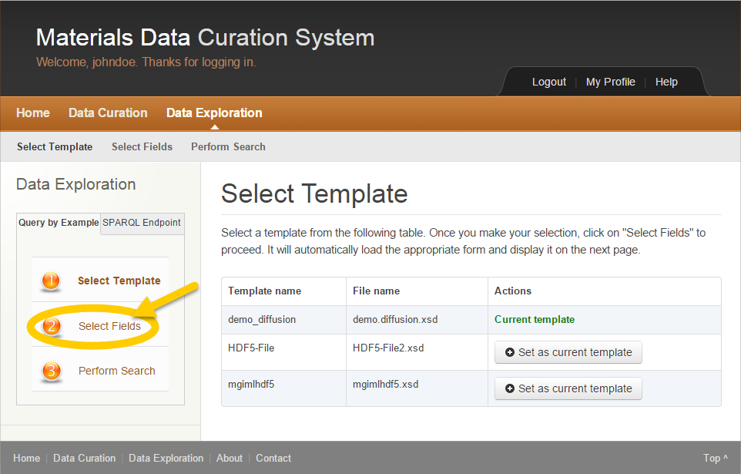

Figure Data Exploration Select Fields

1. Click step 2 **Select Fields** in the left column.

 In Data Exploration, the user must always perform step 1 **Select Template** before step 2 **Select Fields** and step 3 **Perform Search**.

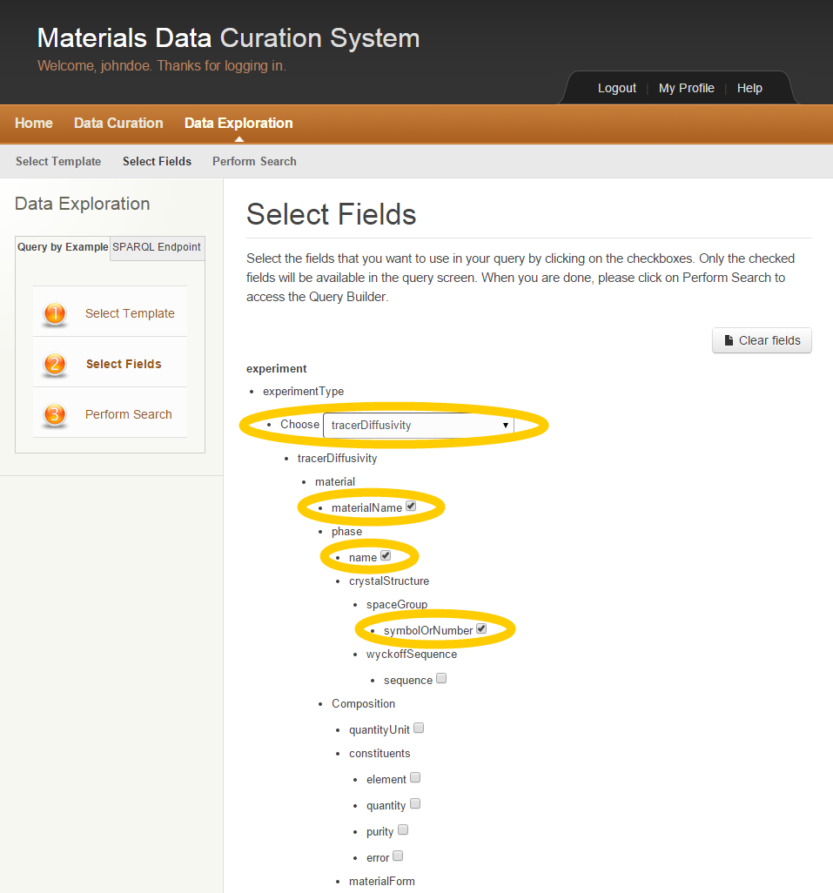

Figure Select Fields within Template

1. Select fields within the current template by clicking on the checkboxes or choosing items within the dropdowns.

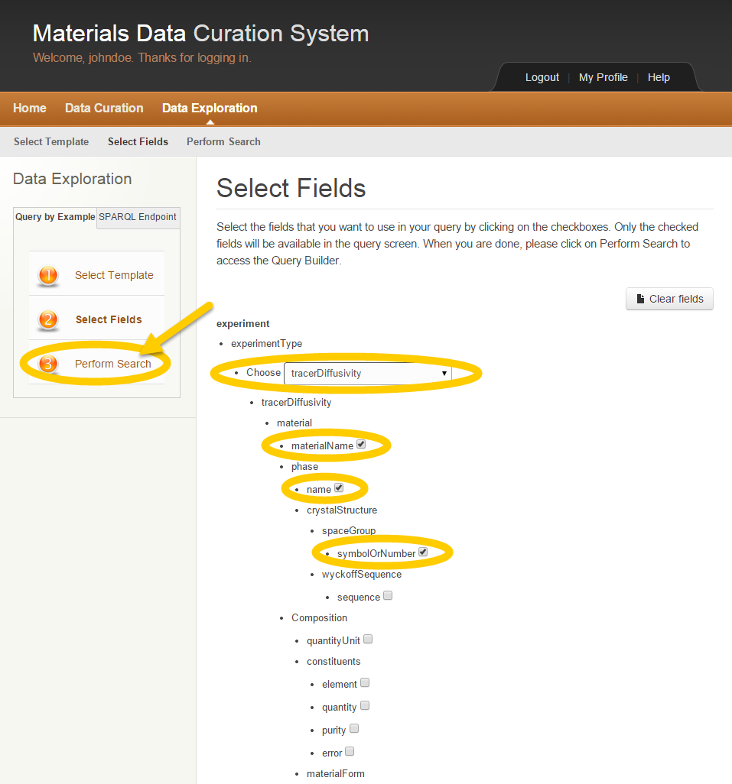

Figure Query by Example Perform Search

1. Click step 3 **Perform Search** to build the search query.

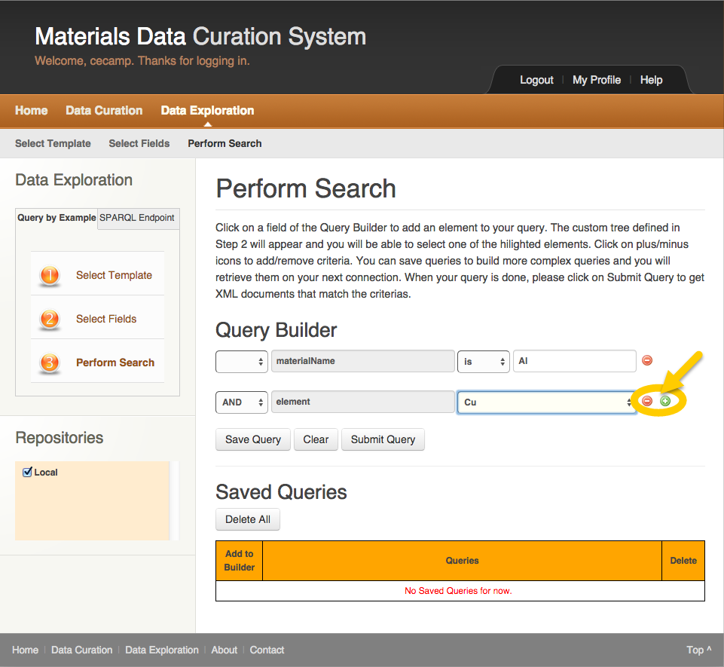

Figure Query by Example Query Builder

1. Build the query by using the provided Query Builder.
2. Use the Add, Reduce icons to add or remove statements to the query.

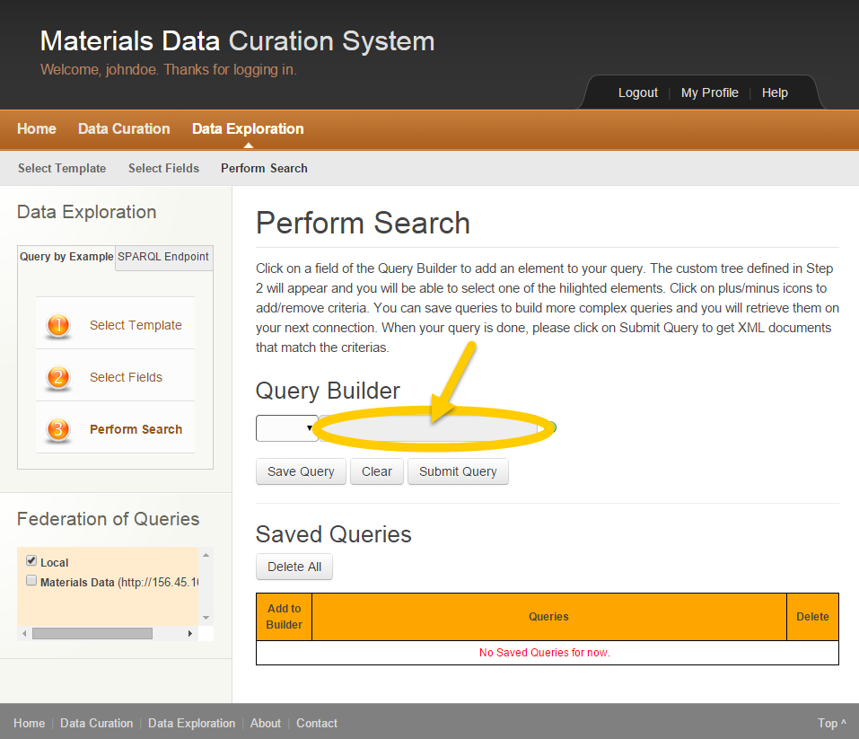

Figure Query by Example Define Query

1. Click inside each field to further define the query.



Choices the user has made in the previous **Select Fields** step appear within a Select an Element window.

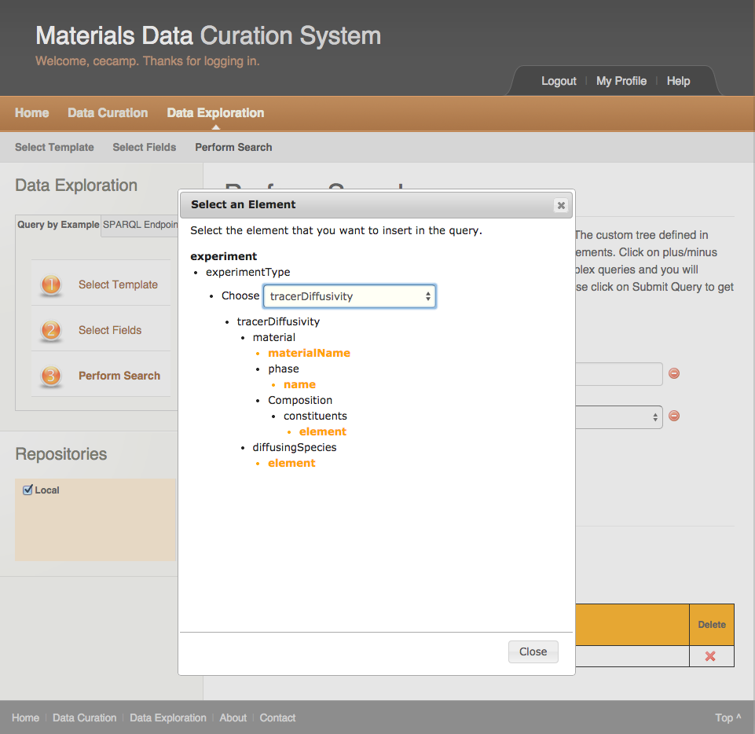

Figure Query by Example Select an Element

1. Click on the items to include in the query one at a time.



The items appear in the query builder as statements.

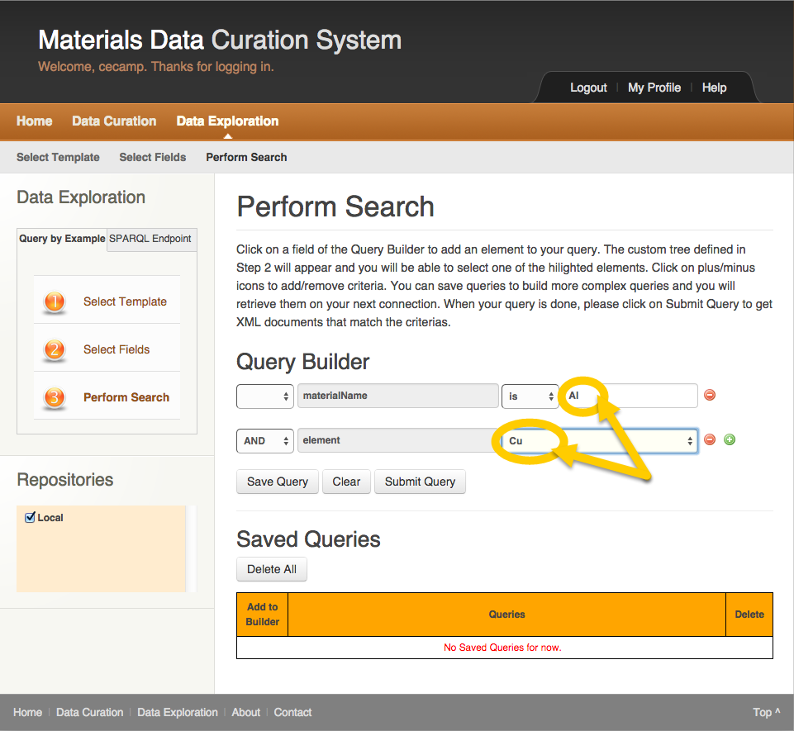

Figure Query by Example Element Selected

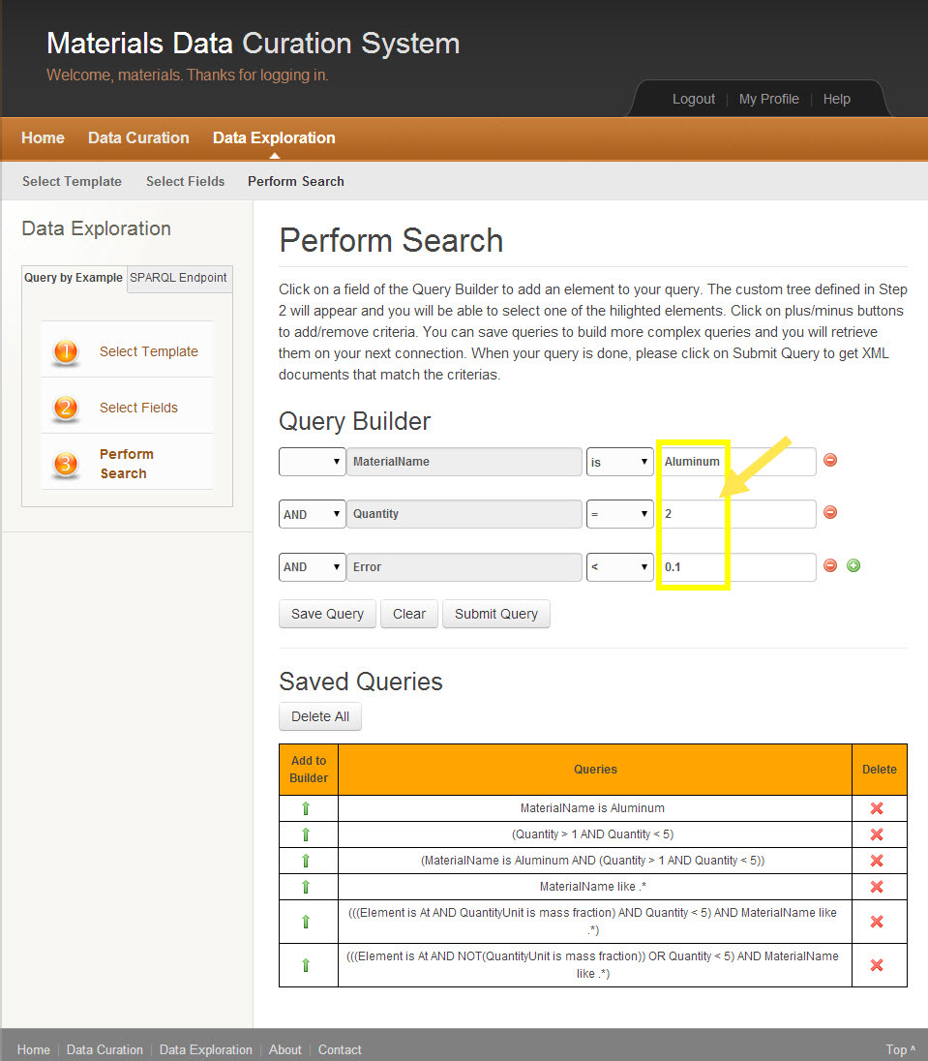

Figure Query by Example

1. Enter values in the corresponding text fields of each statement.
2. Complete steps 8, 9, and 10 for each of the fields within the query.

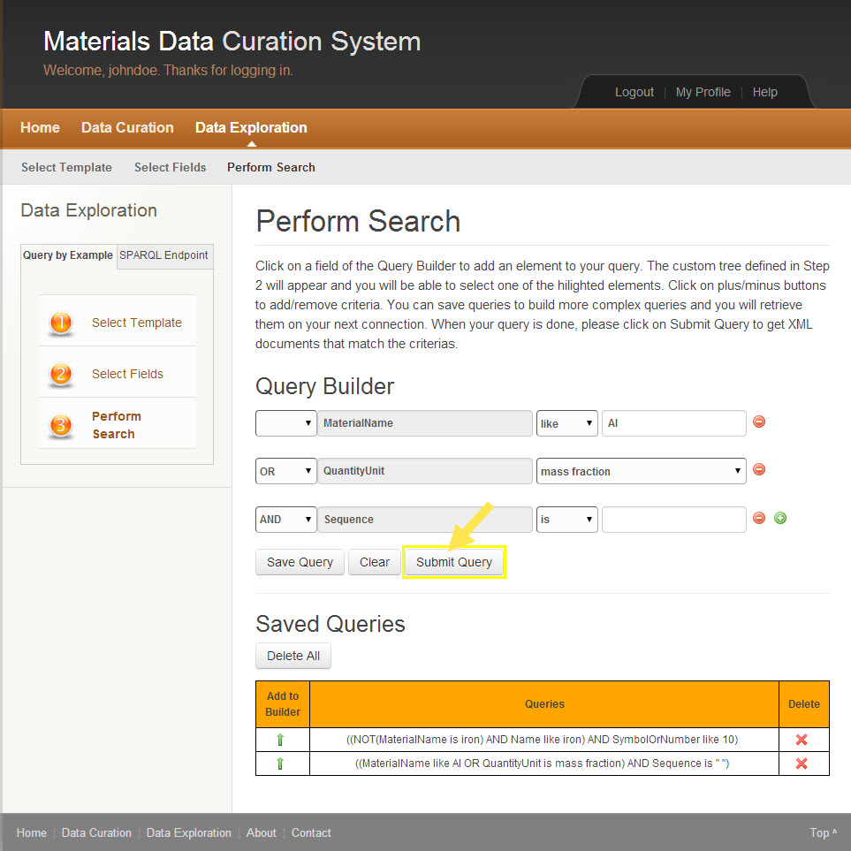

Figure Query by Example Submit Query

1. Click the **Submit Query** button to run the query.



The query results appear.

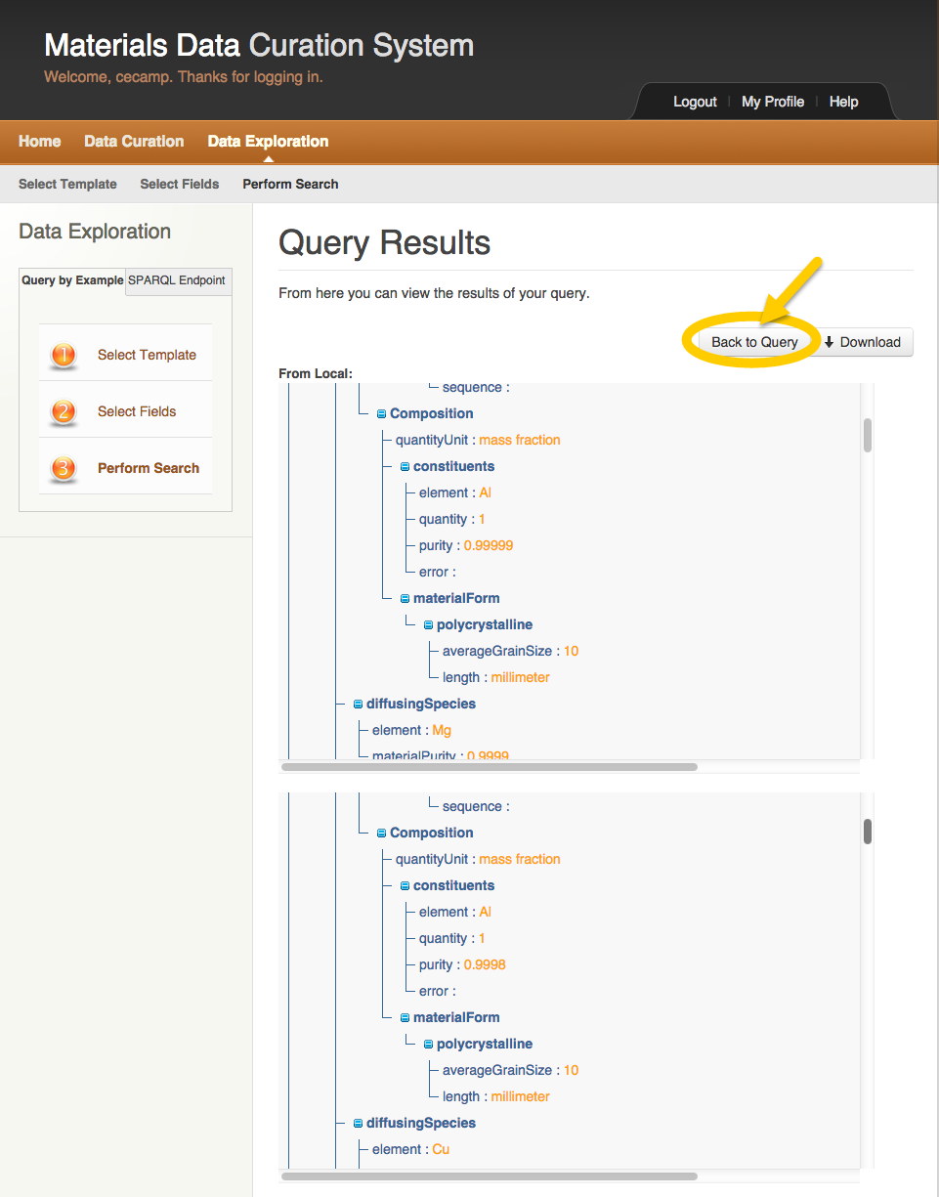

Figure Query by Example Query Results

1. Click the **Back to Query** button to review the query, save it or refine it further.

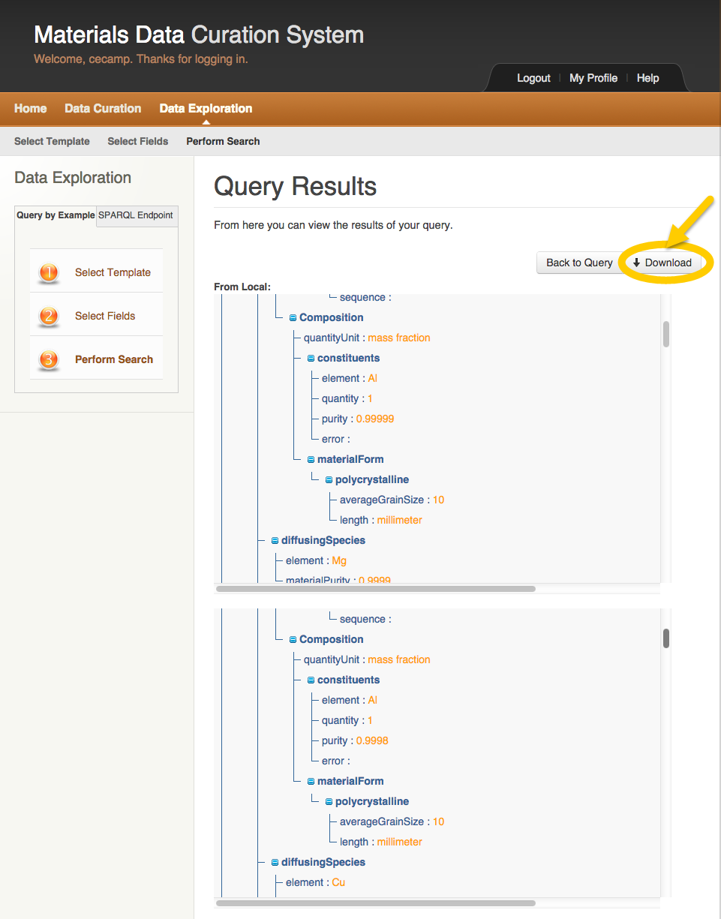

Figure Query by Example Download

1. Click the **Download** button to save the results of the query to the user’s computer.

The user is able to save the query results in the following formats: txt, xml, etc.

The user may save queries for future use.

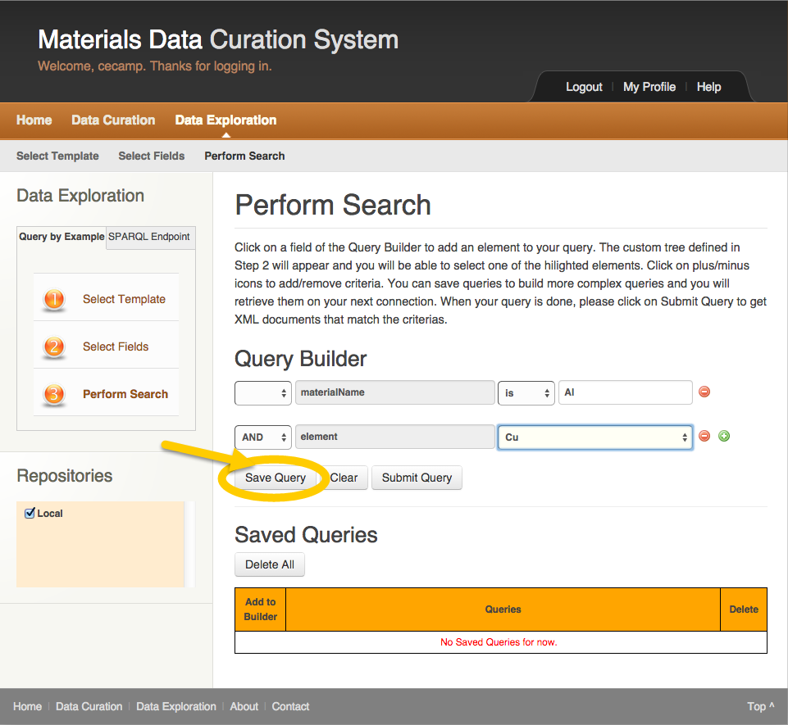

Figure Query by Example Save Query

1. Click the **Save Query** button to save the query for future use.

The saved query appears in the Queries table.

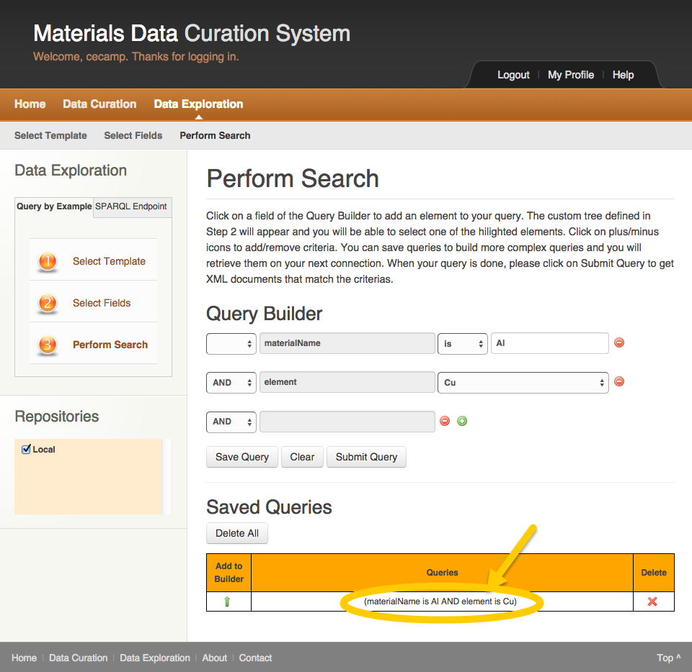

Figure Query by Example Saved Queries

1. Click the **Up** **Arrow** icon to add a previously saved query to the Query Builder.
2. Click the **X** icon to delete a previously saved query.

### SPARQL Endpoint Query

The SPARQL Endpoint Query is the second data exploration and querying tool. This tool allows the user to run queries which can be copied and pasted free form.



Figure Data Exploration Main Page

1. Click **Data Exploration** in the top left.

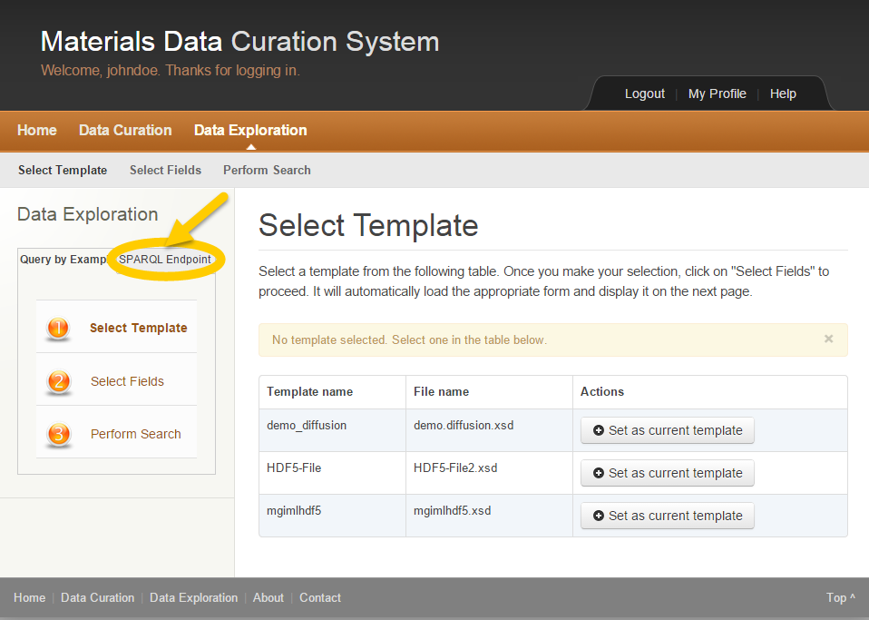

Figure SPARQL Endpoint Query

1. Click **SPARQL Endpoint** in the top left.

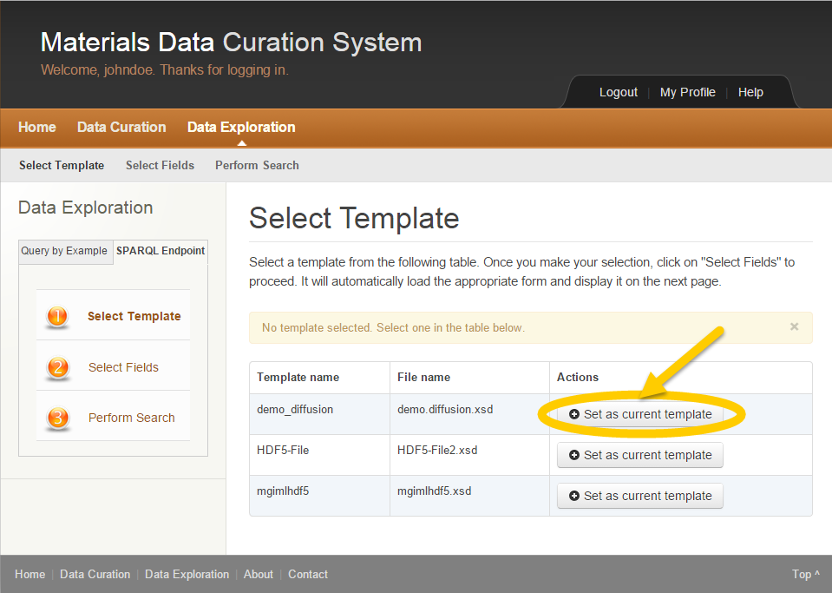

Figure SPARQL Endpoint Query Select Template

1. To complete step 1 **Select Template**, click the **Set as current template** button in the Actions column.

The user explores data within MDCS depending on a template selected.

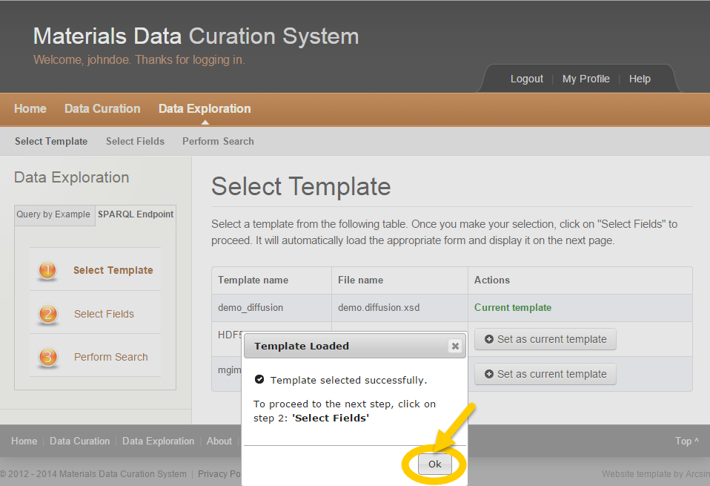

Figure SPARQL Endpoint Template Loaded

1. Click the **Ok** button.



In the Actions column, the selected template is now designated as **Current** **template**.

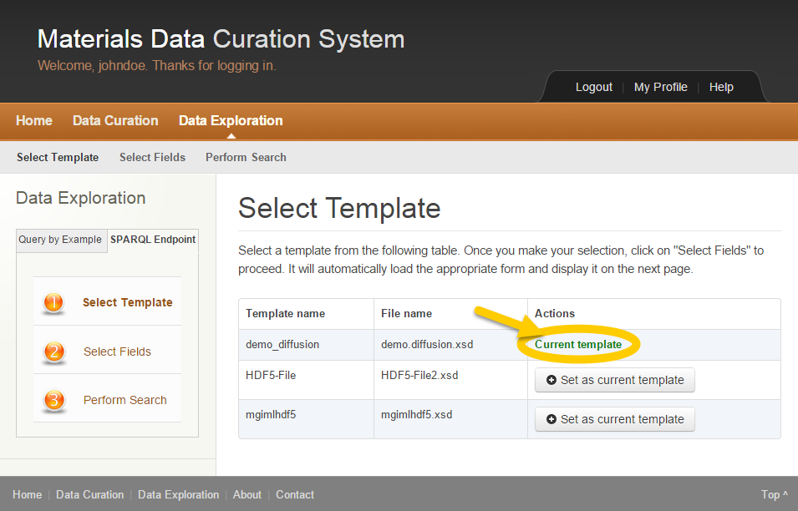

Figure SPARQL Query Current Template

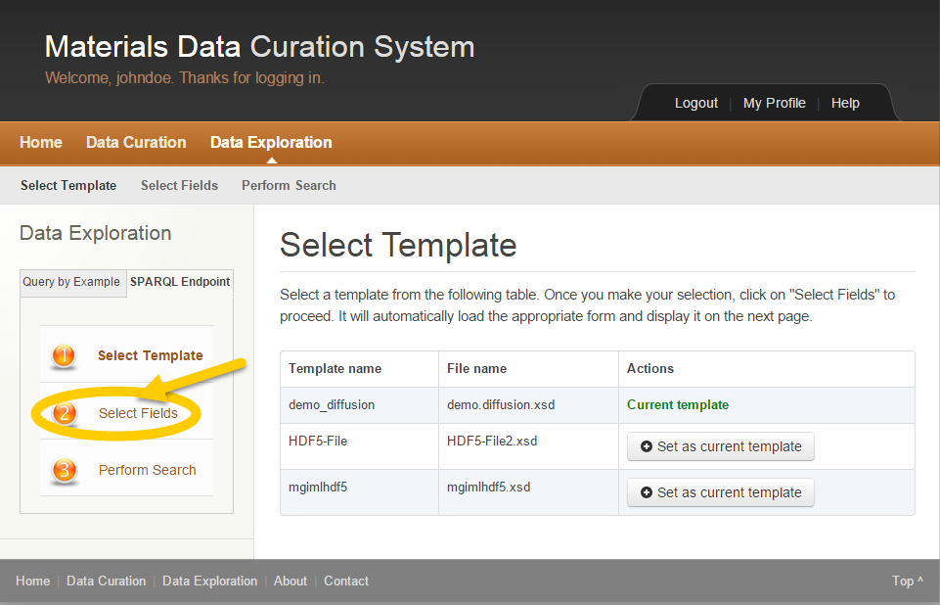

Figure SPARQL Query Select Fields

1. Click step 2 **Select Fields** in the left column.

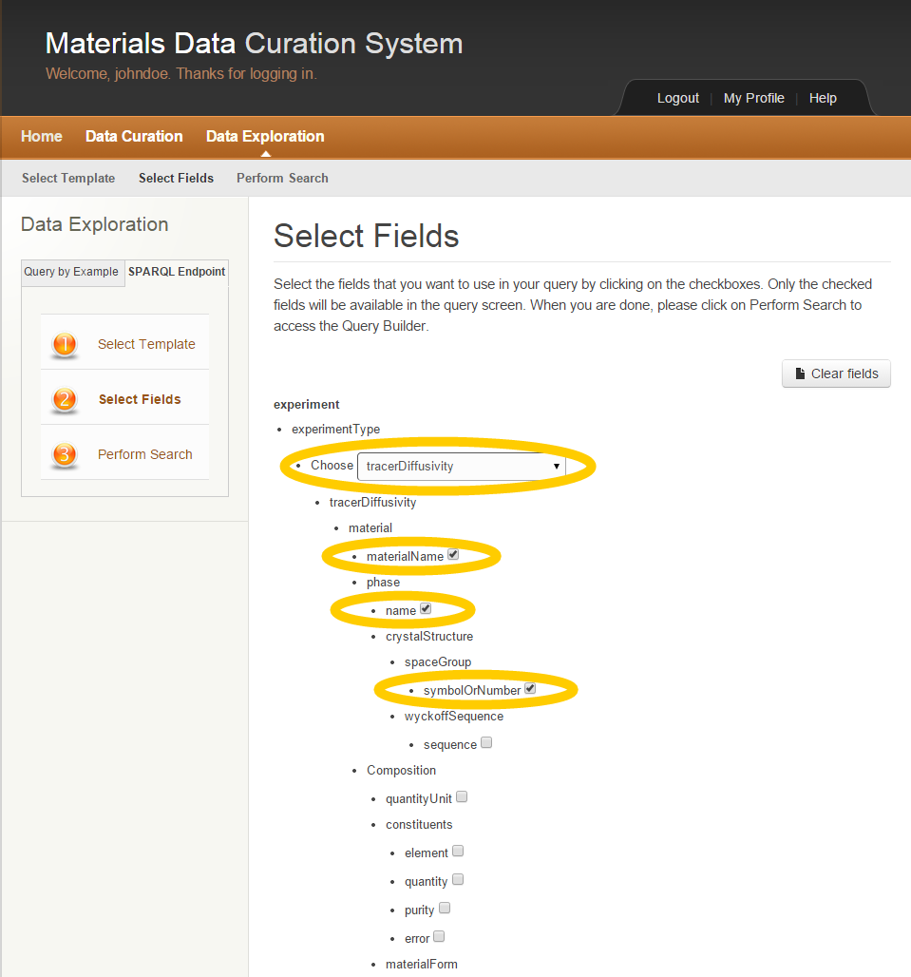

Figure SPARQL Query Select Fields

1. Select fields within the current template by clicking on the checkboxes or choosing items within the dropdowns.

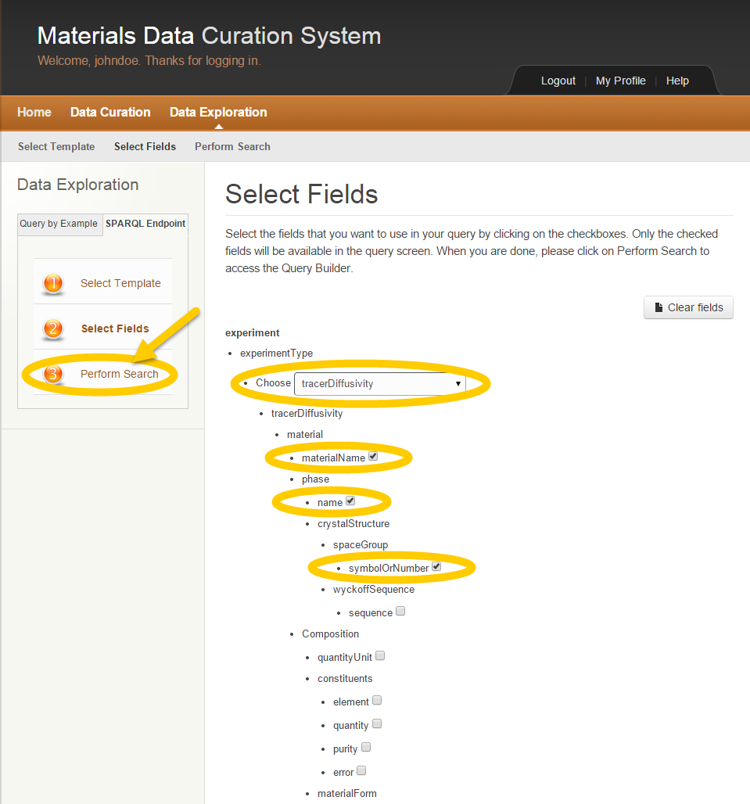

Figure SPARQL Query Perform Search

1. Click step 3 **Perform Search**.



The SPARQL Endpoint Query Perform Search page appears to allow the user to write a SPARQL query.

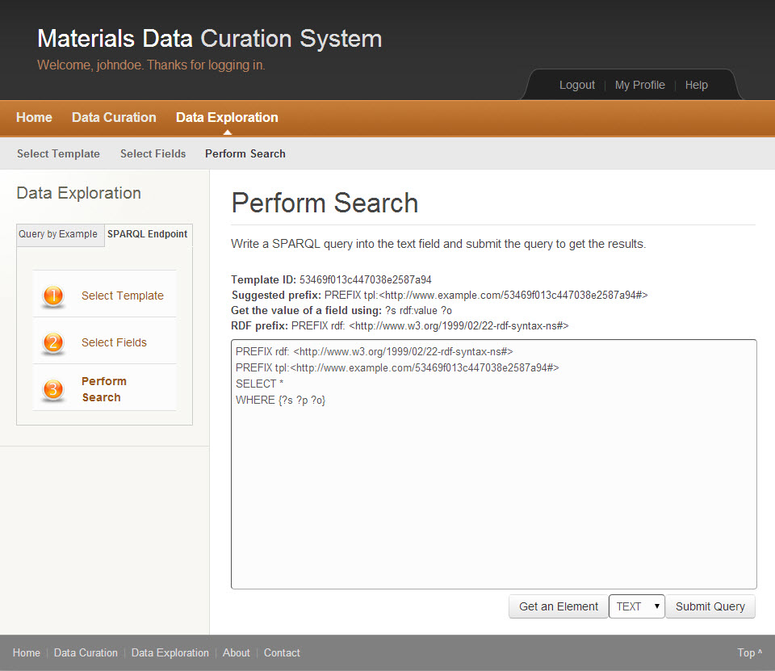

Figure SPARQL Query Perform Search

1. Write a SPARQL query within the text field.

*The user may copy and paste previously created queries within this text field.*

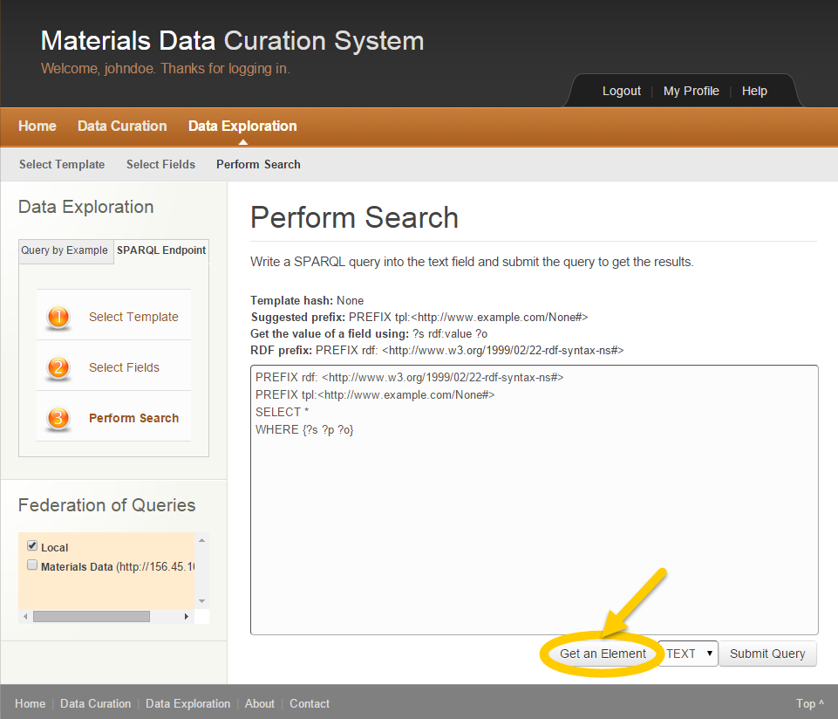

Figure SPARQL Query Get an Element

1. Click the **Get an Element** button to refine the query by using items selected within the current template in step 2.

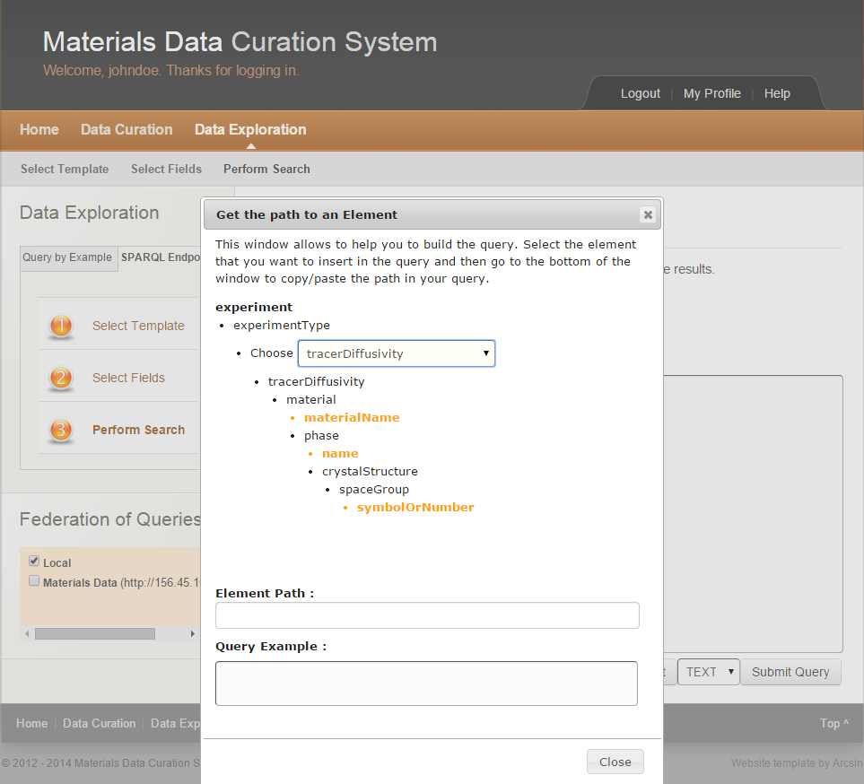

Figure SPARQL Query Get an Element

1. Select items within this window to assist in building the SPARQL query.

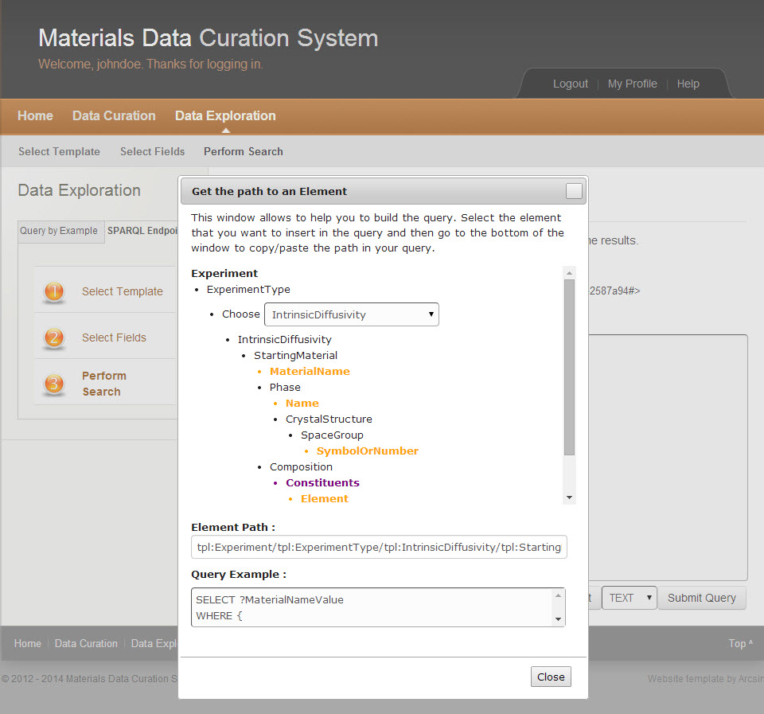

Figure SPARQL Query Get an Element

The Element Path as well as the Query Example get filled in to assist in building the SPARQL query.

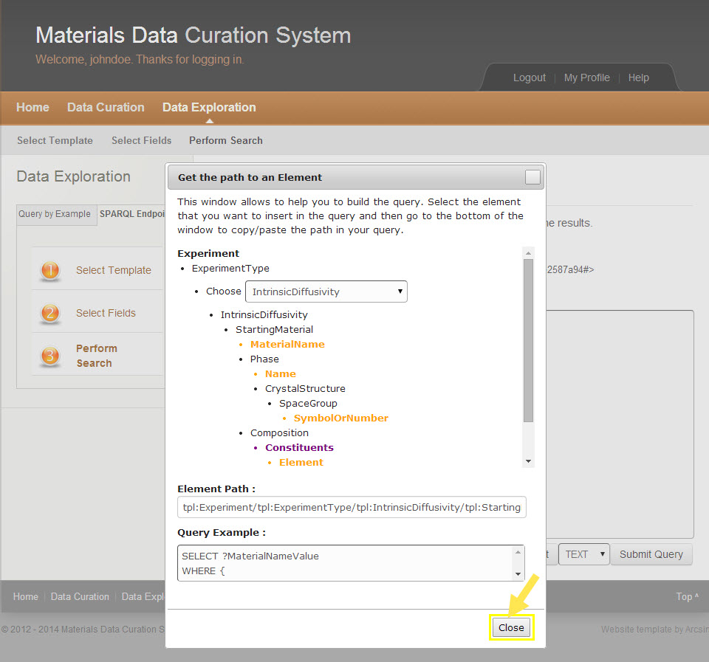

Figure SPARQL Query Get an Element

1. Click the **Close** button to complete.

The main SPARQL Query page appears.

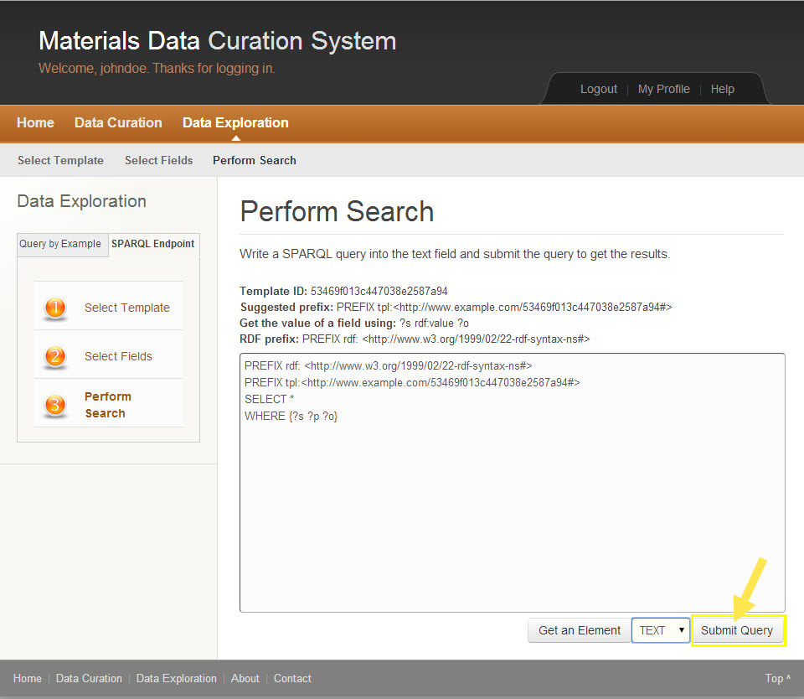

Figure SPARQL Query Submit Query

1. Click the Submit button to run the query.

*The user may choose to save the query results in the following file formats: TEXT, XML, CSV, TSV, JSON.*

Your query results appear.

## E-mail Template

E-mailing a template is currently a step outside of MDCS. A scientist would email a template to the MDCS Administrator. The Administrator uploads the template to MDCS and informs the scientist that it’s ready for use.

.

# RESTful API

MDCS supports RESTful APIs. The MDCS REST-based APIs allow the integration with other Web services, data entry, query, and retrieval.

The REST-based API has been implemented using the Django REST Framework:

<http://www.django-rest-framework.org/>

The documentation for the API was done using Django REST Swagger:

<https://github.com/marcgibbons/django-rest-swagger/>

The documentation can be accessed on the MDCS under '/docs/api' of the base URL.

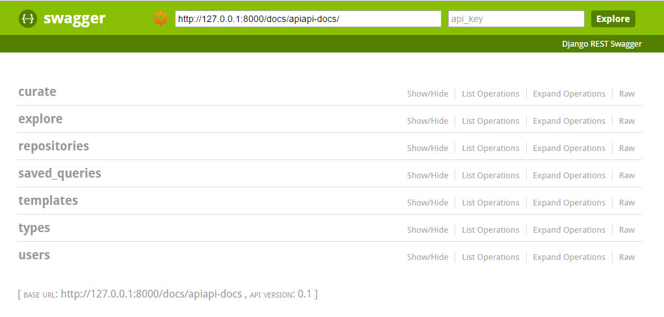

Figure RESTful API

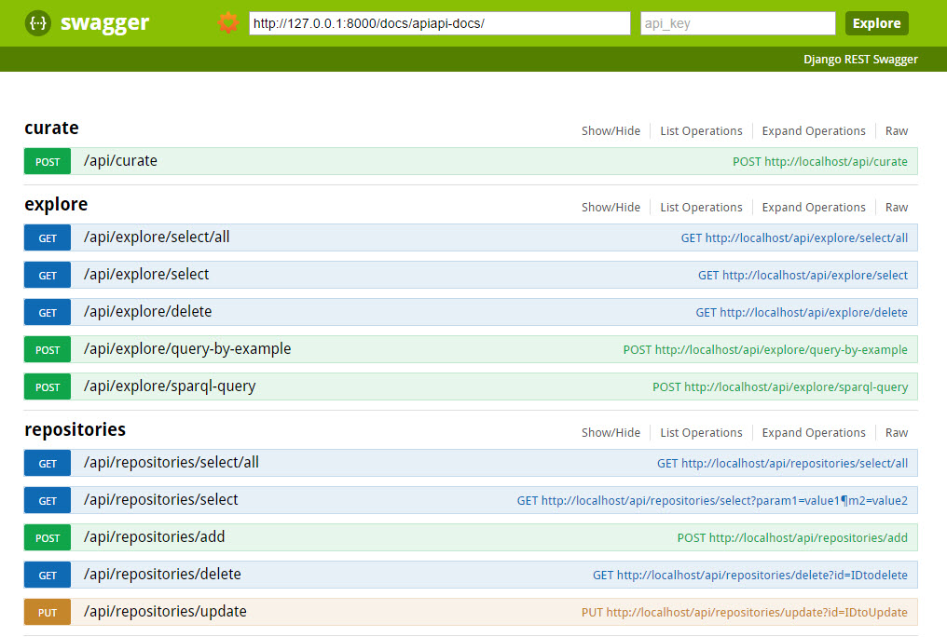

Figure RESTful API Expanded View

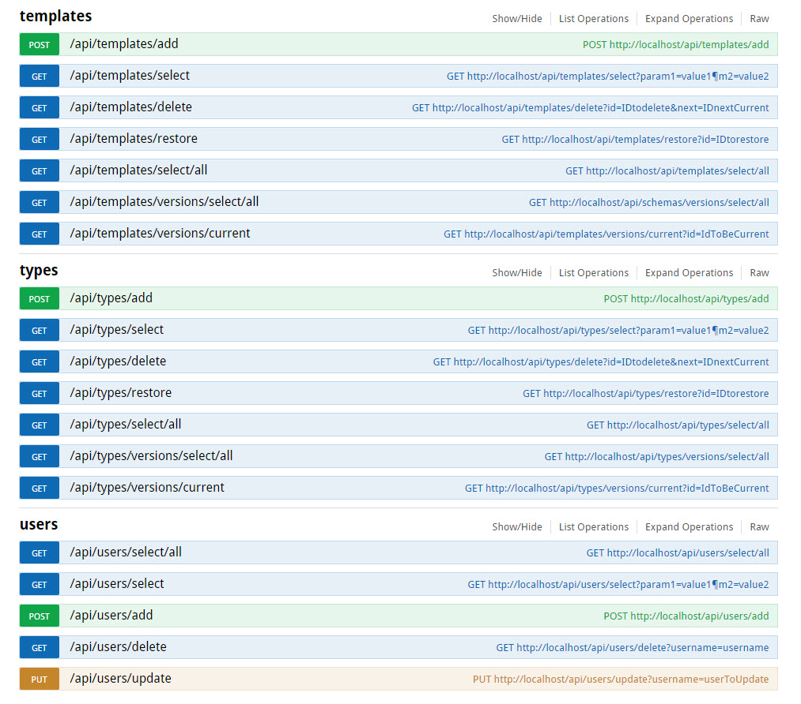

Figure RESTful API Expanded View

# Federation of Queries

An administrator may use federation of queries. This allows the querying from interconnected data repositories.

Federation of Queries is implemented under the Repositories page within the Administration Dashboard. A user must be an administrator to access this page. From the Repositories page, the user is able to add, edit, and delete repository instances.

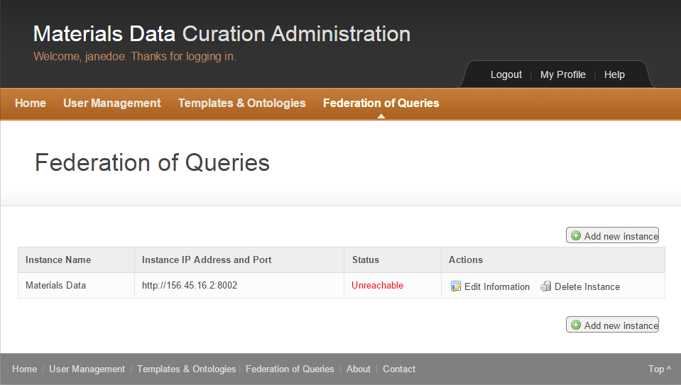

Figure 152 Federation of Queries

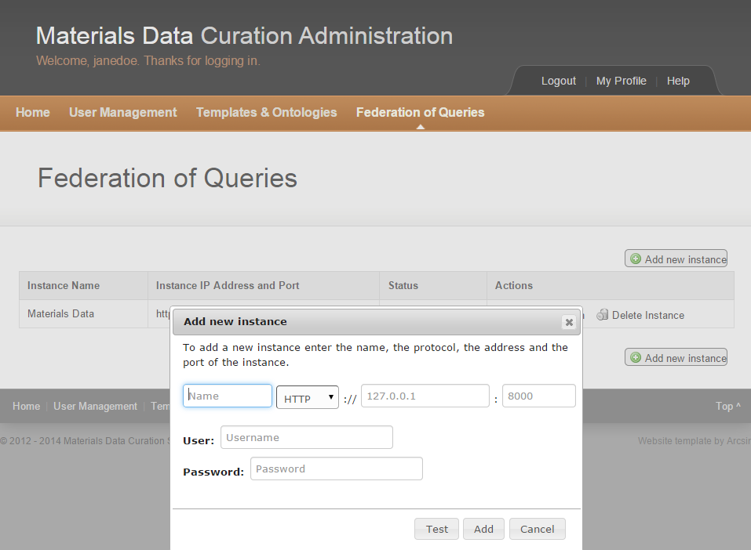

Figure 153 Federation of Queries Add New Instance

# Resources for help

## Resources for help

### MDCS Help

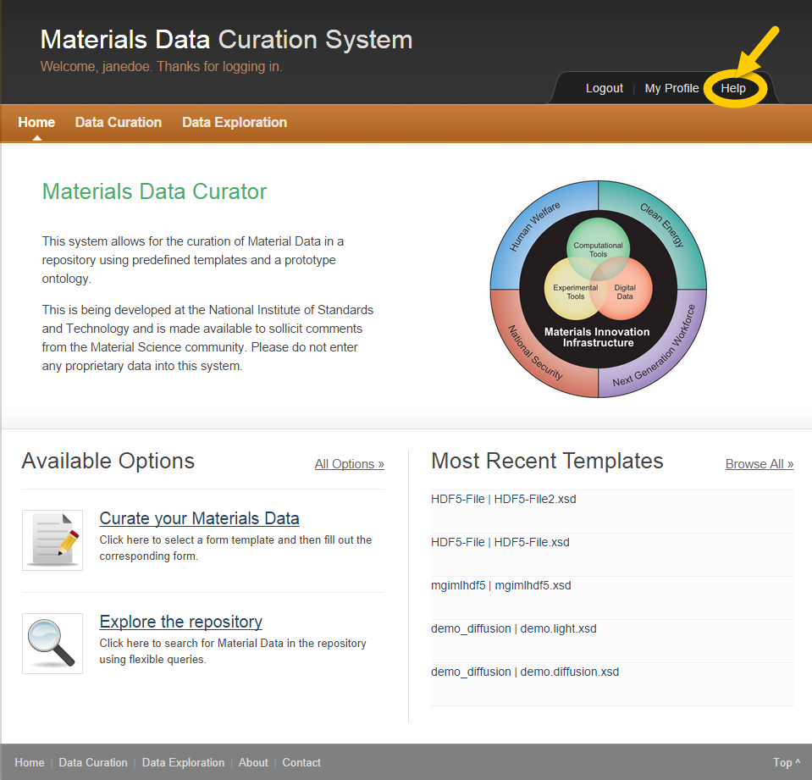

Figure MDCS Help

1. Click the **Help** button for Frequently Asked Questions.



A list of Frequently Asked Questions appears.

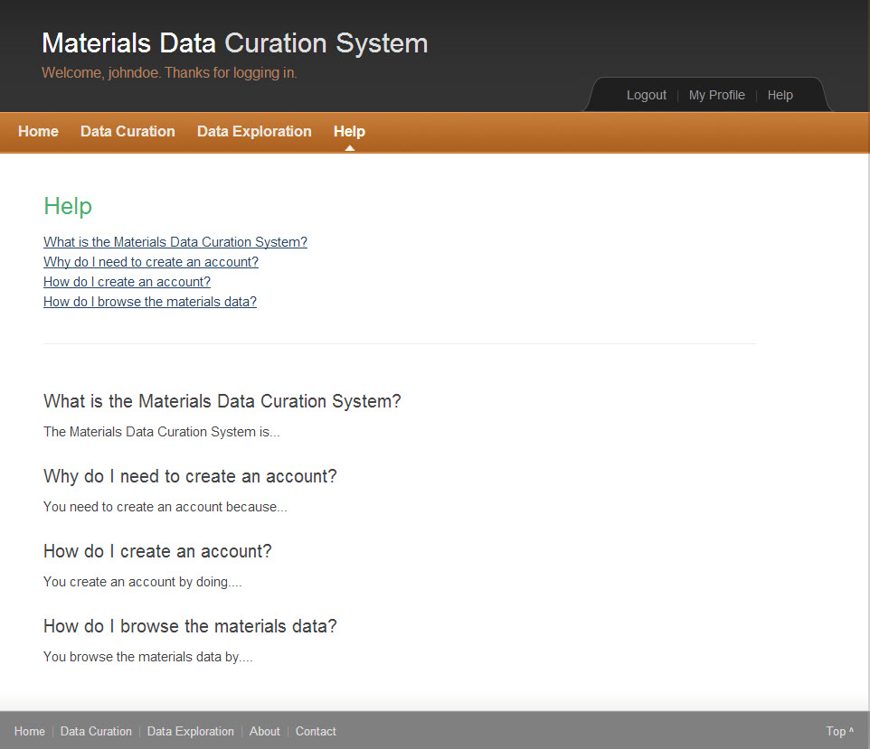

Figure Help FAQs

1. Click selected question for more information.

### MDCS Contact

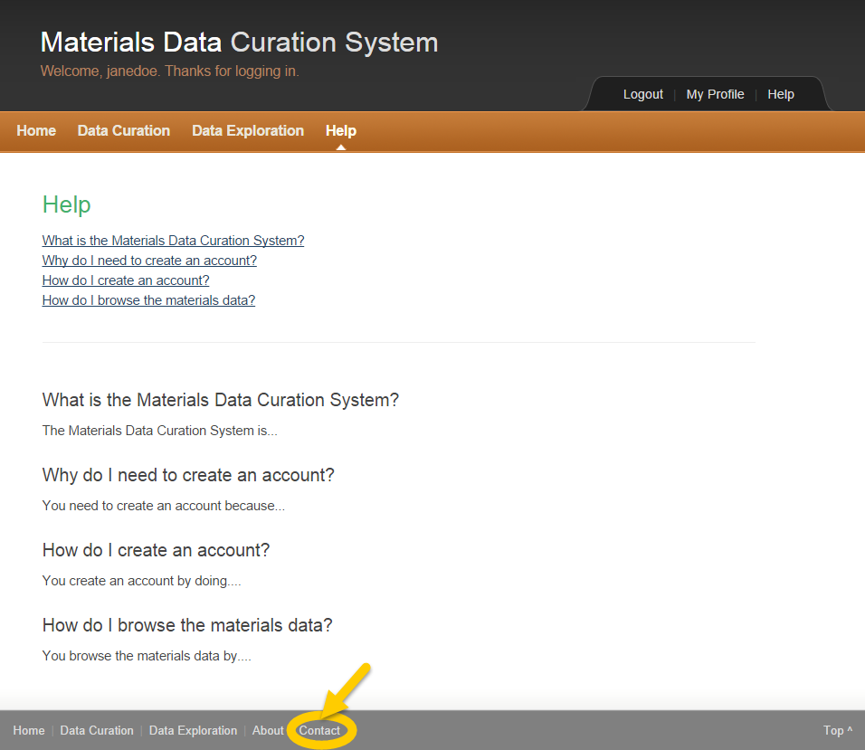

Figure MDCS Contact

1. Click **Contact** in the bottom center of the page.



A form appears to allow you to submit questions or comments to the MDCS administrator.

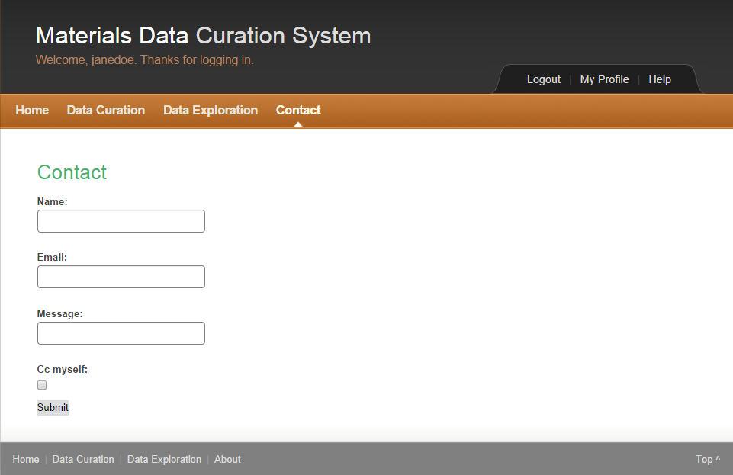

Figure MDCS Contact Form

1. Enter Name.
2. Enter Email.
3. Enter Message.
4. Click the Cc myself checkbox to send yourself a copy of the message.
5. Click the **Submit** button.

### MDCS Support Points of Contact

Technical lead: Sharief Youssef - [Sharief.youssef@nist.gov](mailto:Sharief.youssef@nist.gov)

Project lead: Alden Dima - [alden.dima@nist.gov](mailto:alden.dima@nist.gov)

Information Group Manager: Mary Brady – [mary.brady@nist.gov](mailto:mary.brady@nist.gov)

# System Architecture

# Index

A

**Add Element** icon 24

administrator 6

C

**Clear Fields** button 24

D

Data Exploration 92

**Delete Element** icon 24

**Download** button 25

**Download XML** button 25

I

Information icon 25

Installation instructions 8

Installation Instructions MAC 17

Installation Instructions WIN 8

L

**Load Form** button 24

M

**Mandatory Fields** 24

MGI MDCS 5

MGI MDCS Icons 24

S

**Save Form** button 25

**Save to repository** button 25

scientist 6

**Select Element** button 25

Support Points of Contact 126

System Architecture 127

U

User Guide Tips 25

# Index of Figures

Figure 1 Automated Instructions for Windows 8

Figure 2 Pop-up requesting administrator access 8

Figure 3 MDCS Setup Wizard 9

Figure 4 Select Destination Location 9

Figure 5 Select Start Menu Folder 10

Figure 6 Ready to Install 10

Figure 7 Installing 11

Figure 8 Completing the MDCS Setup Wizard 11

Figure 9 MDCS Shortcut 12

Figure 10 MDCS Shortcut Right Click 12

Figure 11 Open Windows while MDCS is running 13

Figure 12 Request MDCS Account 26

Figure 13 Request MDCS Account Online Form 26

Figure 14 New Account Request Sent Successfully 27

Figure 15 Materials Data Curation System Home 28

Figure 16 MDCS Login Page 29

Figure 17 MDCS Home 29

Figure 18 My Profile 30

Figure 19 Edit My Profile 31

Figure 20 Complete Profile Edit 31

Figure 21 My Profile Save 32

Figure 22 My Profile Saved 33

Figure 23 Profile Edits Done 33

Figure 24 My Profile Change Password 34

Figure 25 Change Password 34

Figure 26 Password Changed 35

Figure 27 Password Change Done 35

Figure 28 My Profile Updated 36

Figure 29 MDCS Logout 37

Figure 30 MDCS Login 38

Figure 31 MDCS Home 39

Figure 32 Administrator Login 40

Figure 33 MDCS Administrator Login 41

Figure 34 User Management 42

Figure 35 User Management Create a New Account 42

Figure 36 User Management Create an Account 43

Figure 37 User Management Create an Account 44

Figure 38 Change a User Account 45

Figure 39 User Management Edit Account 46

Figure 40 MDCS User Permissions 47

Figure 41 Account Requests 47

Figure 42 List of Current Account Requests 48

Figure 43 Templates & Ontologies 48

Figure 44 Template Manager 49

Figure 45 Template Manager Upload Template 49

Figure 46 Upload Template Window 50

Figure 47 Upload Template Choose File 50

Figure 48 Choose Template to Upload 51

Figure 49 Template Upload 51

Figure 50 Template Uploaded 52

Figure 51 Template Table 53

Figure 52 Manage Template Versions 53

Figure 53 Template Version Choose Files 54

Figure 54 Template Version Select File 54

Figure 55 Template Version Upload 55

Figure 56 Template Version Set Current 55

Figure 57 Template Version Uploaded 56

Figure 58 Template Version Registered 57

Figure 59 Edit Template Information 57

Figure 60 Edit Template Information Complete 58

Figure 61 Delete Template 58

Figure 62 Delete Template Confirmation 59

Figure 63 Template Deleted 59

Figure 64 Restore Template 60

Figure 65 Template Restored 61

Figure 66 Templates and Ontologies 62

Figure 67 Manage Ontologies 62

Figure 68 Ontology Manager 63

Figure 69 Ontology Manager 63

Figure 70 Upload Ontology 64

Figure 71 Select Ontology 64

Figure 72 Ontology Upload Window 65

Figure 73 Upload Ontology Window Complete 66

Figure 74 New Ontology Uploaded 66

Figure 75 Manage Ontology Versions 67

Figure 76 Ontology Versions Choose File Window 67

Figure 77 Select Ontology File 68

Figure 78 Ontology Version Upload Window 68

Figure 79 Ontology Version Set Current Window 69

Figure 80 Ontology Version Confirmation Window 69

Figure 81 Updated Ontology Version 70

Figure 82 Edit Ontology Information 71

Figure 83 Edit Ontology Information Window 71

Figure 84 Ontology Information Updated 72

Figure 85 Delete Ontology 72

Figure 86 Ontology Delete Confirmation Window 73

Figure 87 Ontology Deleted 73

Figure 88 Restore Ontology 74

Figure 89 Restored Ontology 75

Figure 90 MDCS Scientist Page 76

Figure 91 Data Curation Main Page 77

Figure 92 Data Curation Template Loaded 78

Figure 93 Current Template Page 79

Figure 94 Data Entry Page 80

Figure 95 Data Entry Dropdowns 81

Figure 96 Data Entry Text Fields 82

Figure 97 Data Entry Add/Reduce Icons 83

Figure 98 Data Entry Select Chemical Element 84

Figure 99 Periodic Table 85

Figure 100 Chosen Element 86

Figure 101 Complete Element Selection 87

Figure 102 Element Selection Completed 88

Figure 103 Data Entry Choose Profile 89

Figure 104 Data Entry Upload Spreadsheet 90

Figure 105 Data Entry Choose File 91

Figure 106 Data Entry Choose File to Upload 92

Figure 107 Data Entry Upload File 93

Figure 108 Data Entry Upload File Button 94

Figure 109 Data Entry File Upload Successful Window 95

Figure 110 Data Entry Citation 96

Figure 111 MDCS View Data 97

Figure 112 XML View (Sample 1) 98

Figure 113 XML View (Sample 2) 99

Figure 114 XML View Download XML 100

Figure 115 XML View Save to Repository 101

Figure 116 Save XML to repository Name File 102

Figure 117 XML Data Saved to Repository 103

Figure 118 Data Exploration 104

Figure 119 Data Exploration Select Template 105

Figure 120 Data Exploration Template Loaded 106

Figure 121 Data Exploration Current Template 107

Figure 122 Data Exploration Select Fields 107

Figure 123 Select Fields within Template 108

Figure 124 Query by Example Perform Search 109

Figure 125 Query by Example Query Builder 110

Figure 126 Query by Example Define Query 111

Figure 127 Query by Example Select an Element 112

Figure 128 Query by Example Element Selected 113

Figure 129 Query by Example 114

Figure 130 Query by Example Submit Query 115

Figure 131 Query by Example Query Results 116

Figure 132 Query by Example Download 117

Figure 133 Query by Example Save Query 118

Figure 134 Query by Example Saved Queries 119

Figure 135 Data Exploration Main Page 120

Figure 136 SPARQL Endpoint Query 121

Figure 137 SPARQL Endpoint Query Select Template 122

Figure 138 SPARQL Endpoint Template Loaded 123

Figure 139 SPARQL Query Current Template 124

Figure 140 SPARQL Query Select Fields 125

Figure 141 SPARQL Query Select Fields 126

Figure 142 SPARQL Query Perform Search 127

Figure 143 SPARQL Query Perform Search 128

Figure 144 SPARQL Query Get an Element 129

Figure 145 SPARQL Query Get an Element 130

Figure 146 SPARQL Query Get an Element 131

Figure 147 SPARQL Query Get an Element 132

Figure 148 SPARQL Query Submit Query 133

Figure 149 RESTful API 135

Figure 150 RESTful API Expanded View 136

Figure 151 RESTful API Expanded View 137

Figure 152 Federation of Queries 138

Figure 153 Federation of Queries Add New Instance 139

Figure 154 MDCS Help 140

Figure 155 Help FAQs 141

Figure 156 MDCS Contact 142

Figure 157 MDCS Contact Form 143